|  |  |
| --- | --- |
| Sr no |  |
| 1 | Angular Setup |
| 2 | Component |
| 3 | Selectors |
| 4 | Data Bindings |
| 5 | Directives |
| 6 | Custom Event Binding |
| 7 | Template Reference Variable |
| 8 | [ViewChild Decorator](#_ViewChild_(@)_Decorator) |
| 9 | View Encapsulation |
| 10 | Ng-content / Projected Content |
| 11 | Life Cycle Hooks |
| 12 | @ContentChild Decorator |
| 13 | Custom Attribute Directive |
|  |  |
|  |  |
|  |  |

# Angular Setup

* How to install angular?
  + npm i -g @angular/cli
  + ng -v
* How to create project in angular?
  + ng new hello-world
* How to run angular project?
  + ng serve
* How to create component?
  + ng generate component <component-name >
  + ng g c myComponent
* service?
  + ng g s <service_name>
* directive?
  + ng g d <directive_name>

# Component

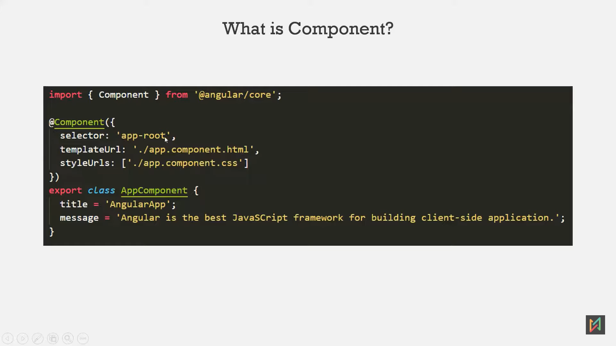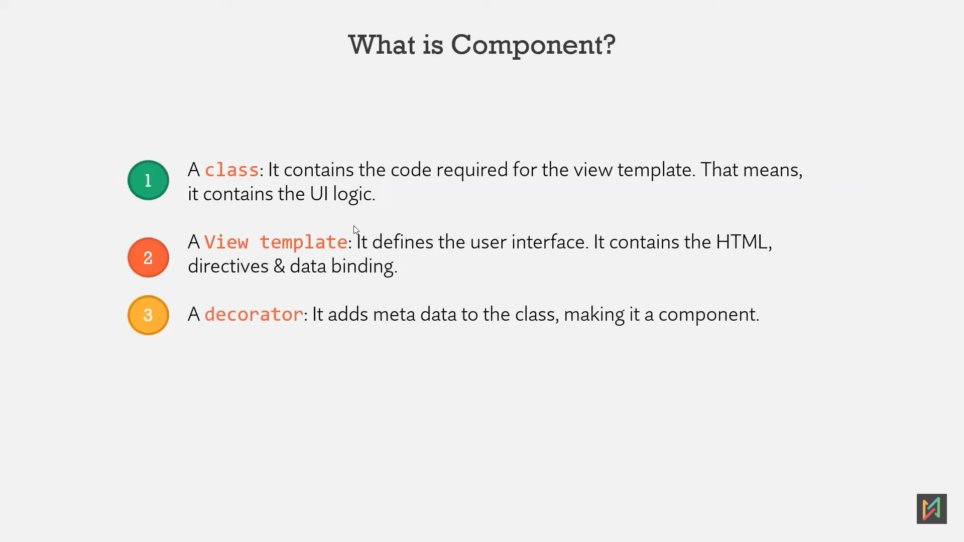

Decorator: @Component

# Selector

**Ways to use selector:**

1. **Selector as HTML tag:**TS file: @Component{  
    selector: ‘app-nav’  
   }  
   then Another html file we use as tag: <app-nav></app-nav>
2. **Selector as HTML Attribute ([]):**TS file: @Component{  
    selector: ‘ [app-nav]’  
   }  
   OTHER HTML: <div app-nav ></div>
3. **Selector as CSS Class (.):**TS file: @Component{  
    selector: ‘ .app-nav’  
   }  
   OTHER HTML: <div class=”app-nav” ></div>

# Data Binding:

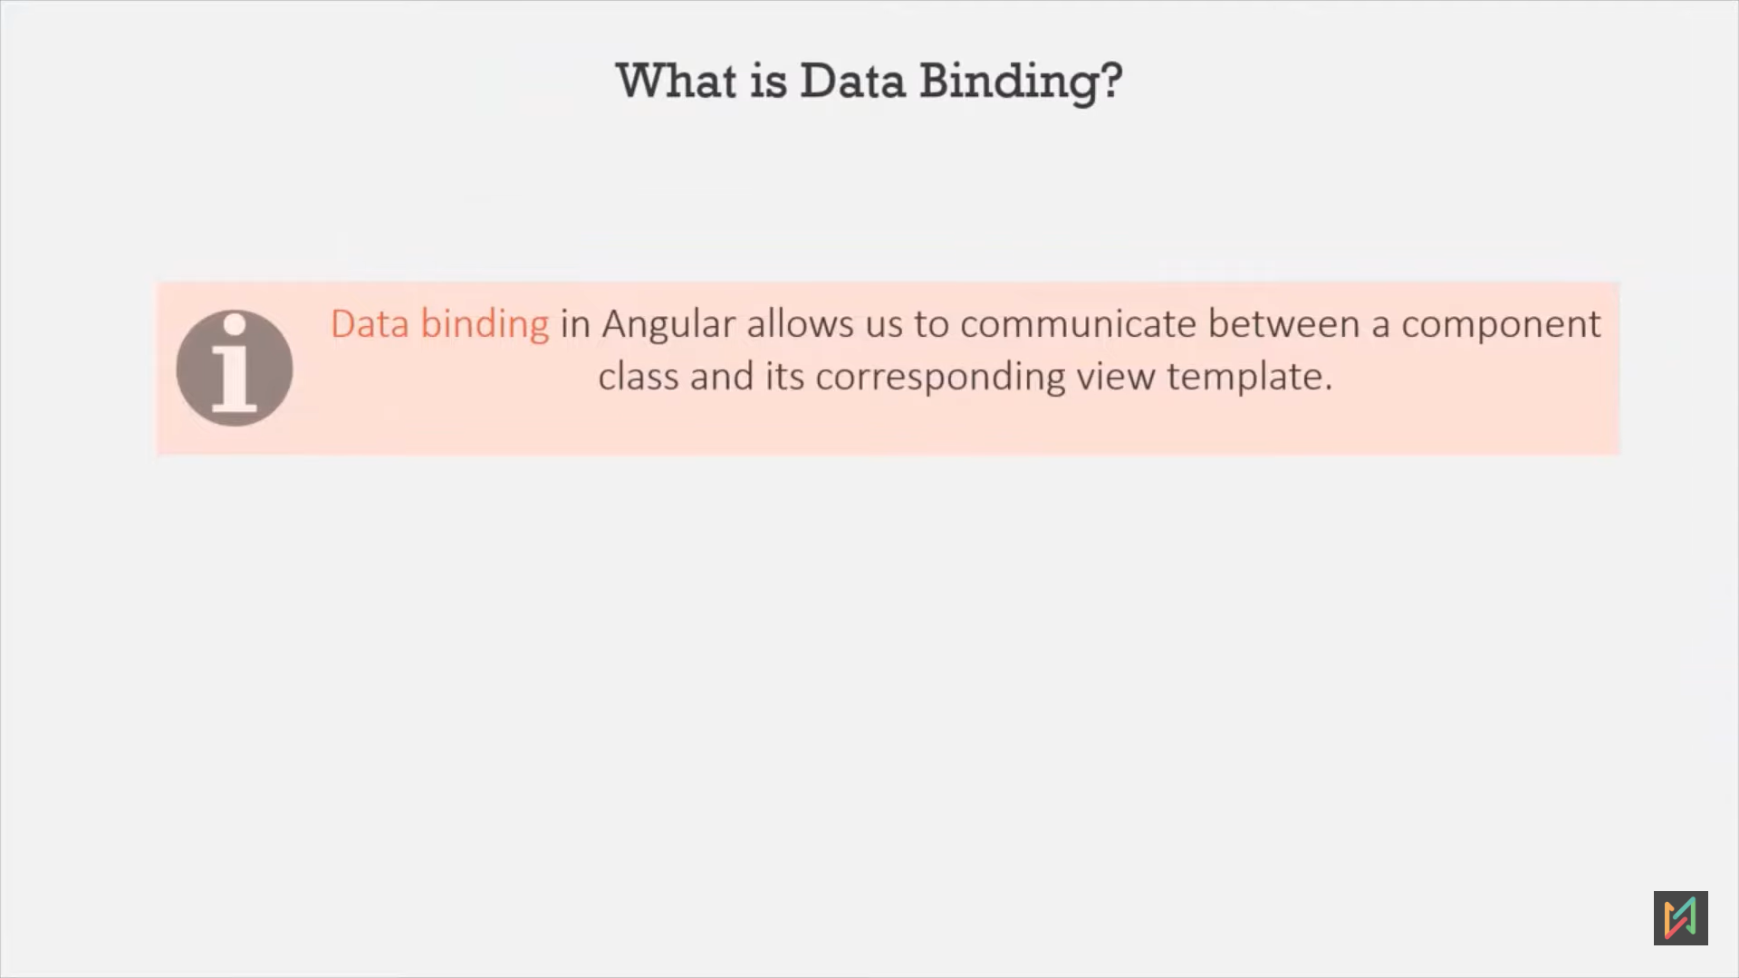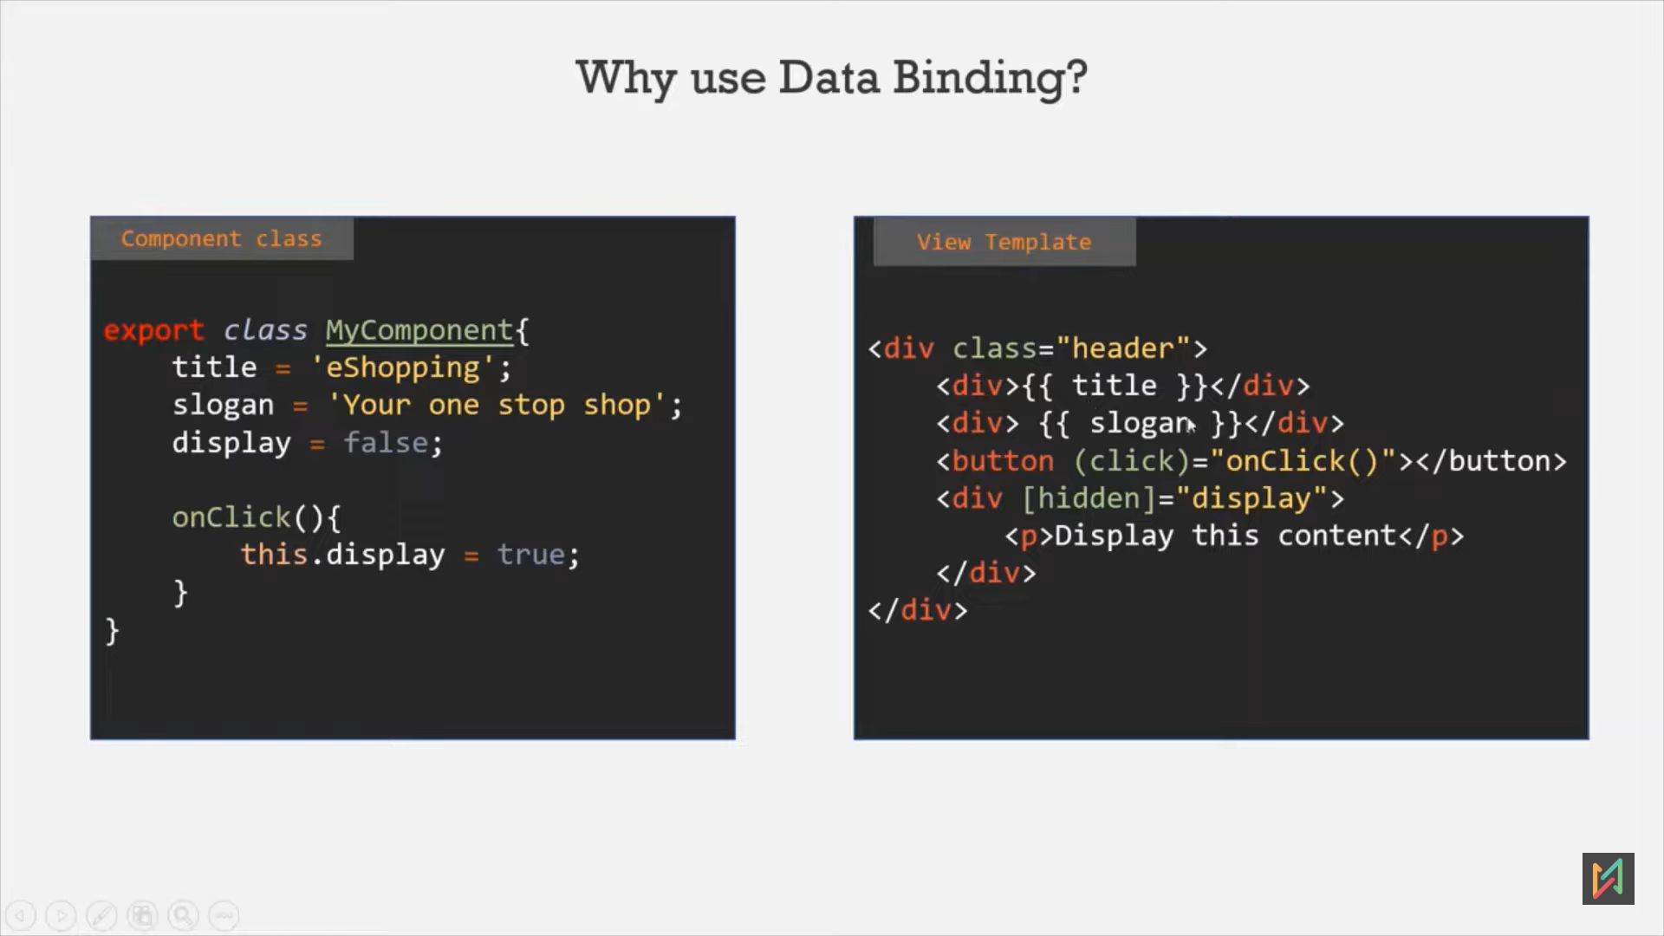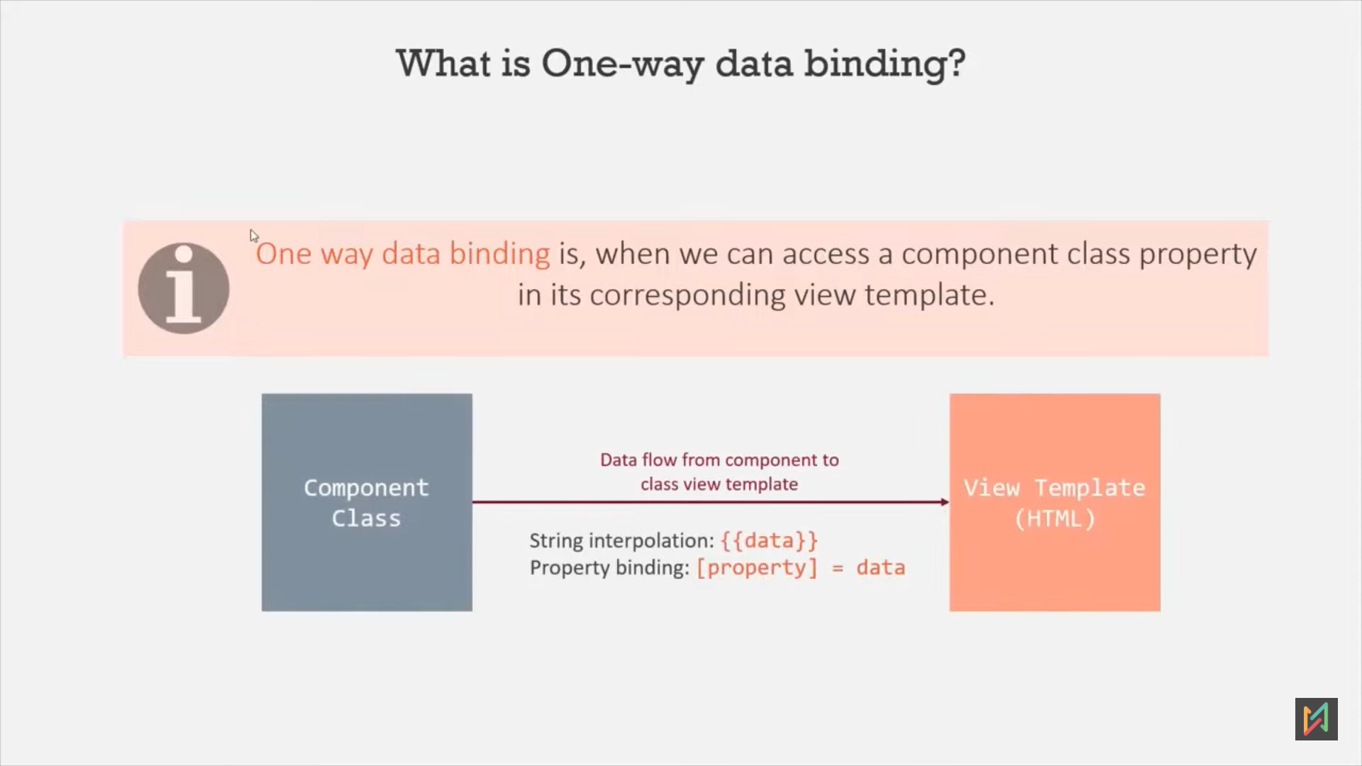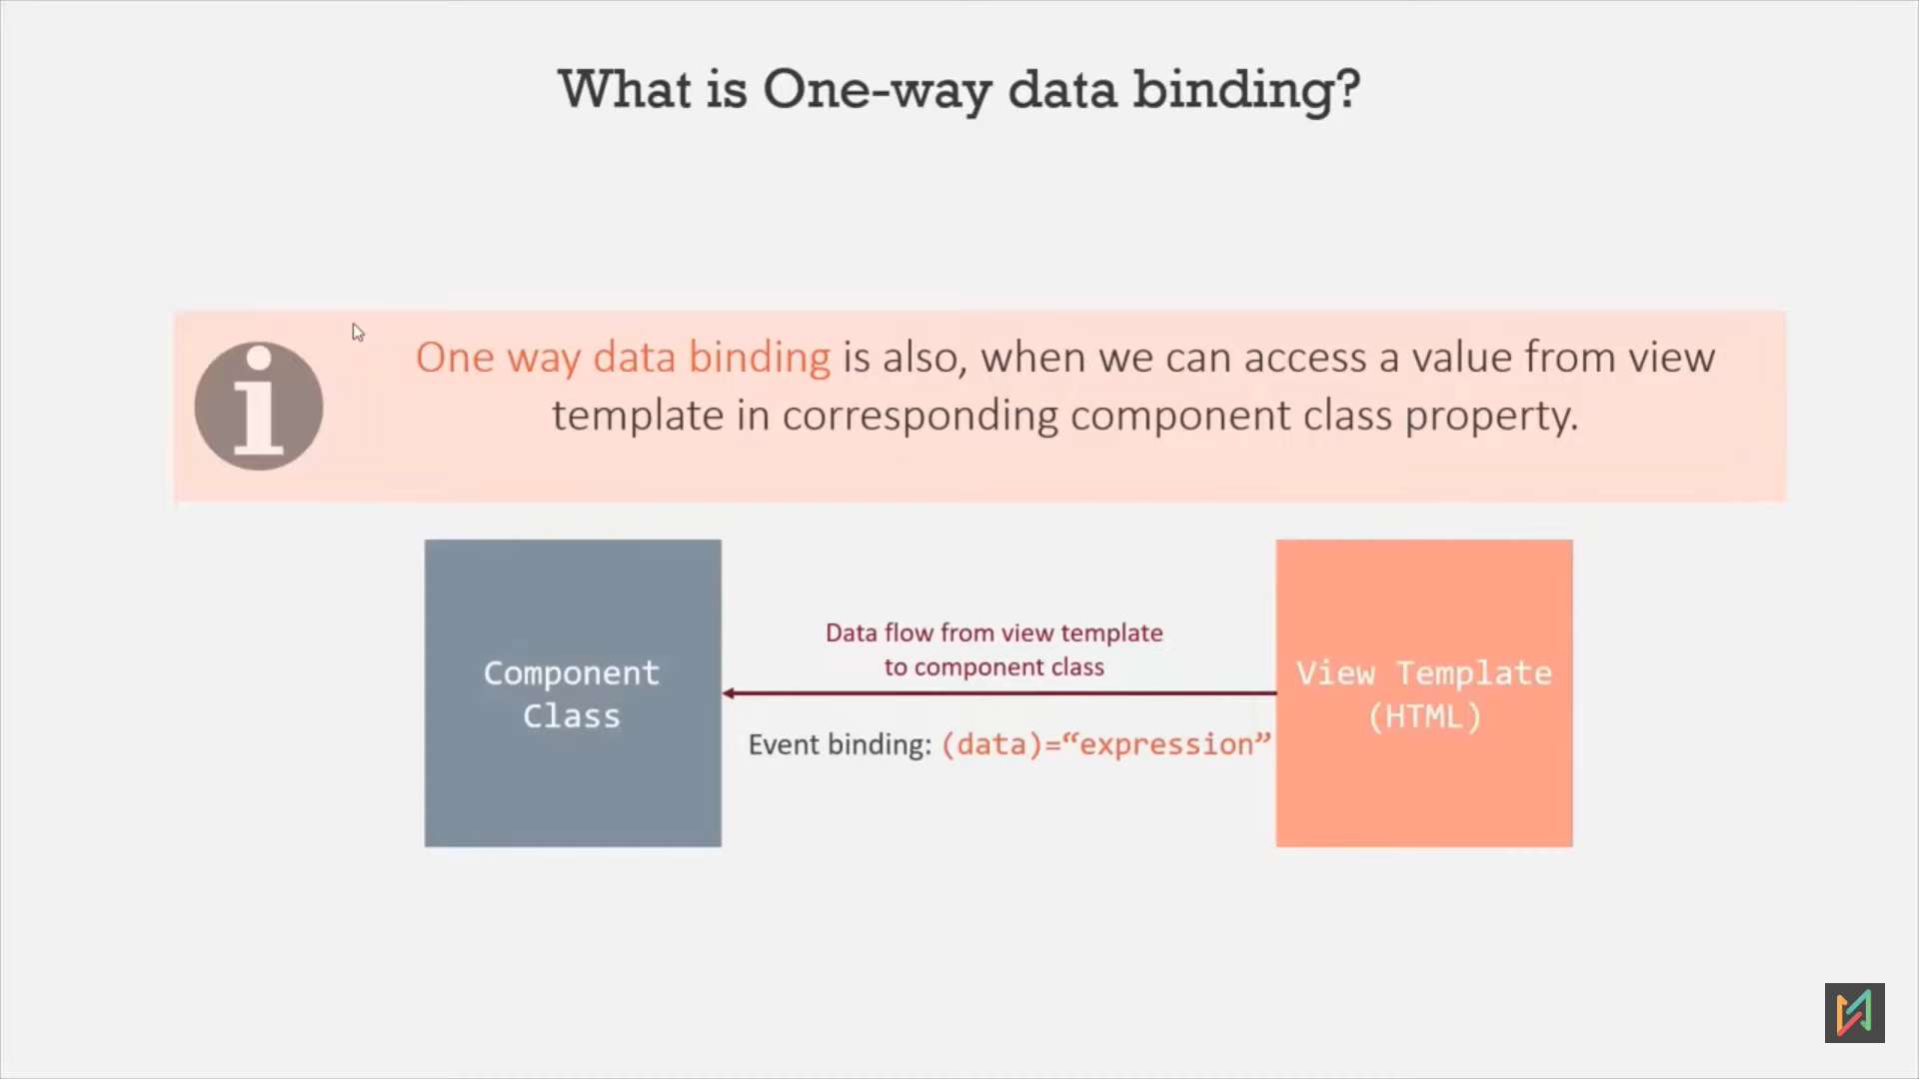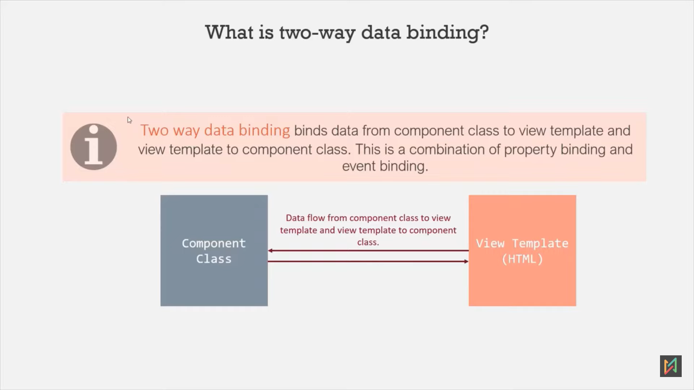

1. Types of Data Binding:
   1. One Way:
      1. TS to HTML (Component class to view templete):
         1. String Interpolation:  
            {{data}}  
            TS: name :string = “Sagar””   
            HTML: <h1> {{name}} </h1>
         2. Property Binding:  
            [property]=’data’  
            TS: var isDisable: boolean = true   
            HTML: <div [disable]=”isDisable” ></div>
      2. HTML To TS:
         1. Event Binding:  
            (data)=”expression”  
            HTML: < input type="text" (input)=“myInputData($event)”/>  
             <p>You search for: {{ inputData }} ></p>  
              
            TS: inputData: string = “”;  
             myInputData(event:any) { this.inputData = event.target.value; }
   2. Two Way:  
      - It’s a combination of property binding and event binding.  
      - To use it, we need to import FormsModule to app.module.ts file.  
      - TS: my2Data: string = “mobile”  
       HTML: <input type="text" [(ngModel)]="my2Data"/> // default value is “mobile”  
        
       <p>You searched for: {{my2Data}}</p>  
       TS: my2Data: string = “mobile”

# Directives

* Directives are simply an instruction to the DOM.
* Basically, these are custom HTML attributes, which tells angular to change the style or behavior of DOM element.
* Components are the building block of the Angular application.   
  Similarly, directives are also the building block of the Angular application.
* Command: **ng generate directive highlight** 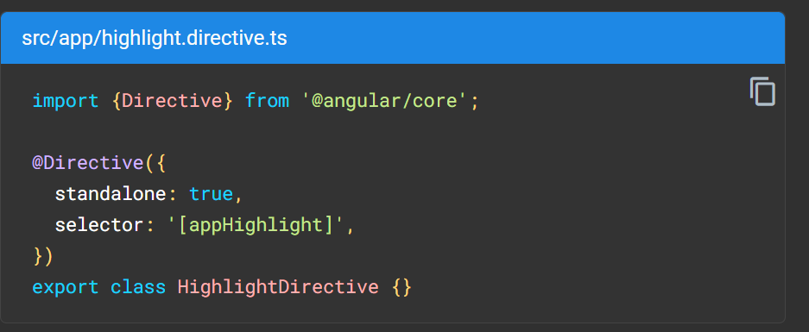
* **Types**:
  + **Component**:  
    Directive with a template.   
    @Component
  + **Structural**:  
    Change layout of the elements.  
    denoted by * symbol, angular internally convert into <ng-template> tag.
    - *ngIf : <div *ngIf="hero" class="name">{{hero.name}}</div>
    - *ngFor: *[ngFor](https://angular.io/api/common/NgFor)="let item of [1,2,3] as items; trackBy: myTrack; index as i"
    - *ngIf: *ngIf=”exp” *ngIf=”exp as value”
    - ngSwitch
  + **Attribute**:  
    Change appearance or behaviour of a particular element.
    - NgClass:
    - NgStyle: <div [ngStyle]=”currentStyles”
    - NgModel: <input [{ngModel)]=”currentIdem.name”>
* We **cannot use 2 structural directives on single html element.** Like( <div *ngFor=”” *ngIf=””>)  
  solution:  
   <ng-container *ngFor=”” > <div *ngIf=”” ></div> </ ng-container>
* Types:
  + @Component
  + Custom Directive:   
    @Directive(selector:’[changeDivGreen]’) export class ChangeDivGreen{}  
     <div changeDivGreen> hi </div>
  + Build In Directive:
  + Structural Directive:
    - *ngIf:  
      - It’s a structural directive, so we need prefix as *.  
      **-** used to add or remove element from a webpage based on a given condition.  
      - if the condition assigned to ngIf returns true, it will add the element on which it is used to the webpage. Otherwise, if the condition returns false, it will remove that element from the webpage.  
      - HTML: <input type="text" [(ngModel)]="my2Data"/> // default value is “mobile”  
       <p *ngIf=“ my2Data!=‘’; else noDataMsg ”>You searched for: {{my2Data}}</p>   
      <ng-template #noDataMsg > <p>No search.</p> </ng-template>
    - *ngFor:  
      - It’s a structural directive.  
      <div *ngFor= “let item of [1,9,3]”><p>Number is: {{item}}</p></div>  
      <div *ngFor=”let item of [1,5,6,8]; let i=index”>  
       <p>{{i}}:Number is: {{item}}</p>  
      </div>
    - [ngSwitch]=”occupation” *ngSwitchCase=”teacher” *ngSwitchCase=”doctor” *ngSwitchDefault
  + Attribute Directive:
    - ngStyle:  
      - This is an attribute directive. That means it changes the look and behaviour of an html element.  
      - This directive is used to set a CSS style dynamically for an HTML element based on a given typescript expression.  
      - <div [ngStyle]=”{color: item%2===0? ‘Green’: ‘Red’}”>…</div>
    - ngClass:  
      - This is an attribute directive.  
      - used to add a CSS class dynamically to a webpage element.  
      - CSS: .changeBackground{background-color:orange}  
       HTML: <div [ngClass]=“changeBackground: my2Data != ‘’ ” ><input type="text" [(ngModel)]="my2Data"/> </div>  
      if data is available in my2Data variable, ngClass will change the background color.

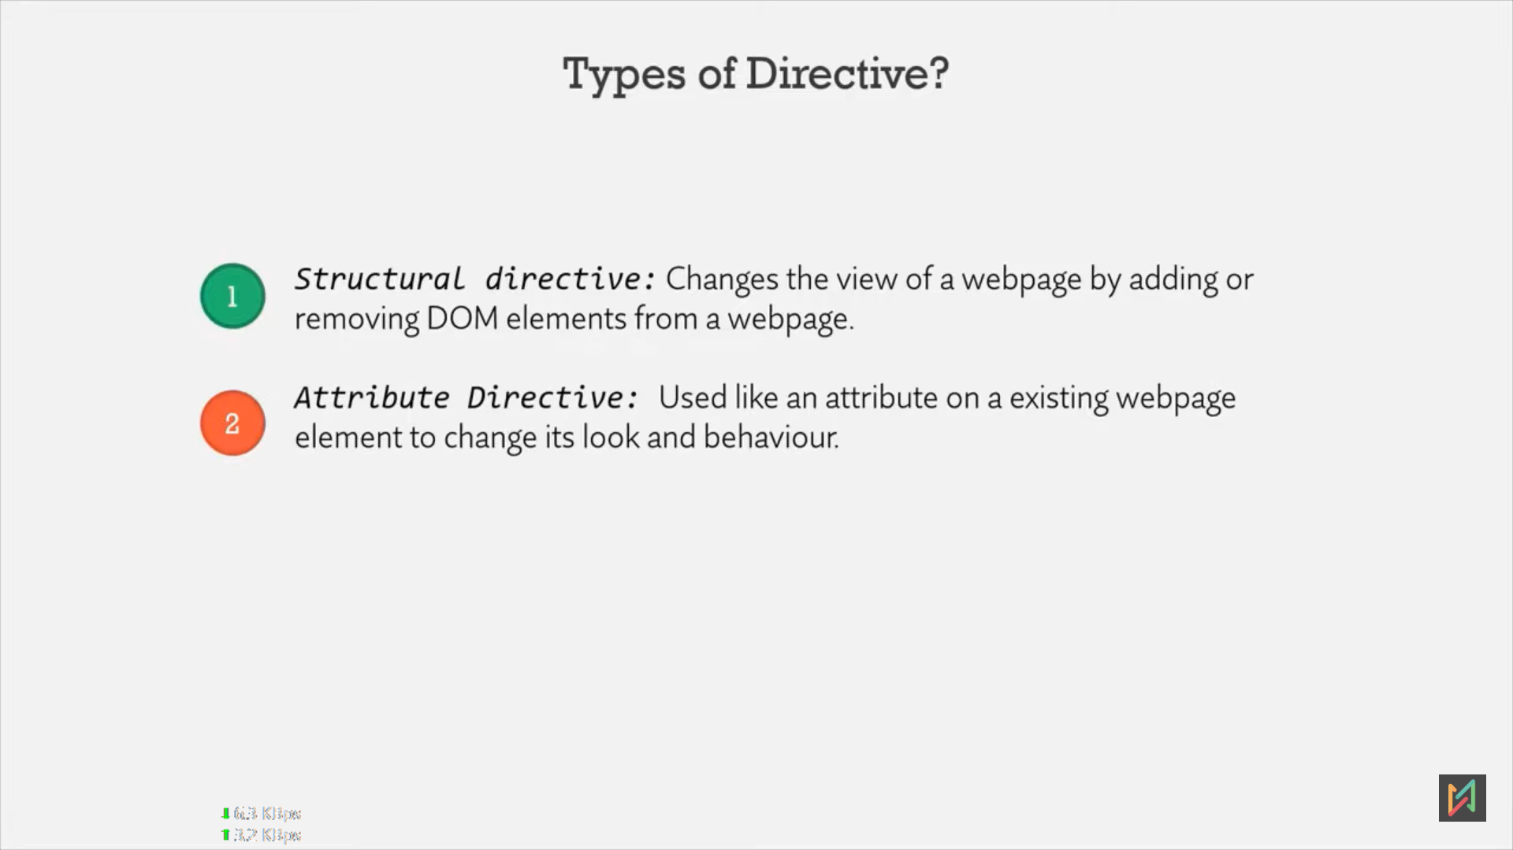 **ngSwitch**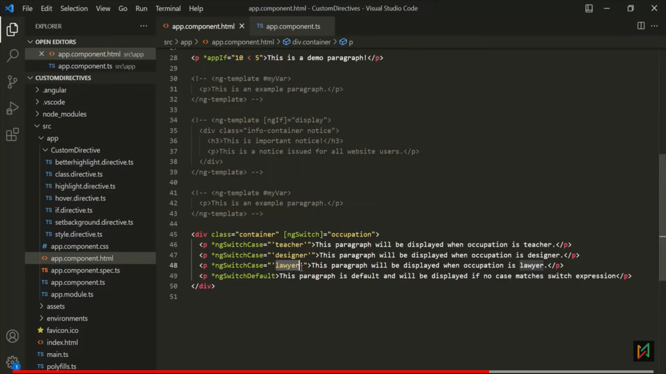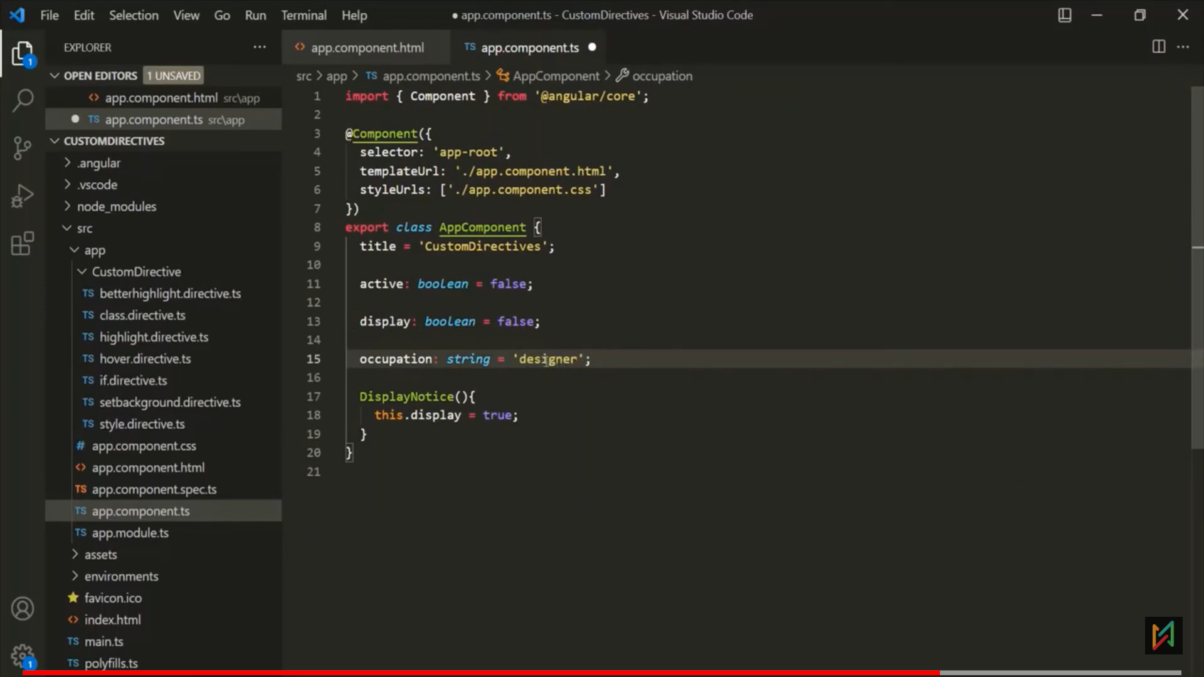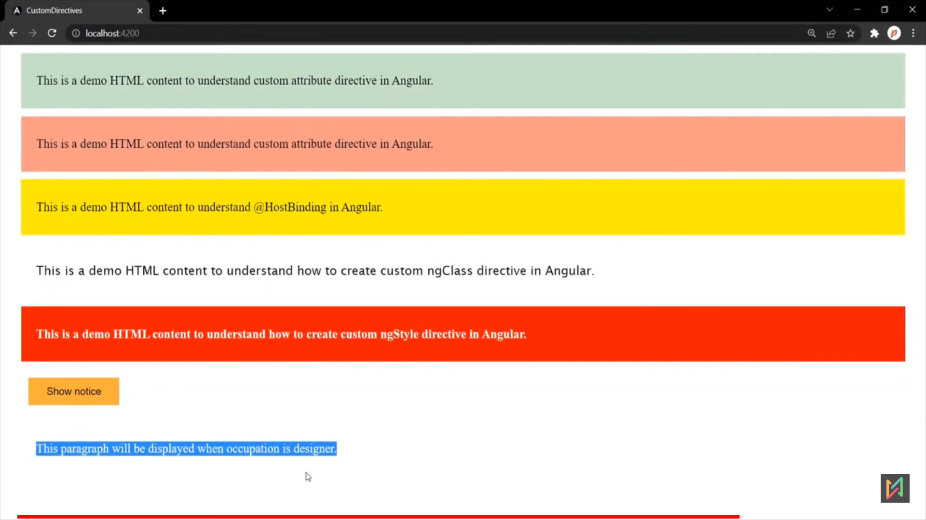

# Custom Event Binding

## Input Decorator:

* + Pass data from parent component to child component using @Input decorator which is in @angular/core.
  + Parent:  
    <app-filter **[all]= “getTotalCourses()”** [free]= “getTotalFreeCourses()” [paid]=“getTotalPremiunCourses()” ></app-filter>
  + Child (app-filter):  
    TS:   
    @Input() all: number =0;  
    @Input() free: number=0  
    **@Input(‘paid’) premium: number =0;** // pass alias name  
    selectedRadioButtonValue: string = ‘All’ // default all courses radio button selected.  
    <input type=”radio” name= “filter” value=”All” [(ngModel)]=”selectedRadioButtonValue” /> <span>{{‘All Courses(‘+ **all**+ ’)’}}  
    <input type=”radio” name= “filter” value=”Free” [(ngModel)]=”selectedRadioButtonValue” /> <span>{{‘Free Courses(‘+ **free** + ’)’}}  
    <input type=”radio” name= “filter” value=”Premium” [(ngModel)]=”selectedRadioButtonValue” /> <span>{{‘ Premium Courses(‘+ **premium**+ ’)’}}

## Output Decorator:

* + Pass data from child component to parent component.
  + To use @Output() decoration, need to import ‘EventEmitter’ from ‘@angular/core’.
  + TS:  
    import { Output, EventEmitter} from ‘@angular/core’;  
    **@Output() filterRadioButtonSelectionChanged: EventEmitter<string> = new EventEmitter<string> ();**  
      
    onRadioButtonSelectionChanged() {  
    this.filterRadioButtonSelectionChanged.emit(this.selectedRadioButtonValue);  
    }  
    HTML:  
    <input type=”radio” name= “filter” value=”All”   
    [(ngModel)]=“selectedRadioButtonValue”  
    **(change)= “onRadioButtonSelectionChanged()”** // event binding all on all element (all, free, paid)  
     /> <span>{{‘All Courses(‘+ all+ ’)’}}
  + Parent:  
     TS: courseCountRadioButton: string = ‘All’;  
     onFilterRadioButtonChanged(data:string) {  
     this.courseCountRadioButton = data;  
     }  
    HTML:   
    <app-filter **(filterRadioButtonSelectionChanged)=“onFilterRadioButtonChanged($event)”**  
    [all]= “getTotalCourses()” [free]= “getTotalFreeCourses()” [Paid]=“getTotalPremiunCourses” ></app-filter>  
      
    <**ng-container *ngFor**= “let course of courses”>   
     <div **\*ngIf= “courseCountRadioButton === ‘All’ || courseCountRadioButton === course.type”** >  
     <p>based on @Output decorator radio button type, courses will display. </p>   
     </div>  
    <ng-container</ng-container>

# Template Reference Variable (#)

* A template reference variable is a reference to any DOM element, Component or a directive in the template.
* It’s **denoted by #**
* Eg.   
  app-child =>  
   <input type=”text” **#myVariable** >  
   <p>{{**myVariable.value**}}</p>  
  **Issue**: Initially page loaded, value is empty so paragraph is also empty, but when we are type something, HTML is unaware of the changes. It wont refresh.  
  **Solution**: add some event, so HTML will refresh the view.  
   => <input type= “text” **#myVariable (keyup)=“0”**>
* <button (click)=”sayHello(myVariable)”> Say Hello </p>  
  **sayHello(inputEl: HTMLInputElement)** { console.log(inputEl.value) }
* Parent component can access child component data Using template ref variable:
  + Child:  
    <tr *ngFor= “let customer of customers” >  
     <td> {{customer.customerNo}} </td>  
     <td> {{customer.name}} </td>  
     <button (click)= “selectedCustomer = customer”>Select</button>  
    </tr>  
    TS:   
    export class MyChild {  
     **selectedCustomer**;  
     customers: Customer[] = [ {customerNo:1, name: “Sagar Patil”}, …}  
    }
  + Parent:  
    <**app-child #customer**> </app-child> // just like @Output// here, local ref variable on component. It will read MyChild class.  
    <p> You have reading {{**customer**.**selectedCustomer?.name** }} </p>
* We **cannot access template references from view to ts**. To access in TS file, use @ViewChild.

# ViewChild (@) Decorator

* Access own view element reference or Child component data from Component (TS file).
* From TS File : 1. Own view .html file 2. Child component class attributes and methods.
* Check Notepad for code.=====================

- **Parent**:

**HTML**:

<div>

<label>DOB: </label> <input type="date" **#dobInput** (blur)="calculateAge()">

</div>

<div>

<label>Age: </label> <input type="text" **#ageInput**>

</div>

<app-demo></app-demo>

{{demoComp.sayHello()}} // call child component method.

**TS**:

import **{ElementRef, ViewChild}** from '@angular/core';

import {DemoComponent} from './demo/demo.component'

export class AppComponent {

**@ViewChild('dobInput') dateOfBirth:ElementRef;** // access view template reference variable data in TS file using ViewChild, so we dont need event to call or read.

@ViewChild('ageInput') age: ElementRef; // class ElementRef{nativeElement:{value:''} }

**@ViewChild(DemoComponent, {static:true})** demoComp**: DemoComponent**; // **access child component**

calculateAge() {

let birthYear = new Date(this.dateOfBirth.nativeElement.value).getFullYear();

let currentYear = new Date().getFullYear();

let age = currentYear - birthYear;

this.age.nativeElement.value = age;

this.demoComp.sayHello() // todo: verify once

}

}

- Child:

export class DemoComponent {

sayHello() {

console.log('Hello from demo component class!');

}

}

# View Encapsulation:

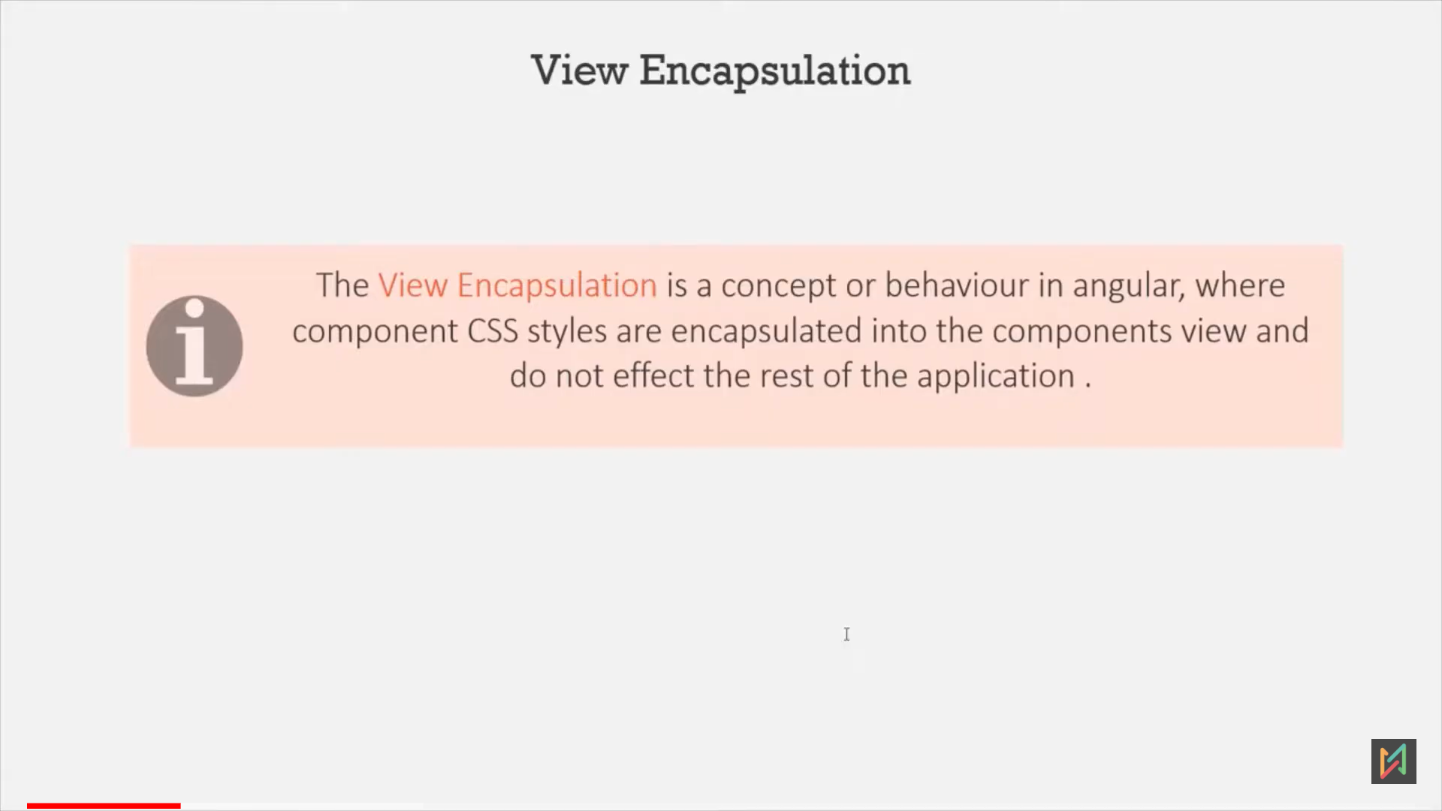 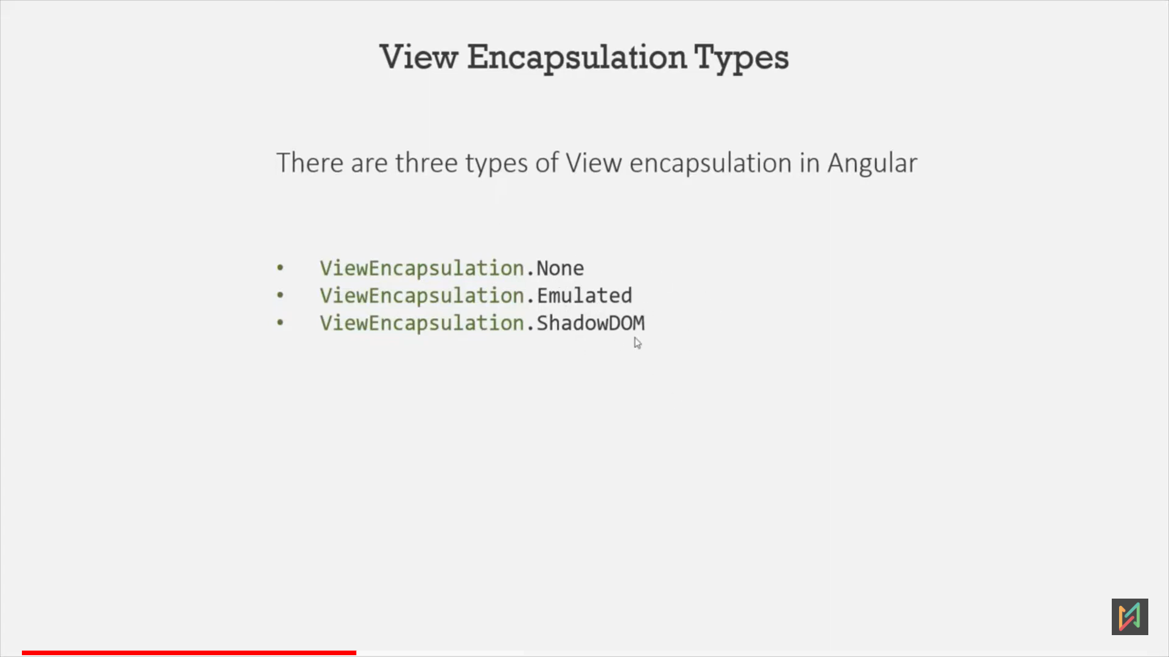

## **1.** Emulated Behaviour

* Angular by default have an Emulated Behaviour.  
  That means, It will add unique attribute in each element by given component. Eg. _ng_content-onci-c11  
  So, css, html will be unique for each component.  
  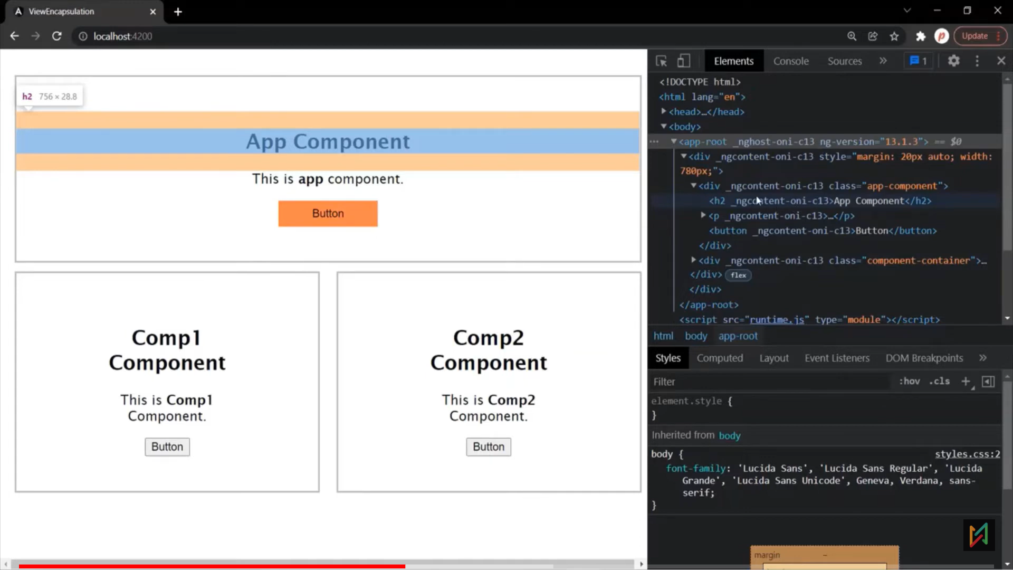 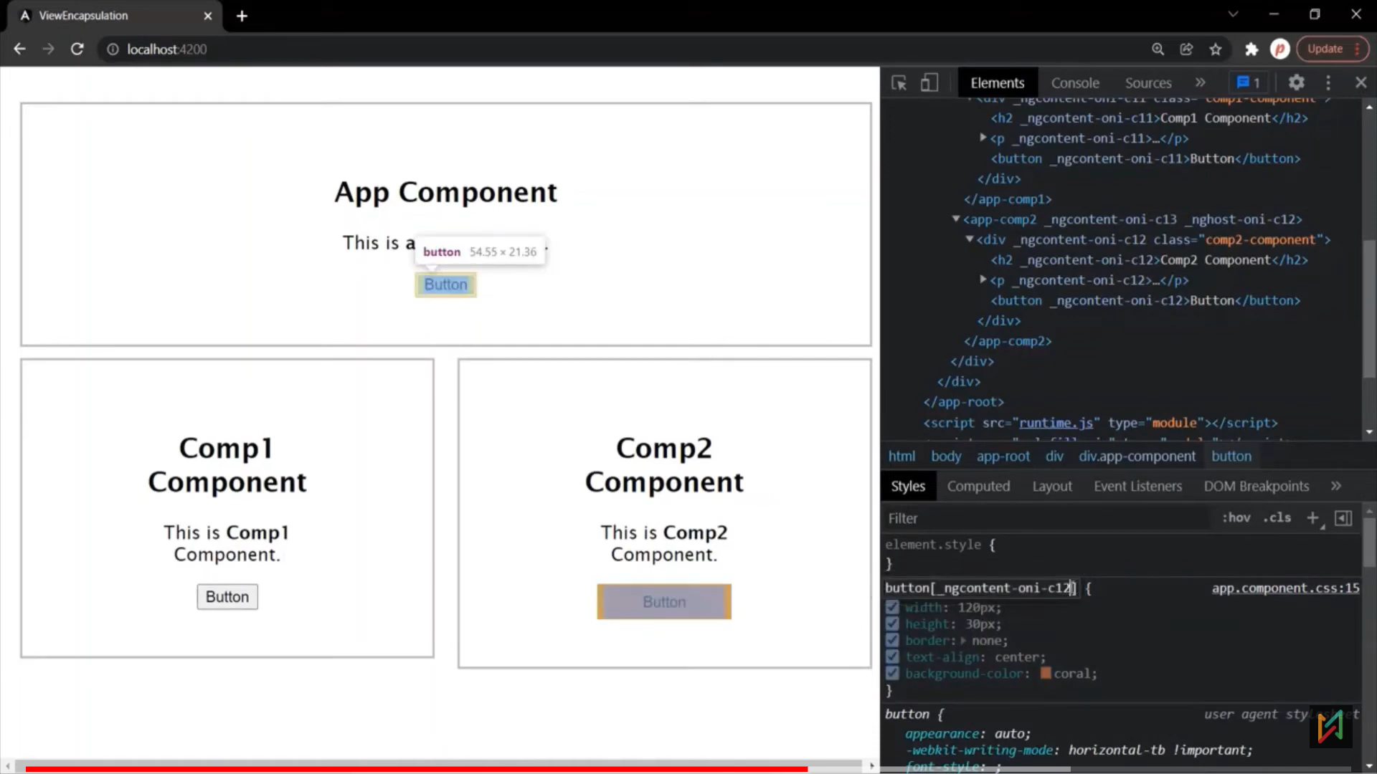

## 2. None Behaviour

- When we select none, then no view encapsulation will be used, So, whatever css will write in parent, it will reflect in child view elements as well. This time, no unique attributes will use.

- eg. If we added css in parent button tag, then same css will apply on child component button tags.

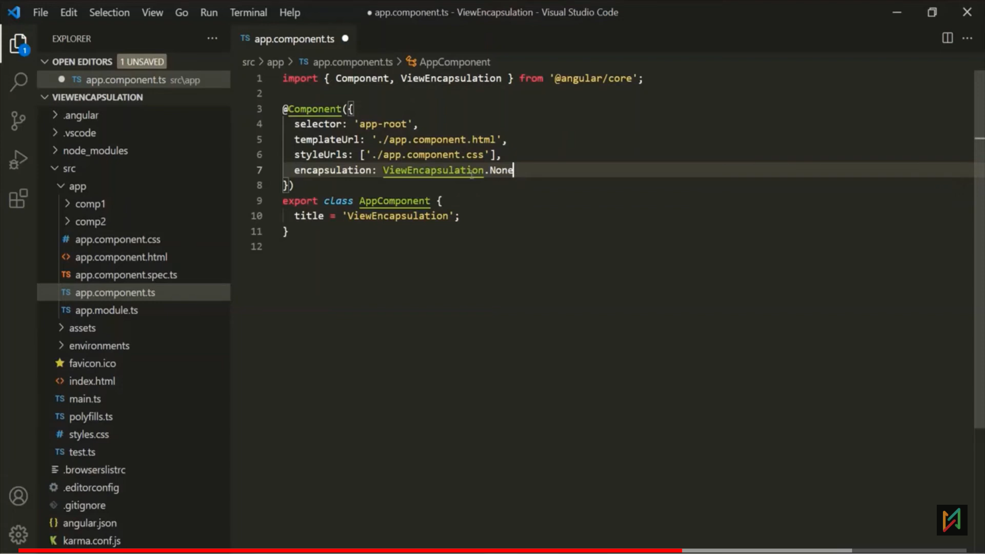 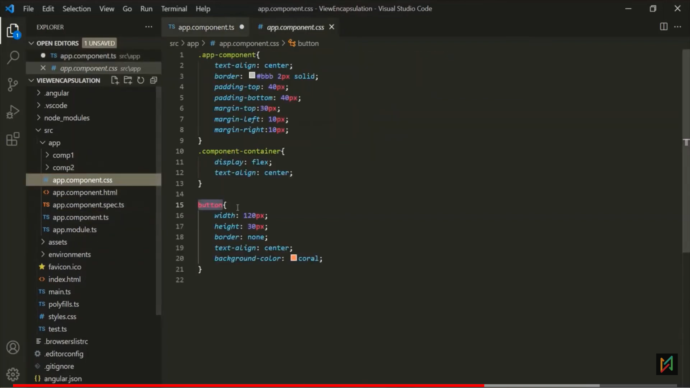 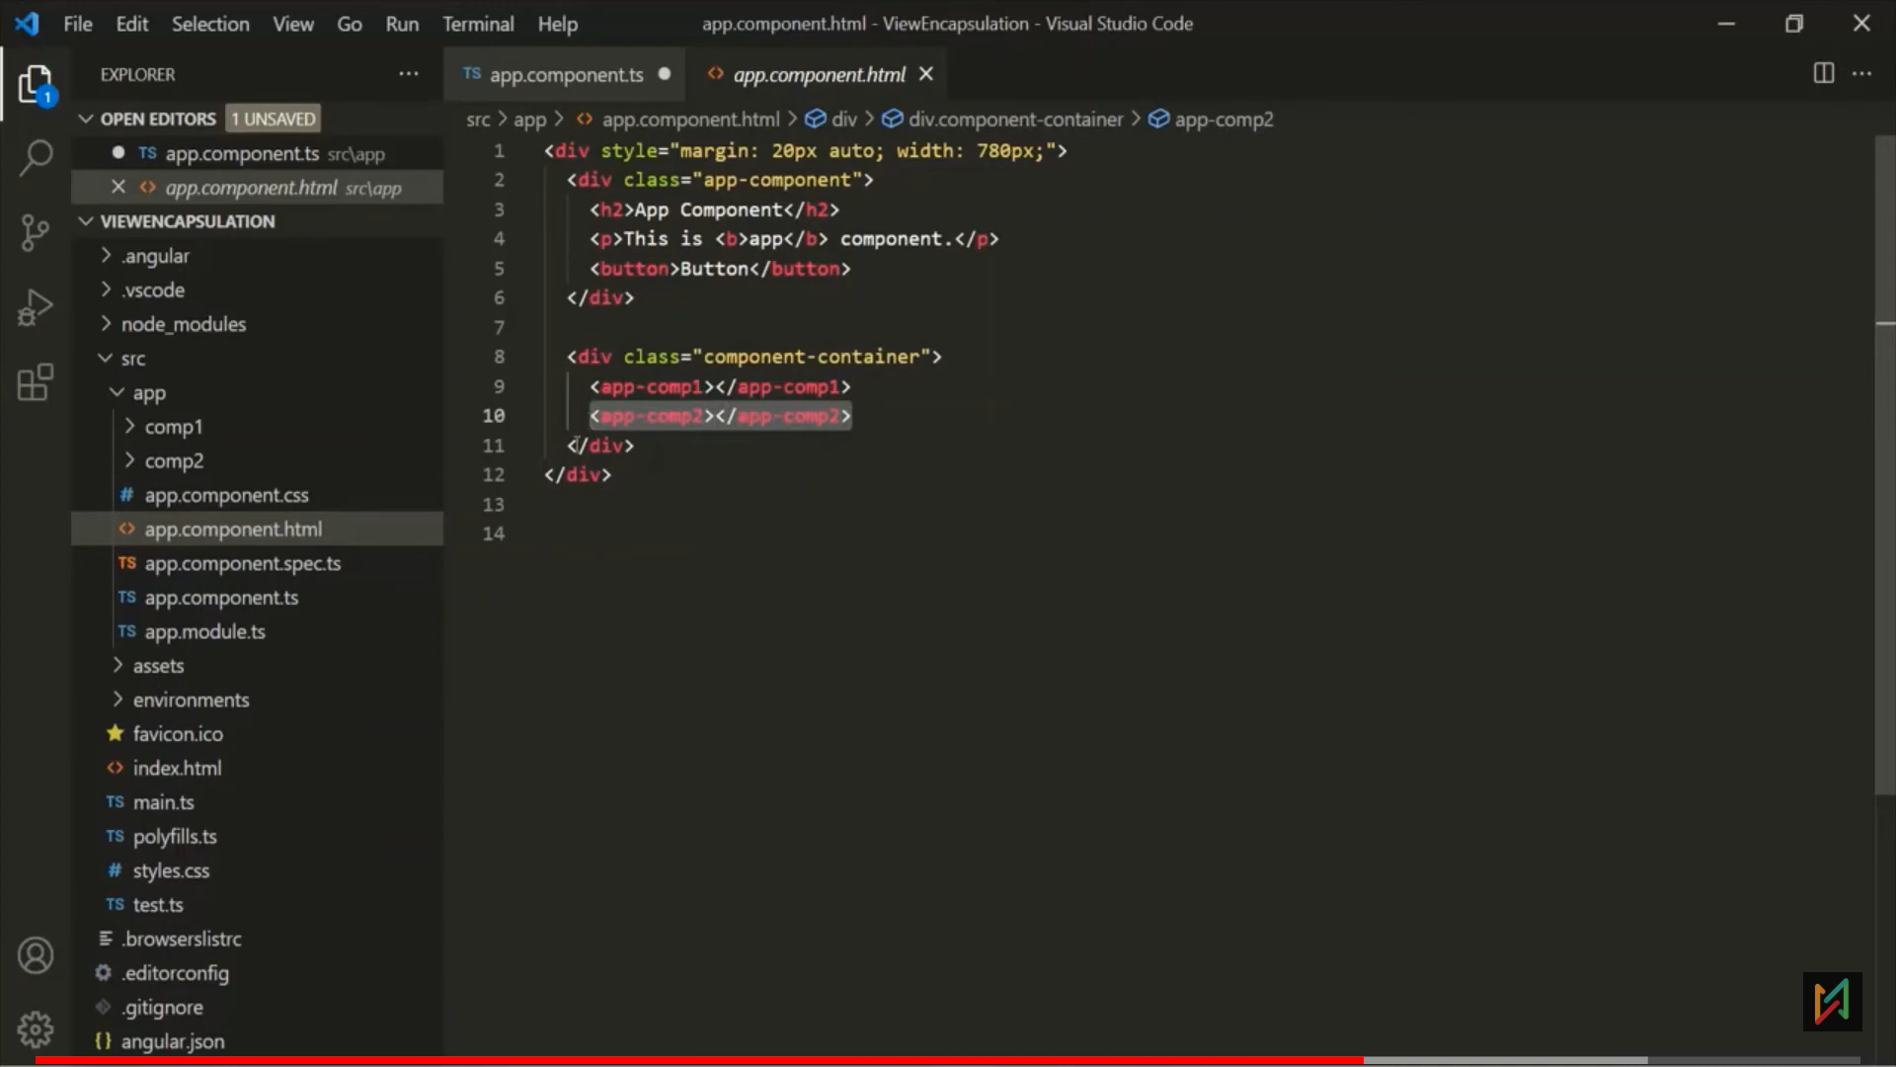

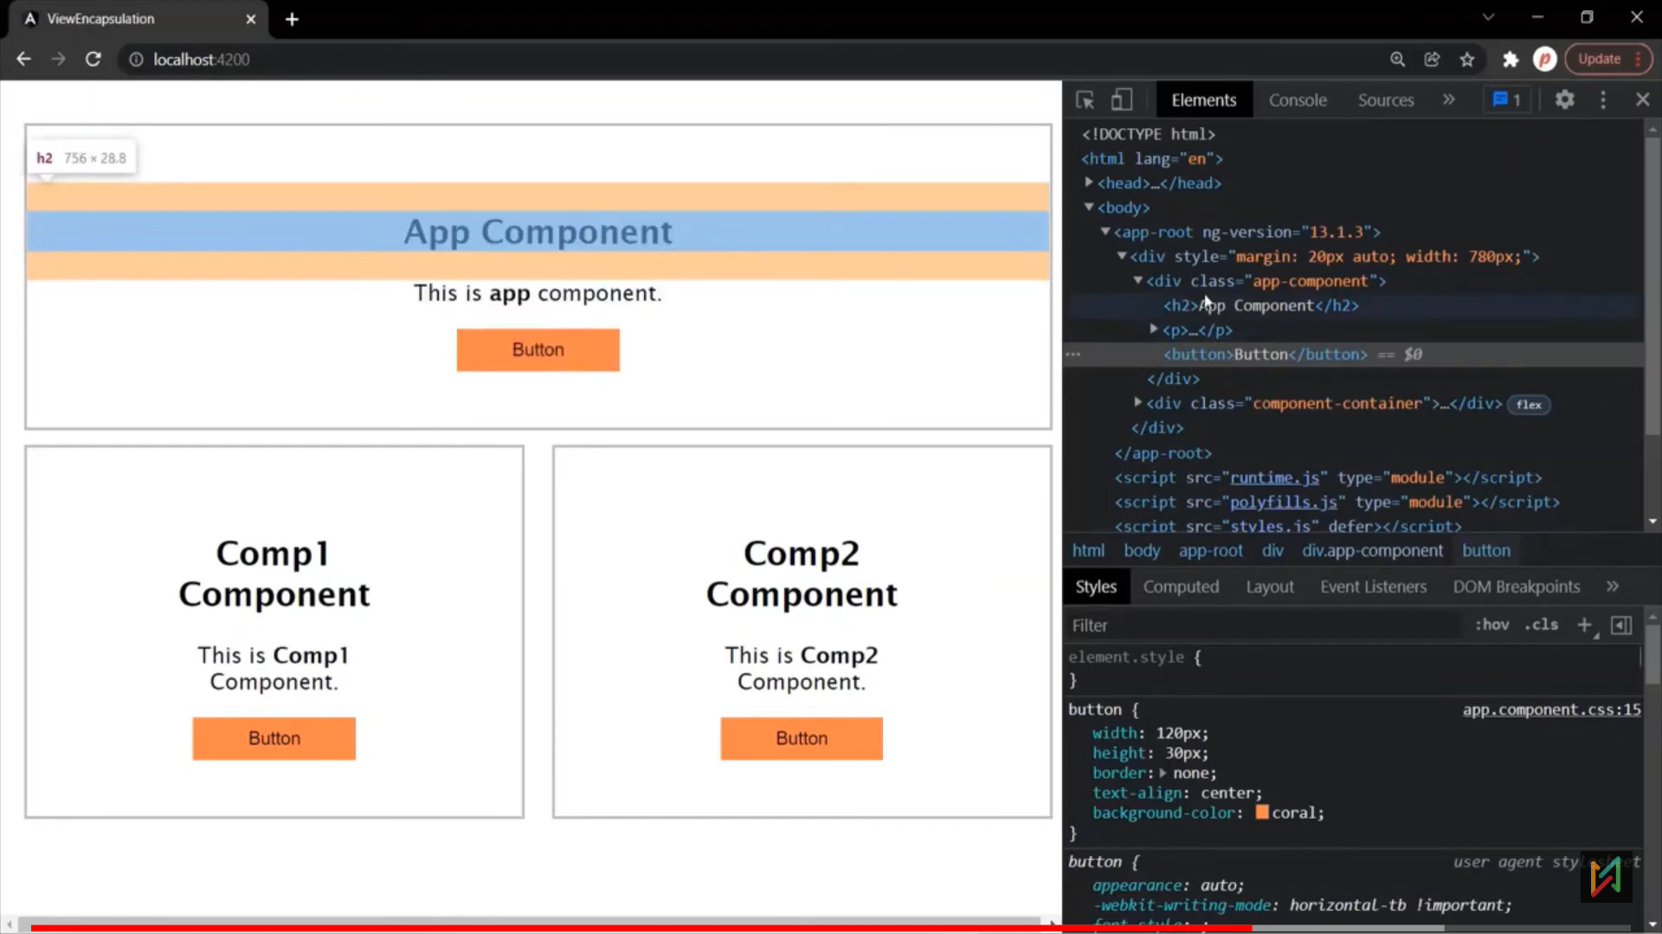

## 3. ShadowDom Encapsulation

- if we apply css in root css (style.css) file, then it will reflect in all the components, it we want to skip parent/global css for any component, then will use ShadowDom encapsulation.

1. Button CSS added globally.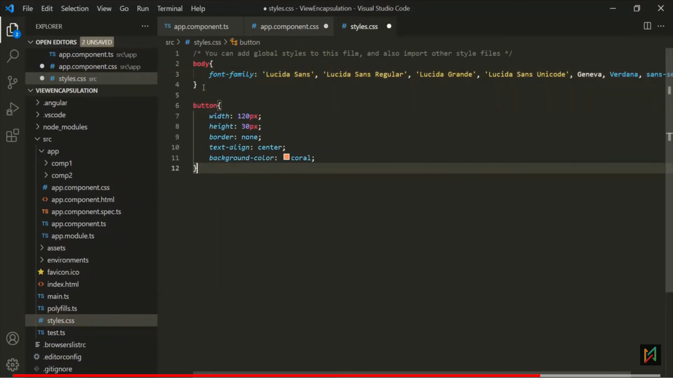 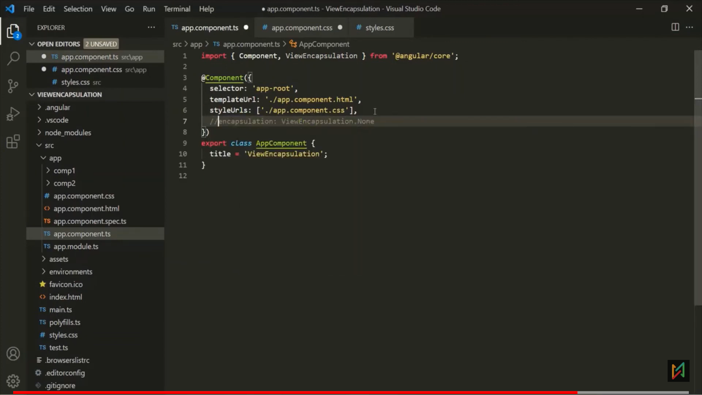 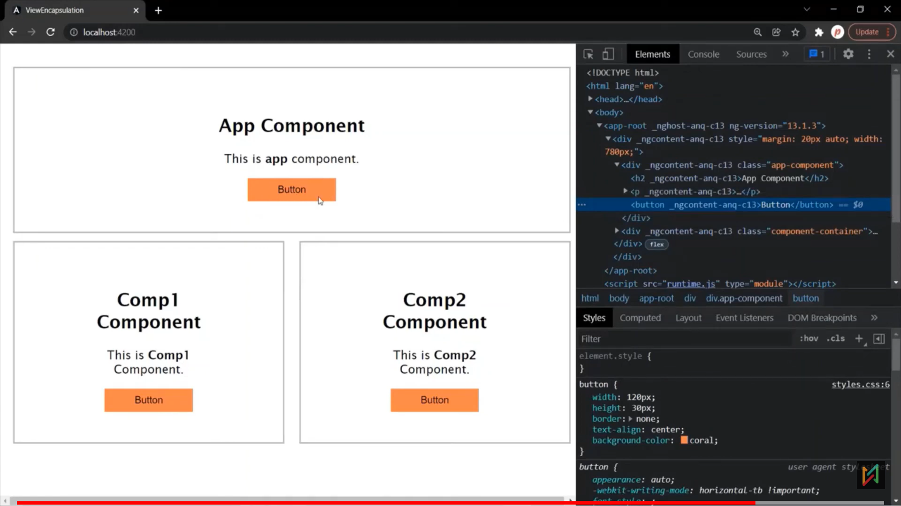

- If we want to remove global CSS on Comp2: 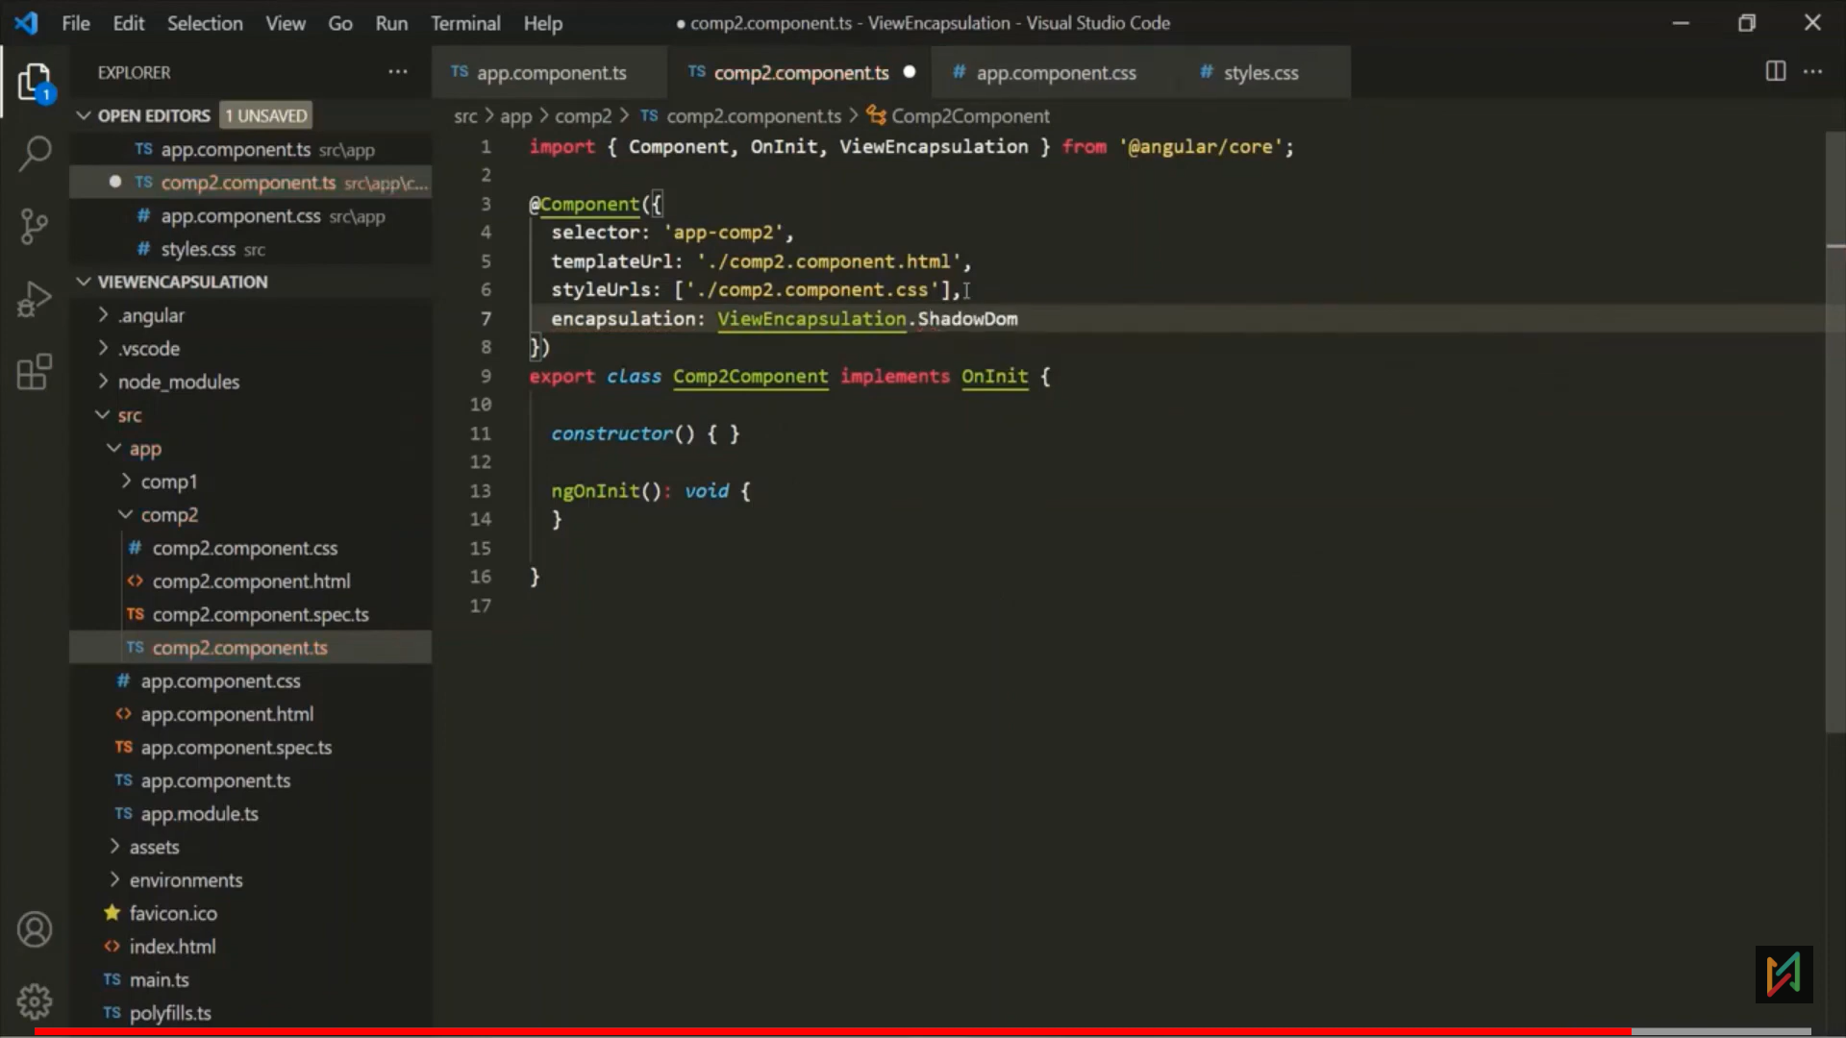 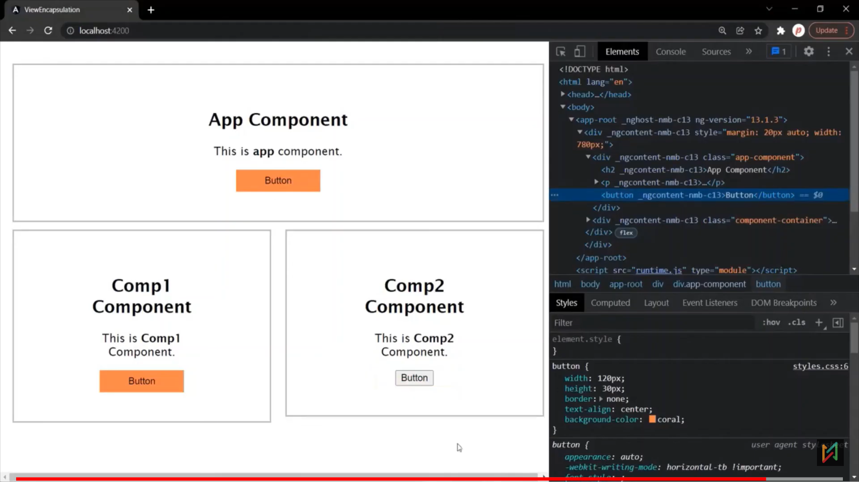

- we use shadow dom, then that component will create its own shadow dom.

- Browser keeps the shodow dom separate from the main dom, And the rendering of the shadowDom and main dom happens separately. That’s why, the feature, state and style of the stay private and not get effected by the main dom.

# Ng-content:

**Projected Content:** Projected content is that HTML content which replaces the <ng-content> directive in child component.

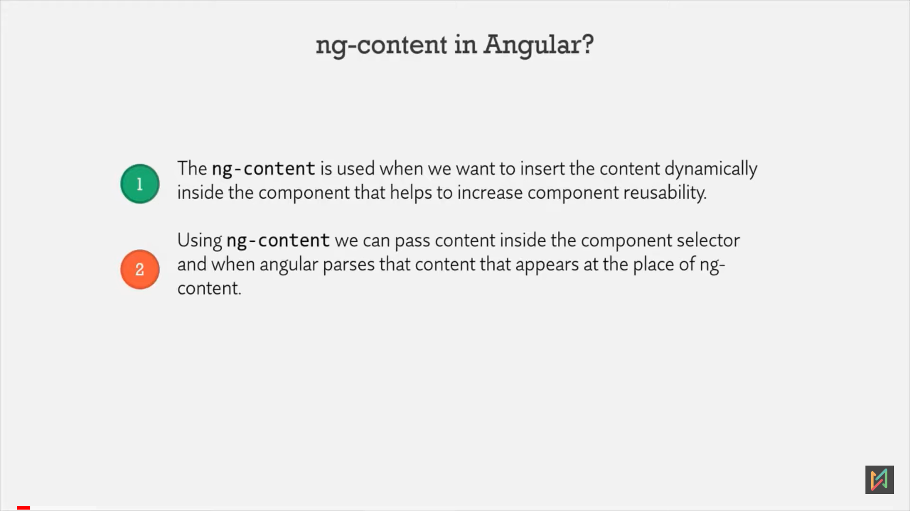

Example 1: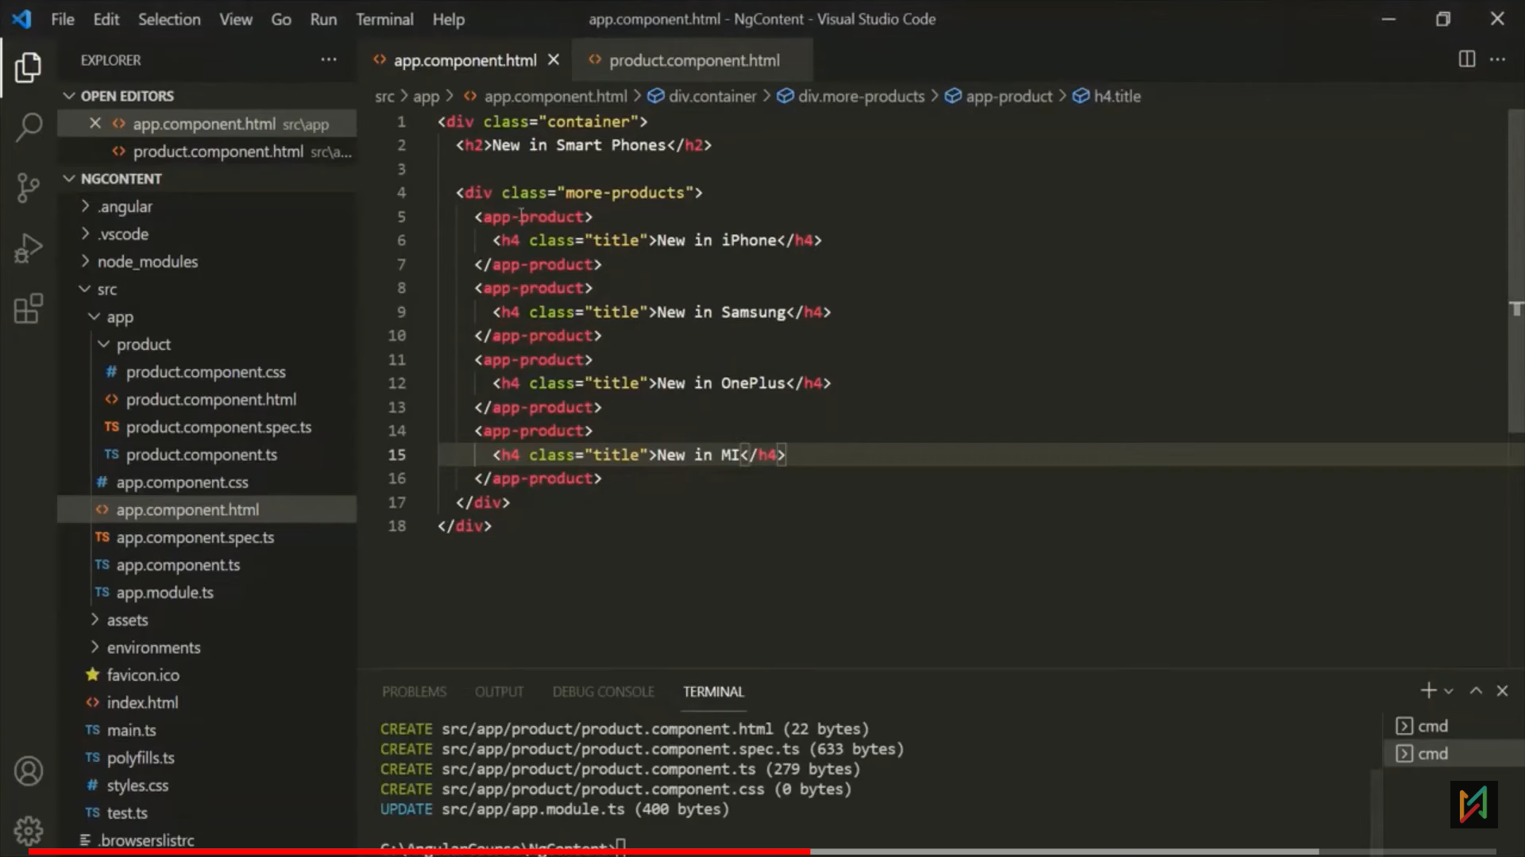 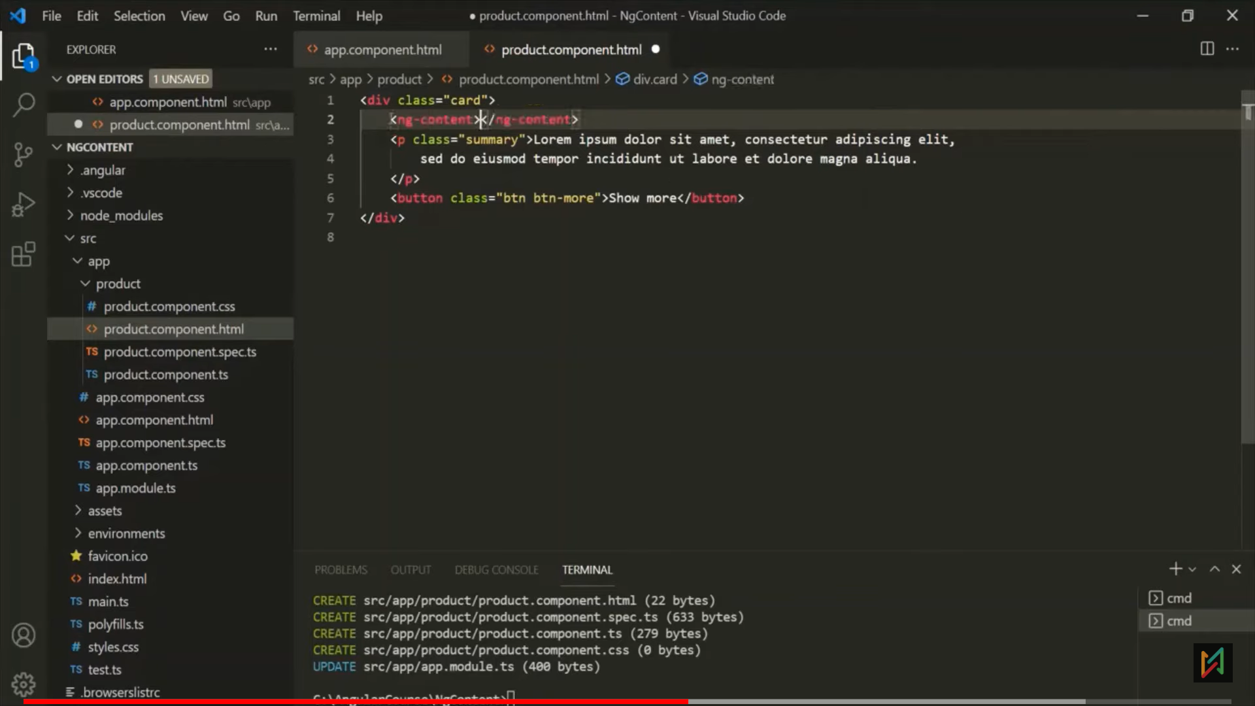

* Here, ng-content will get replace with h4 tag of parent.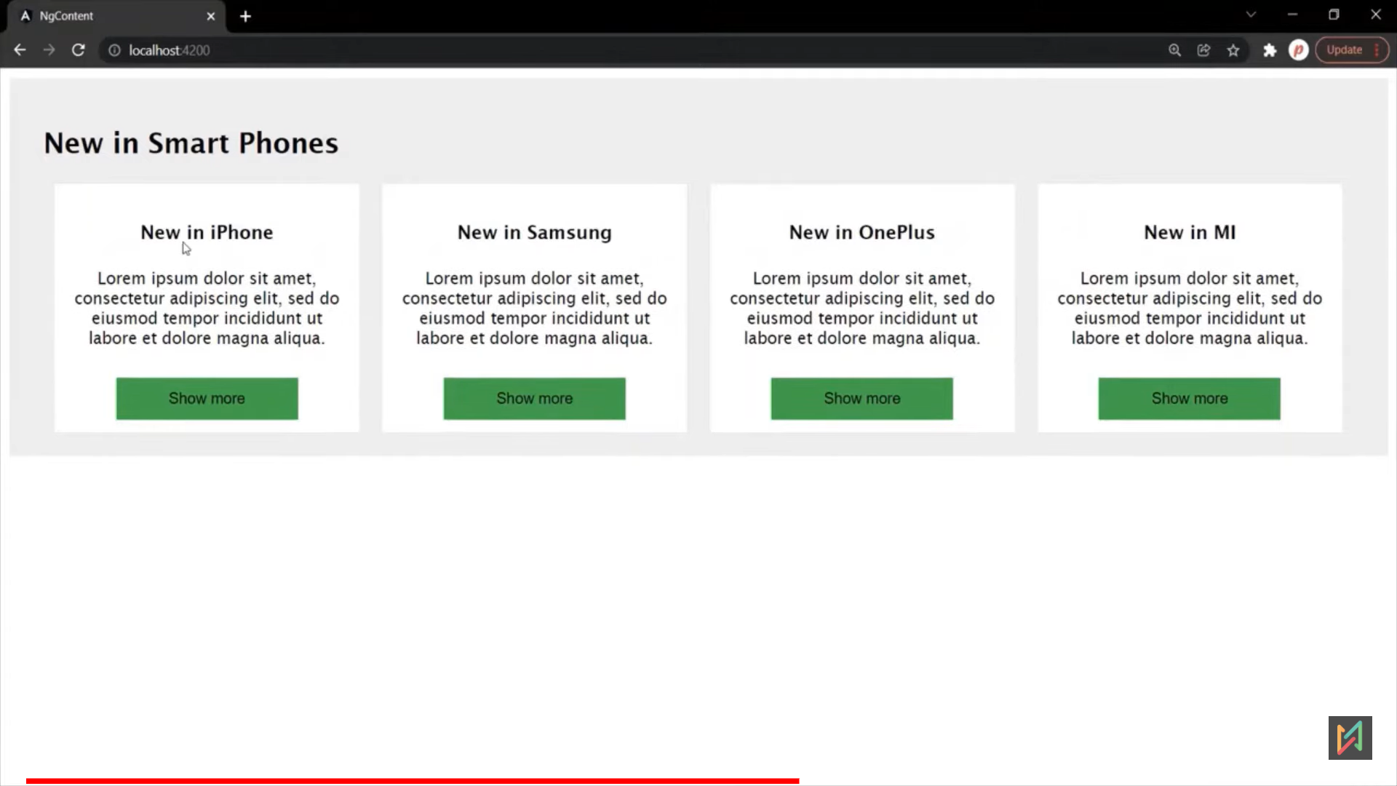

Example 2:  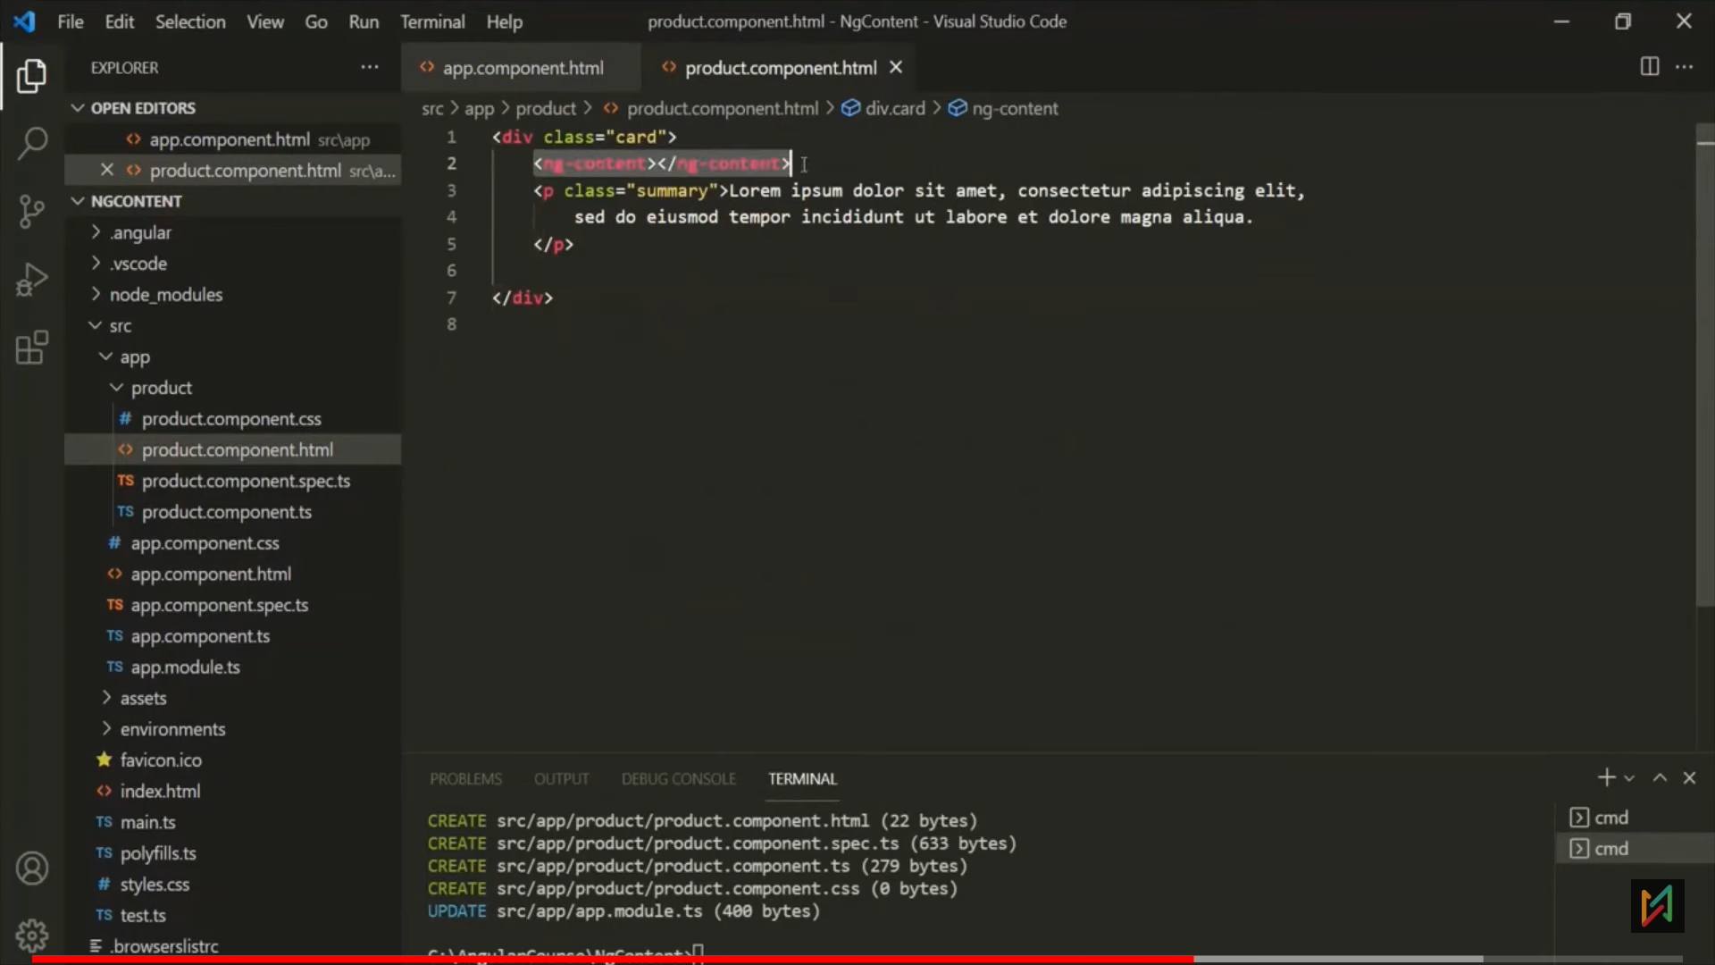 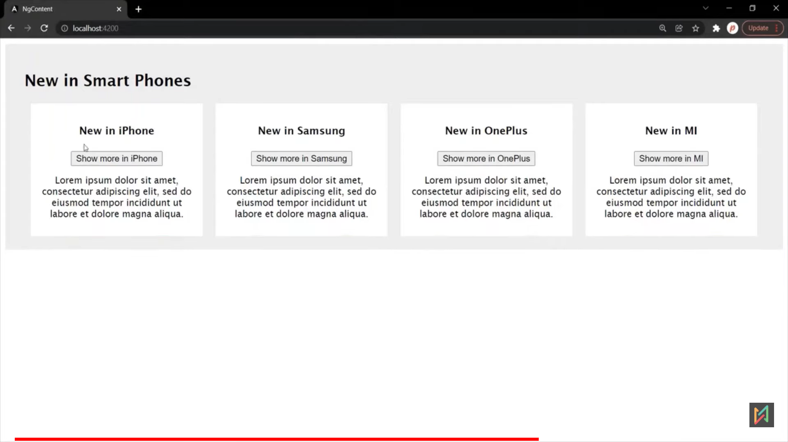

Example 3**:** below, if notice, header and button moved. Angular always replace last occurance of ng-content with the actual content provided in selector.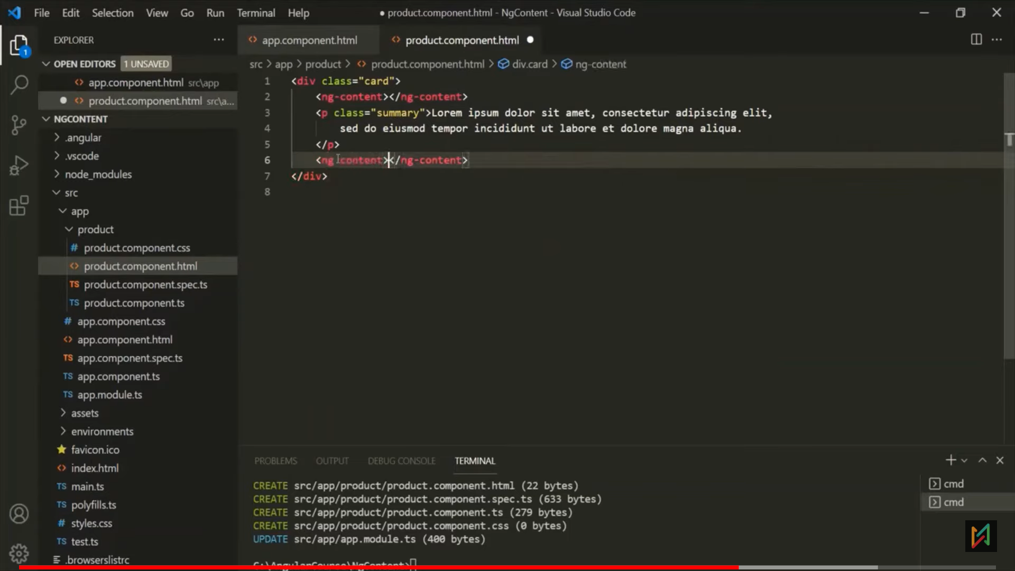 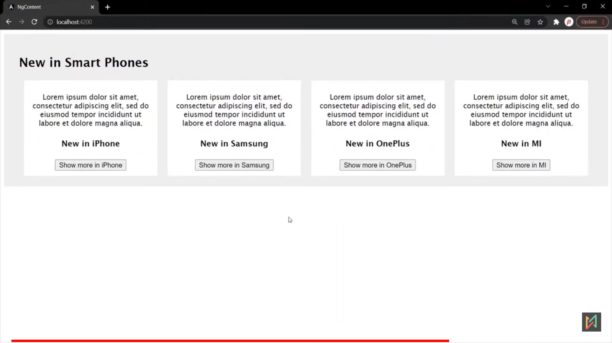

Example 4**:** We can use **select attribute** to select perticular content of selector.

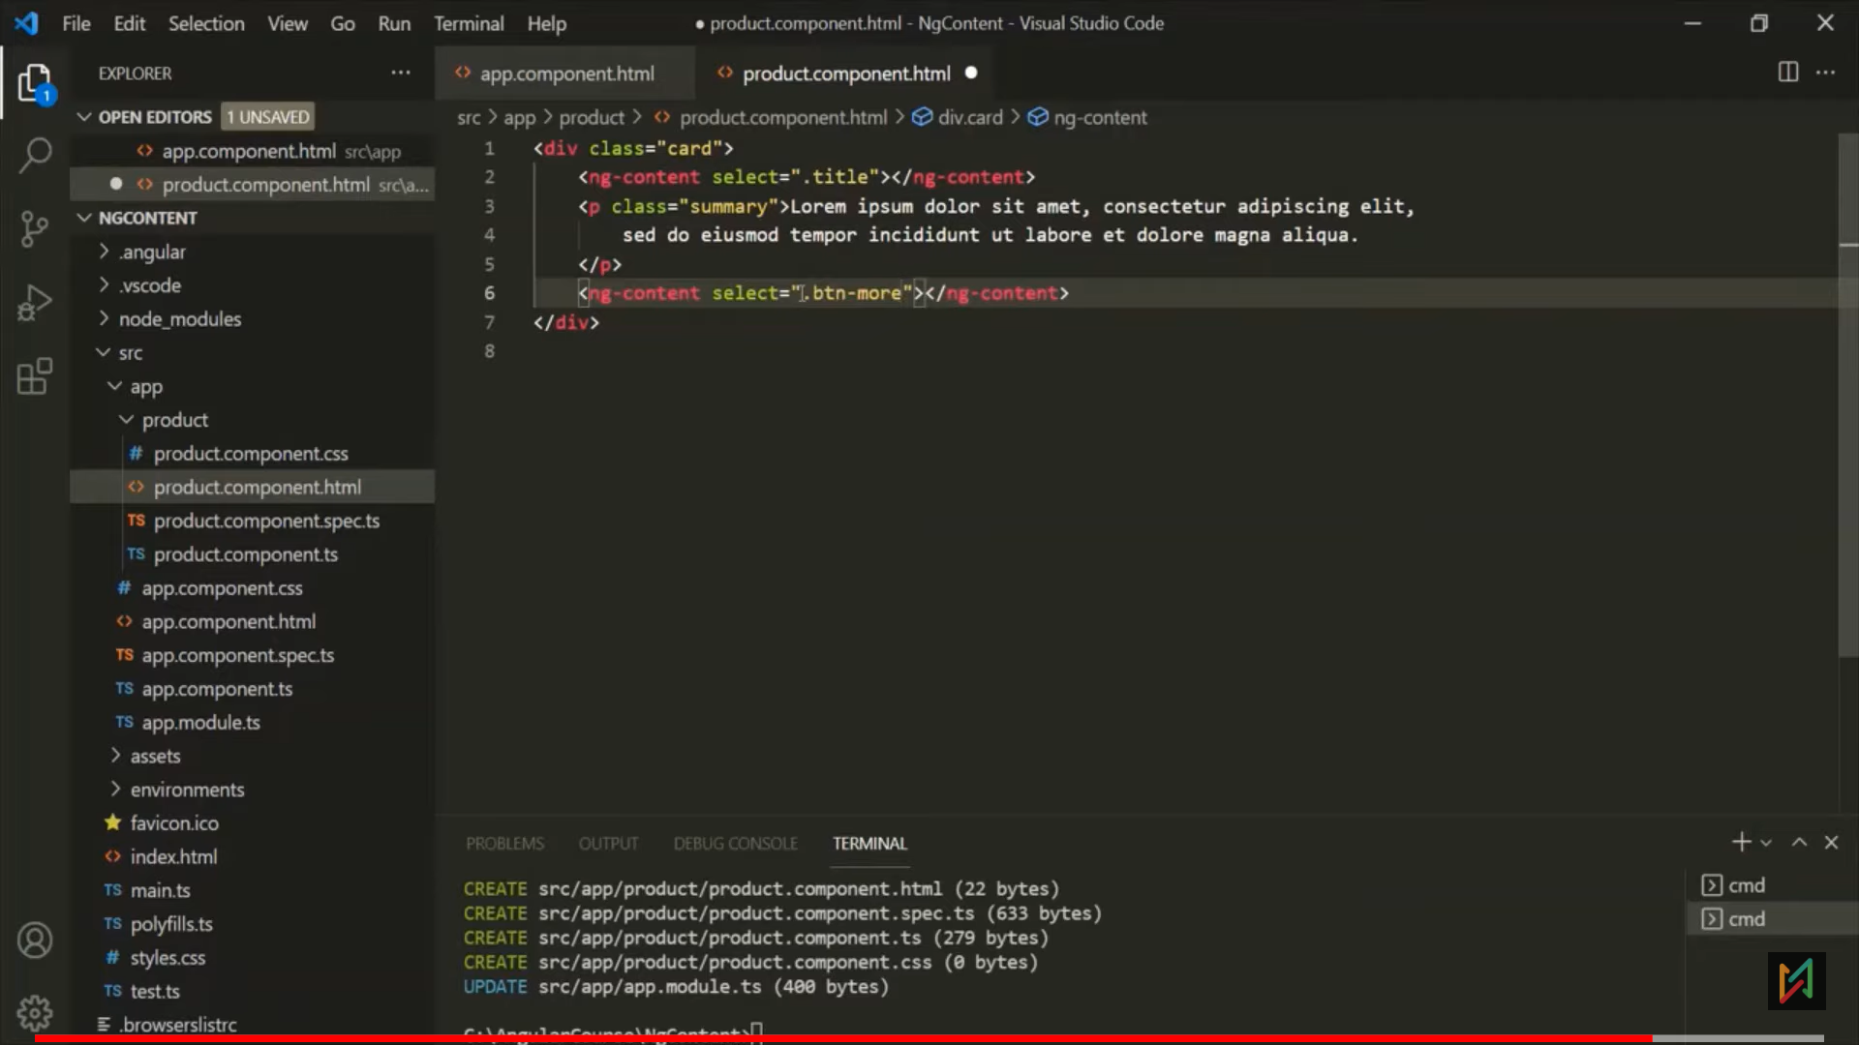 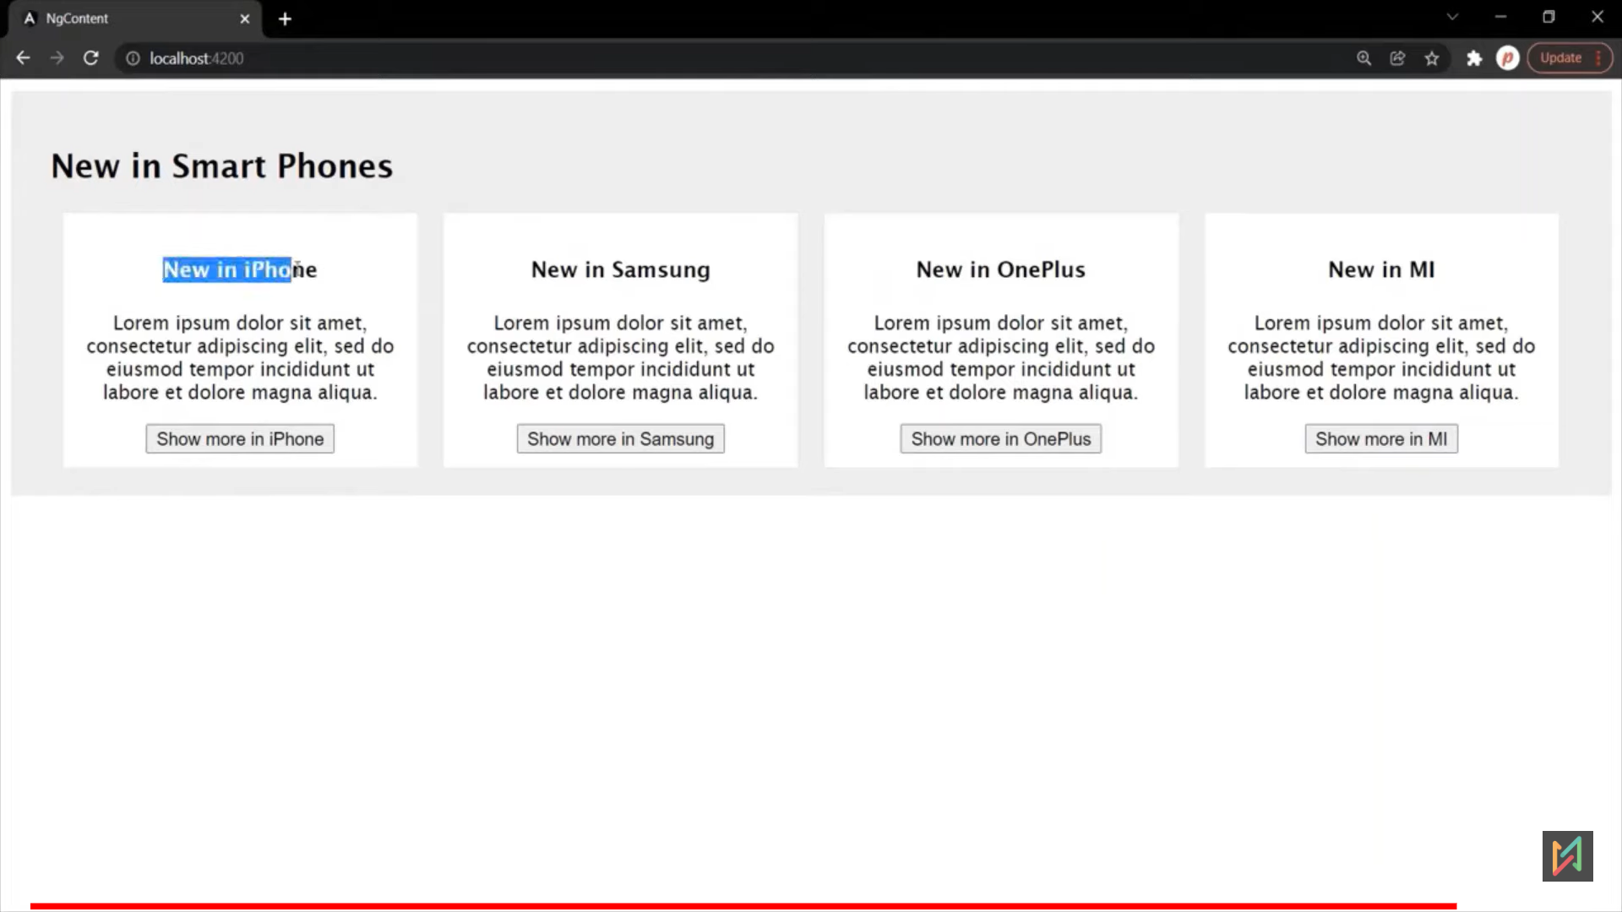

# Angular Life Cycle Hooks

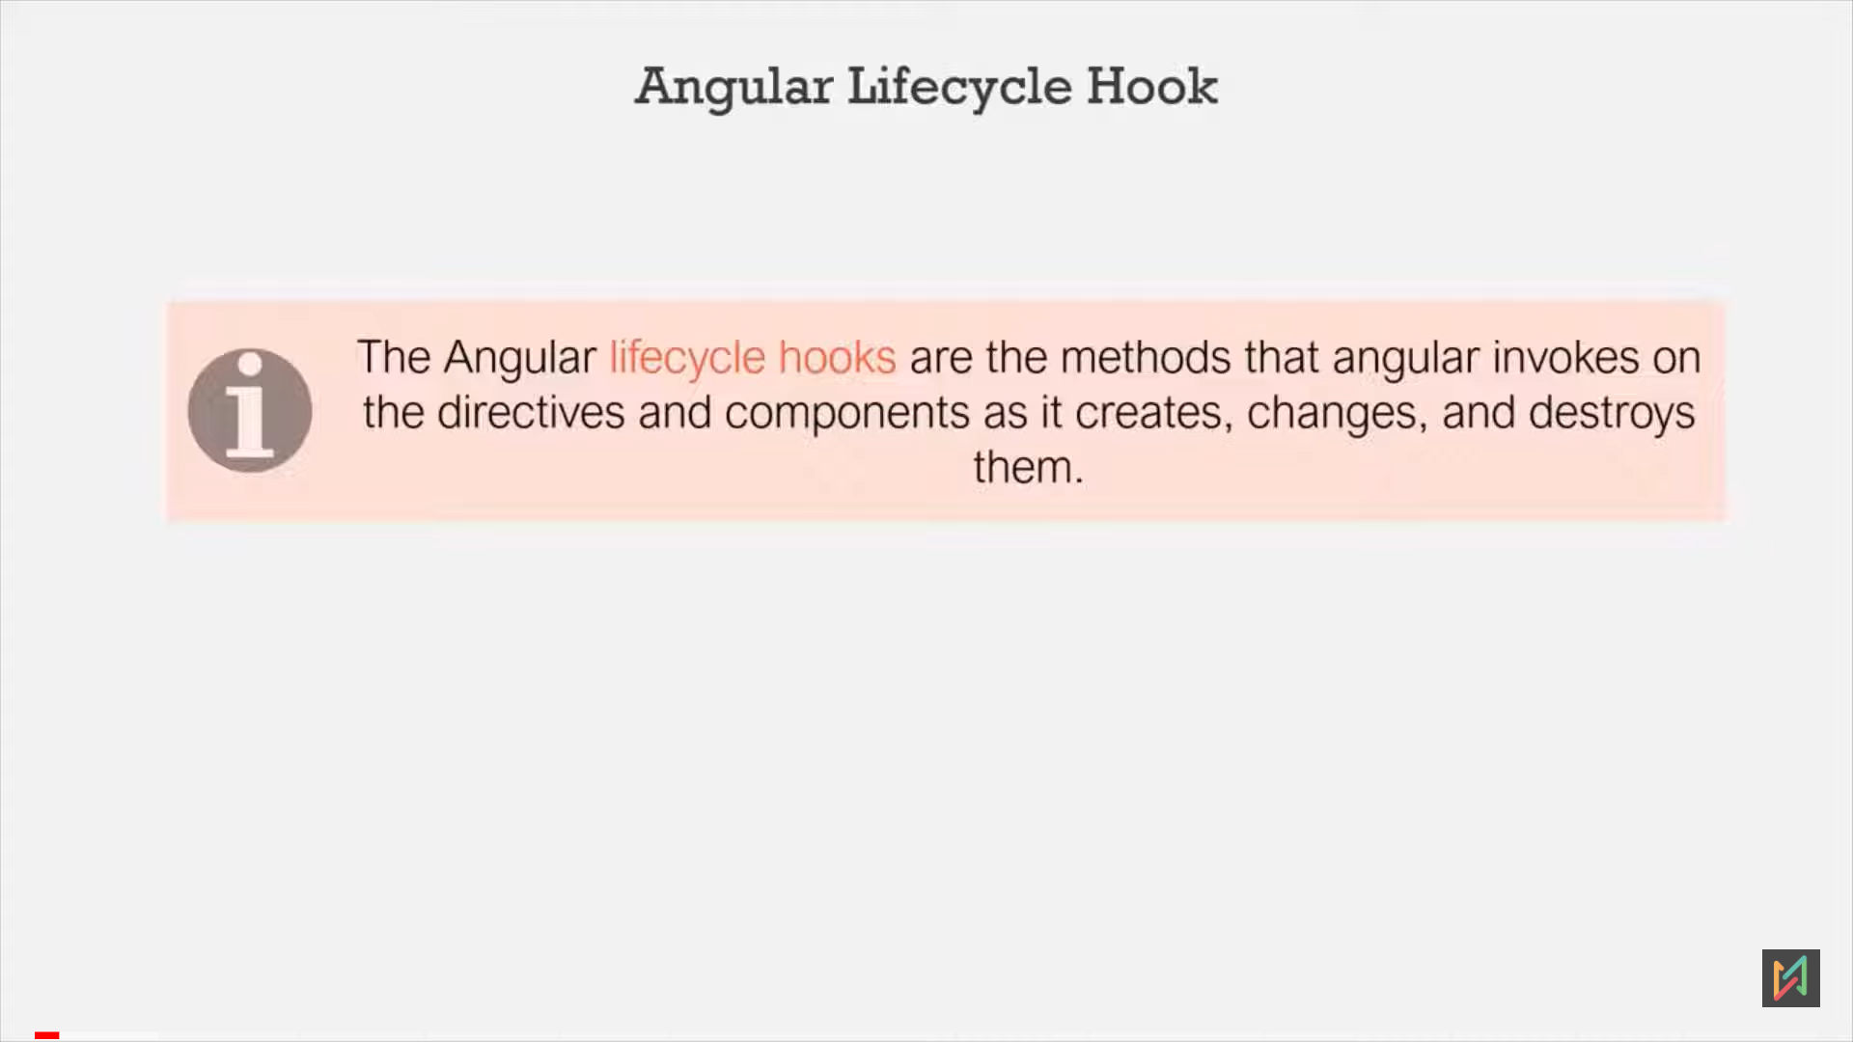

- Below, We have used the selector trice, angular will instanciate product compont trice and add it to the DOM.

- Once new component class is created, it will go to the different phases. We can execute our code in those phases via hooks.

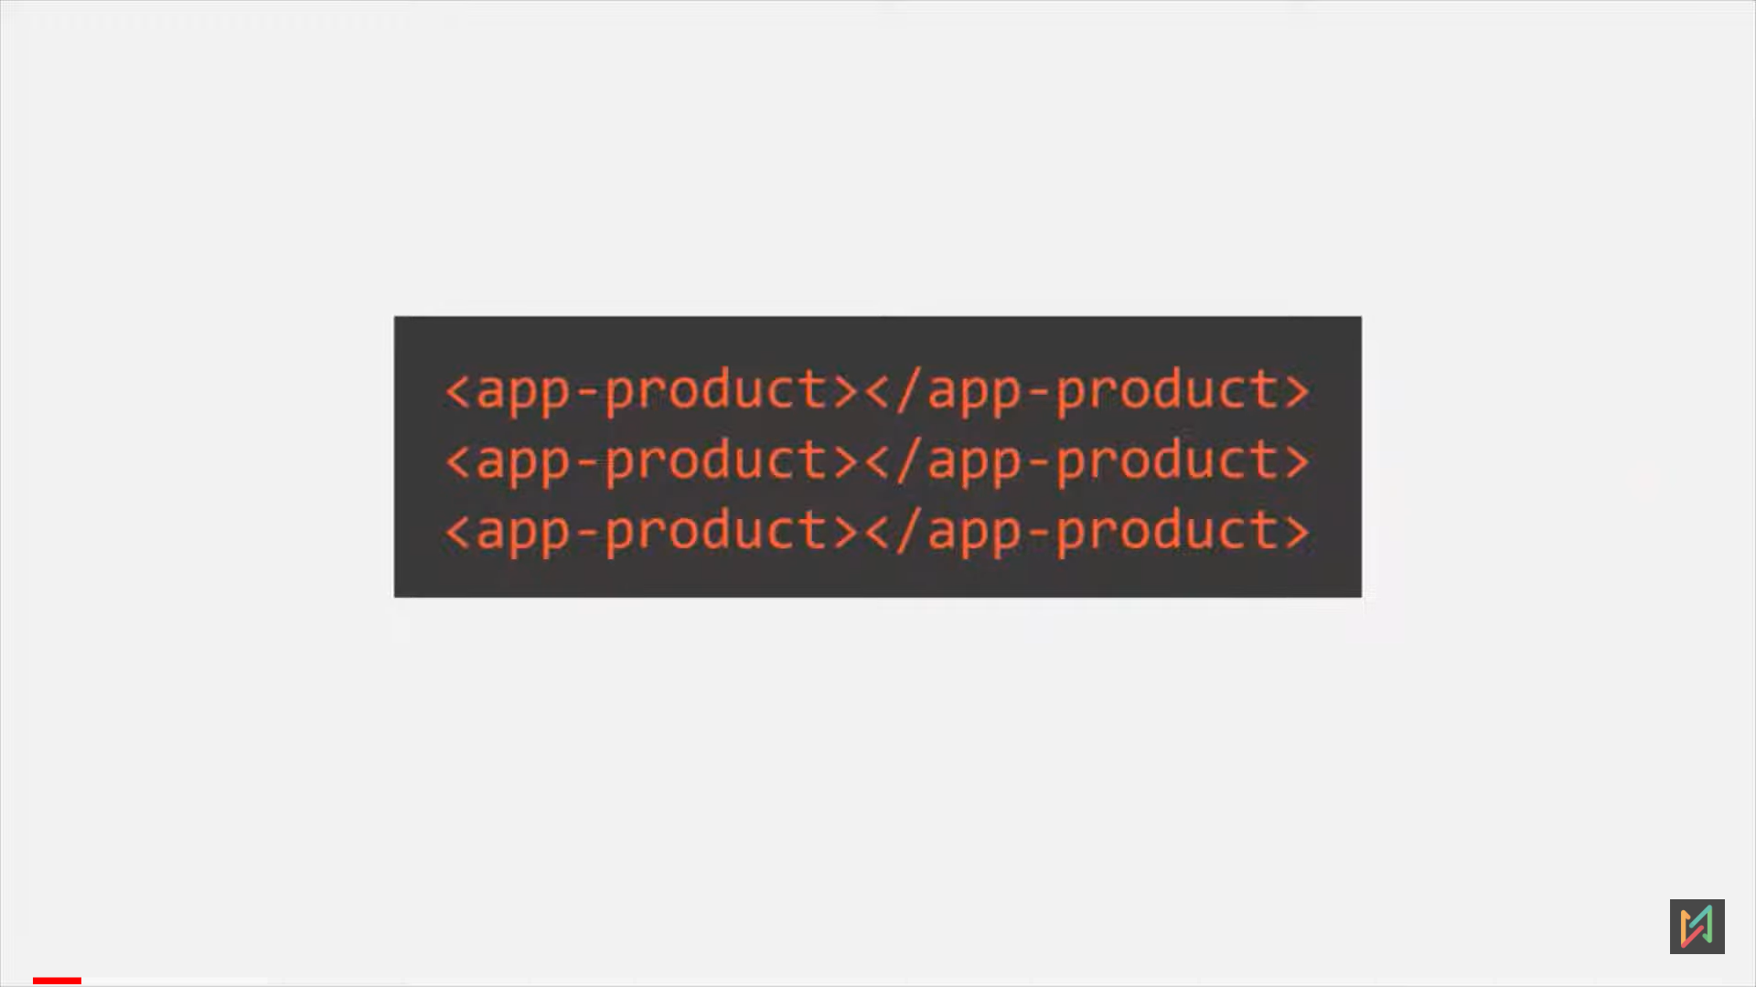

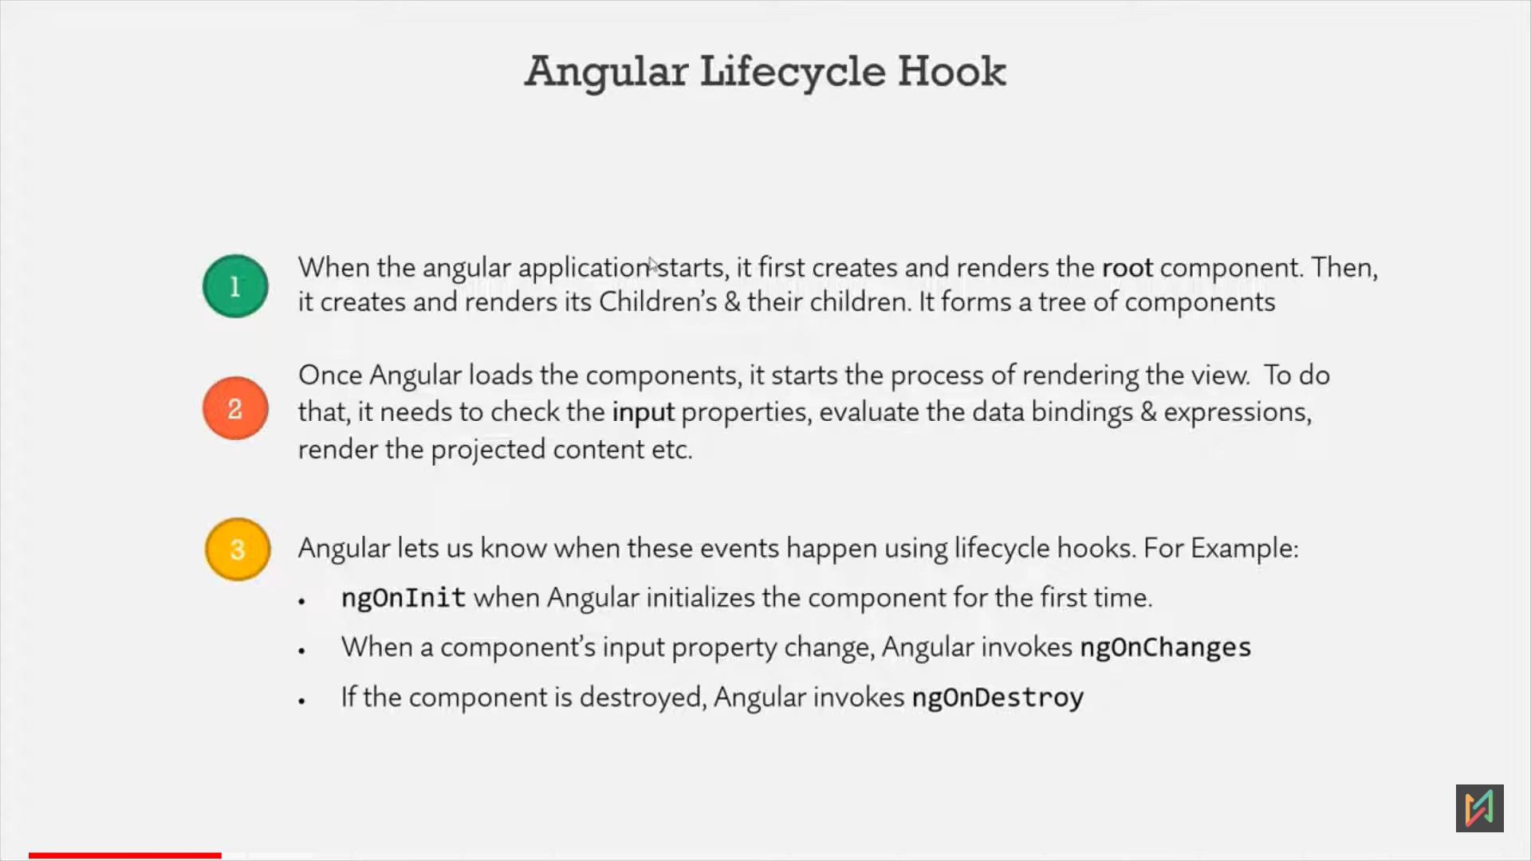 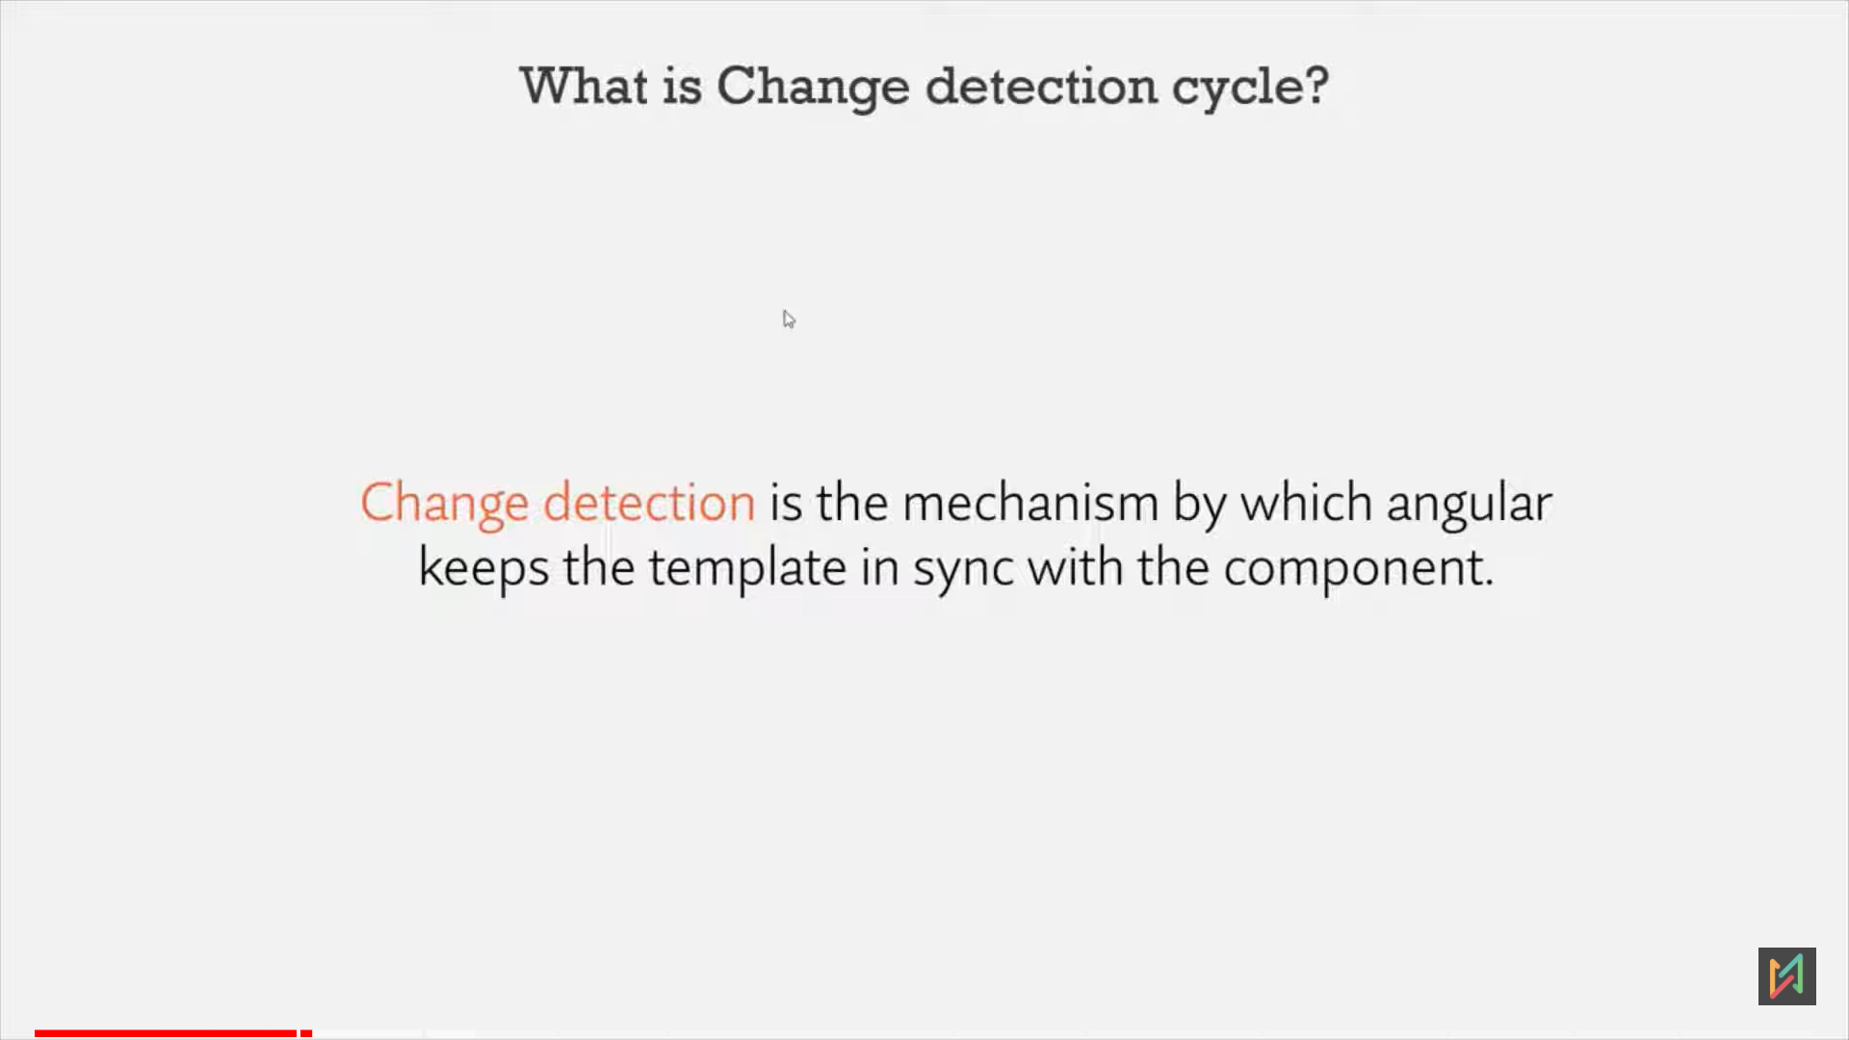 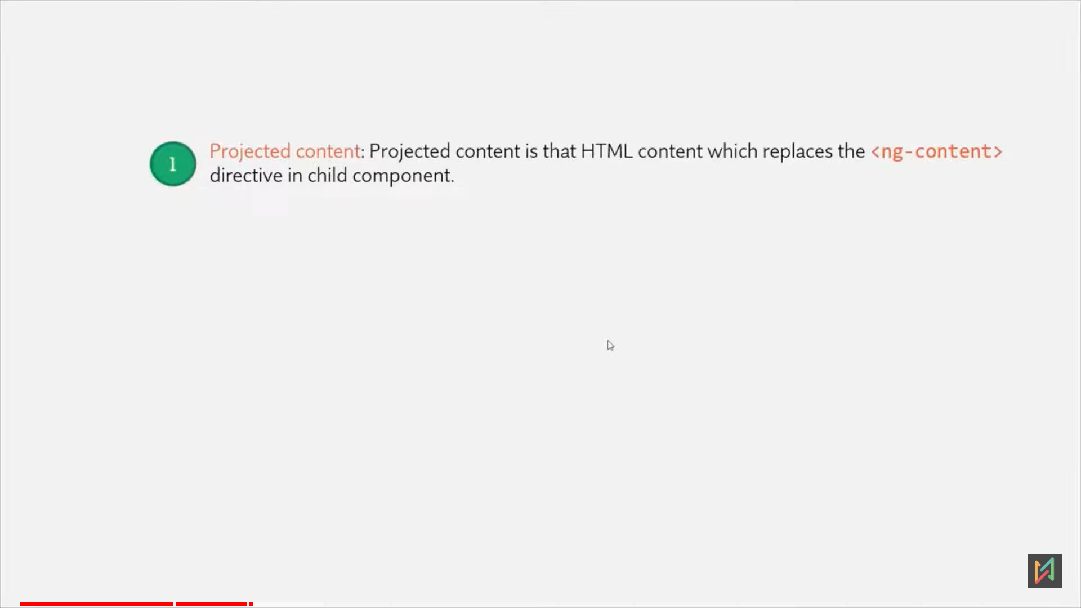 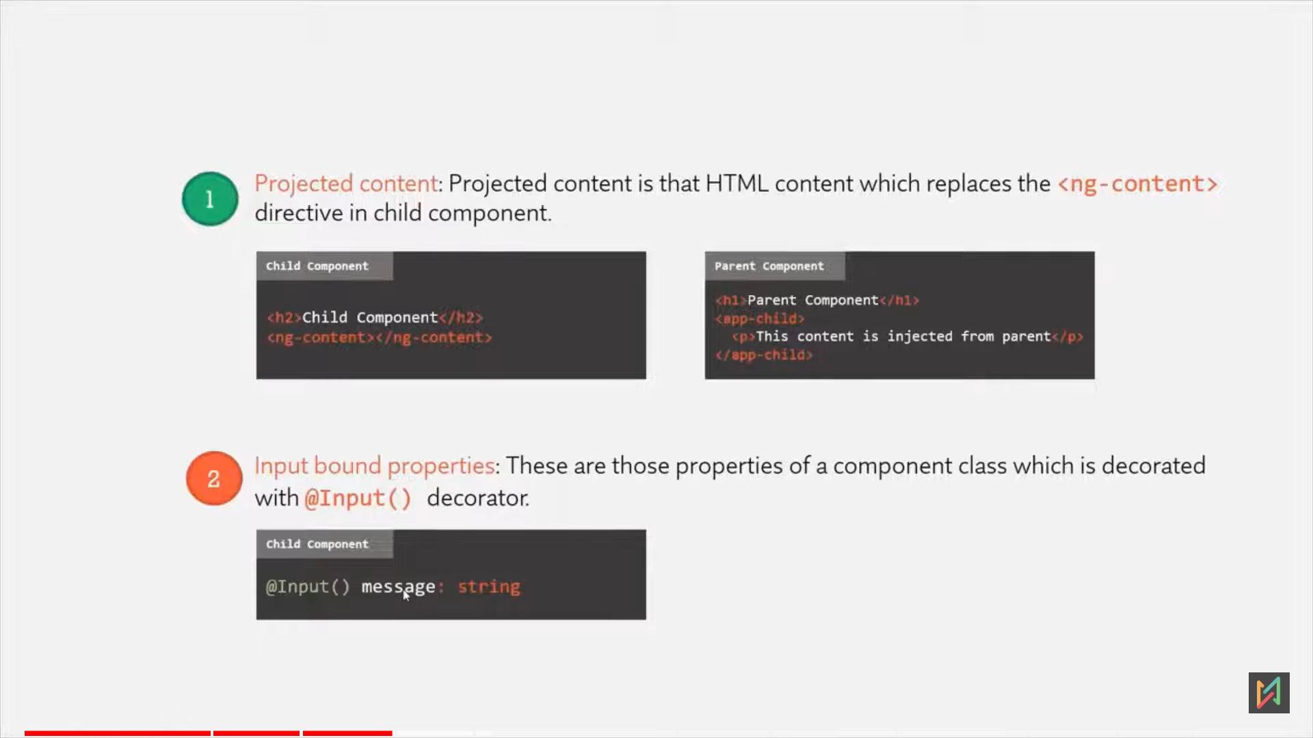

**Angular Lify Cycle Hooks**

**-** There are total 8 life cycle hook and constructor is feature of typescript, so its not a hook.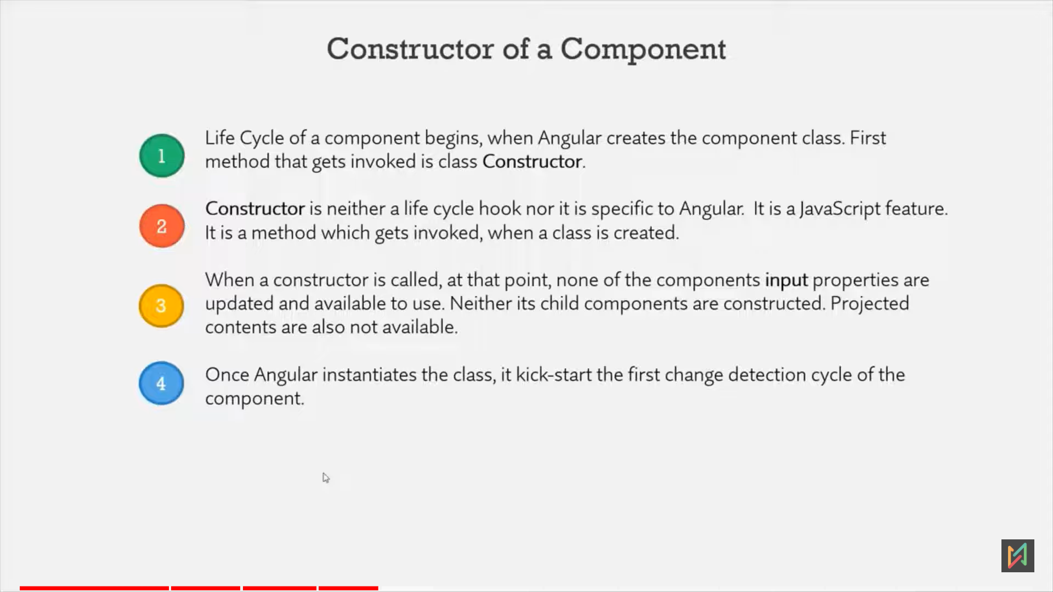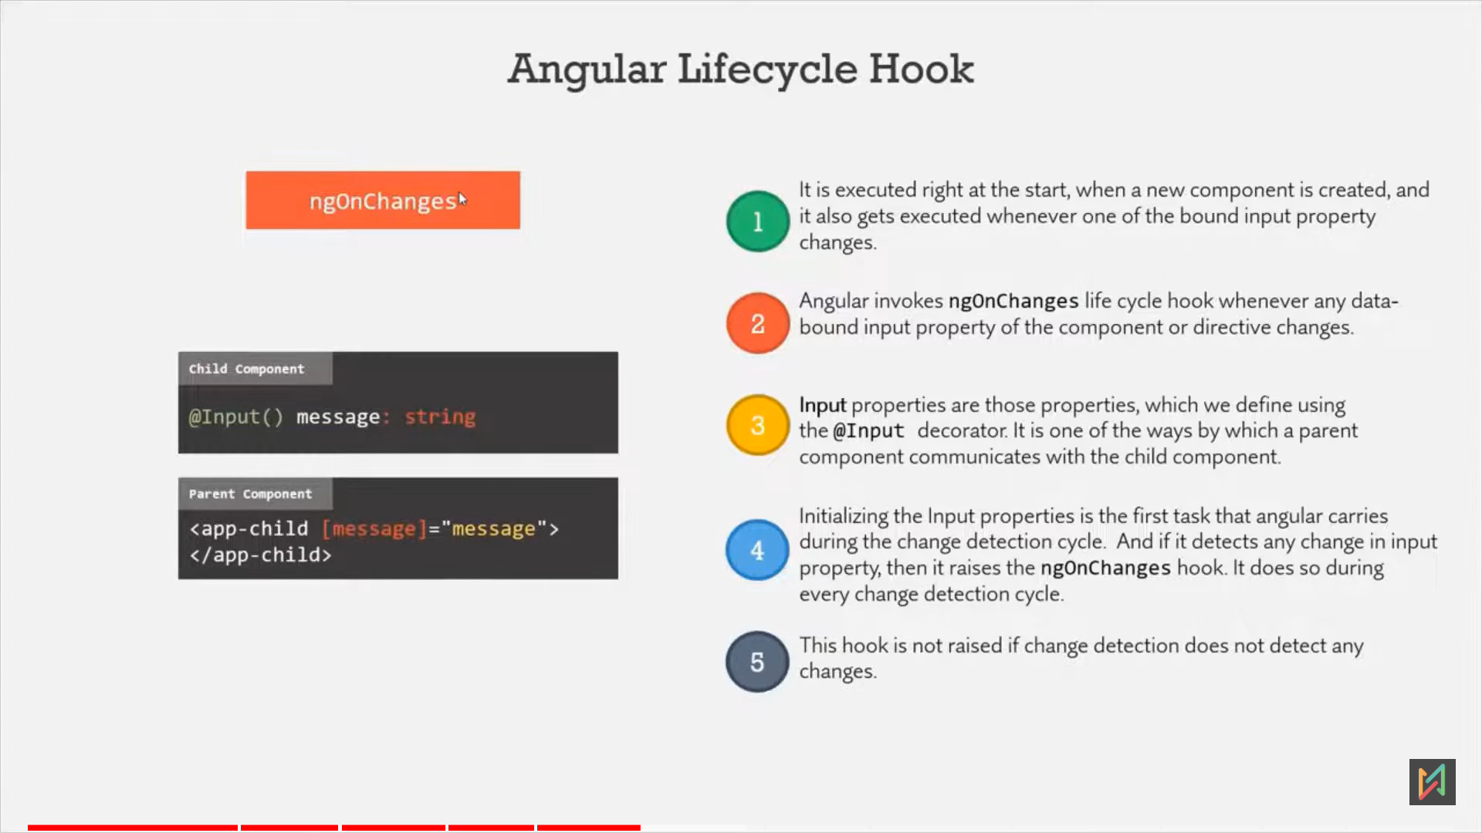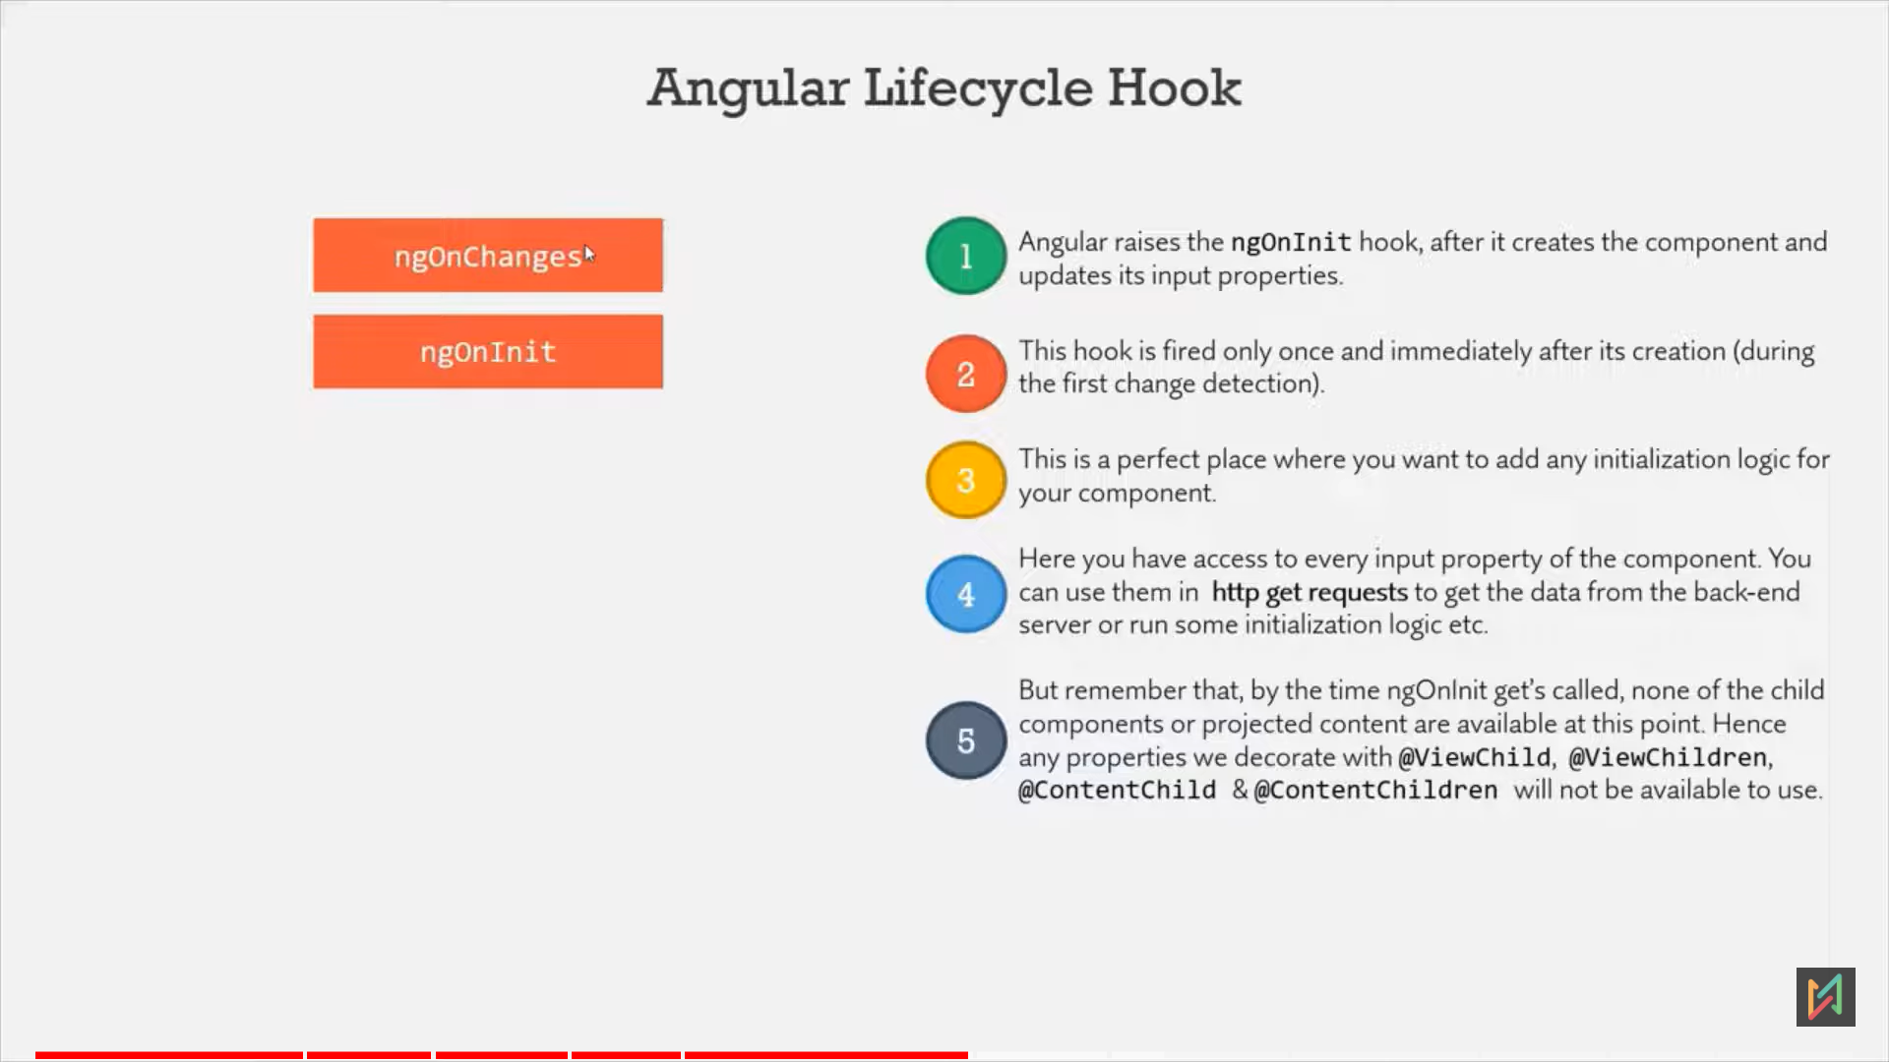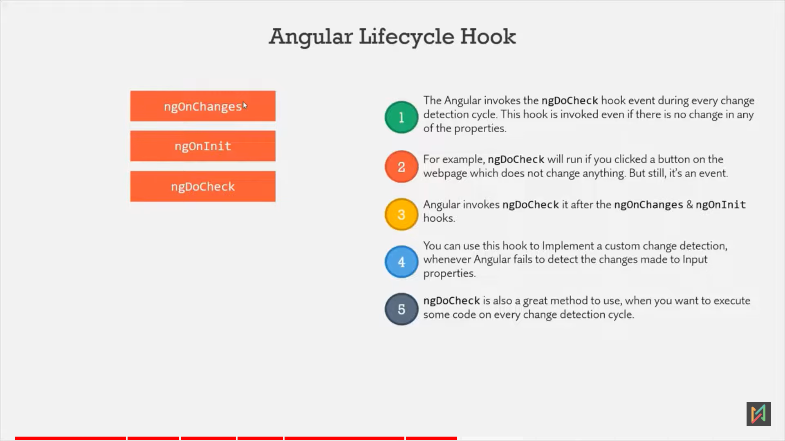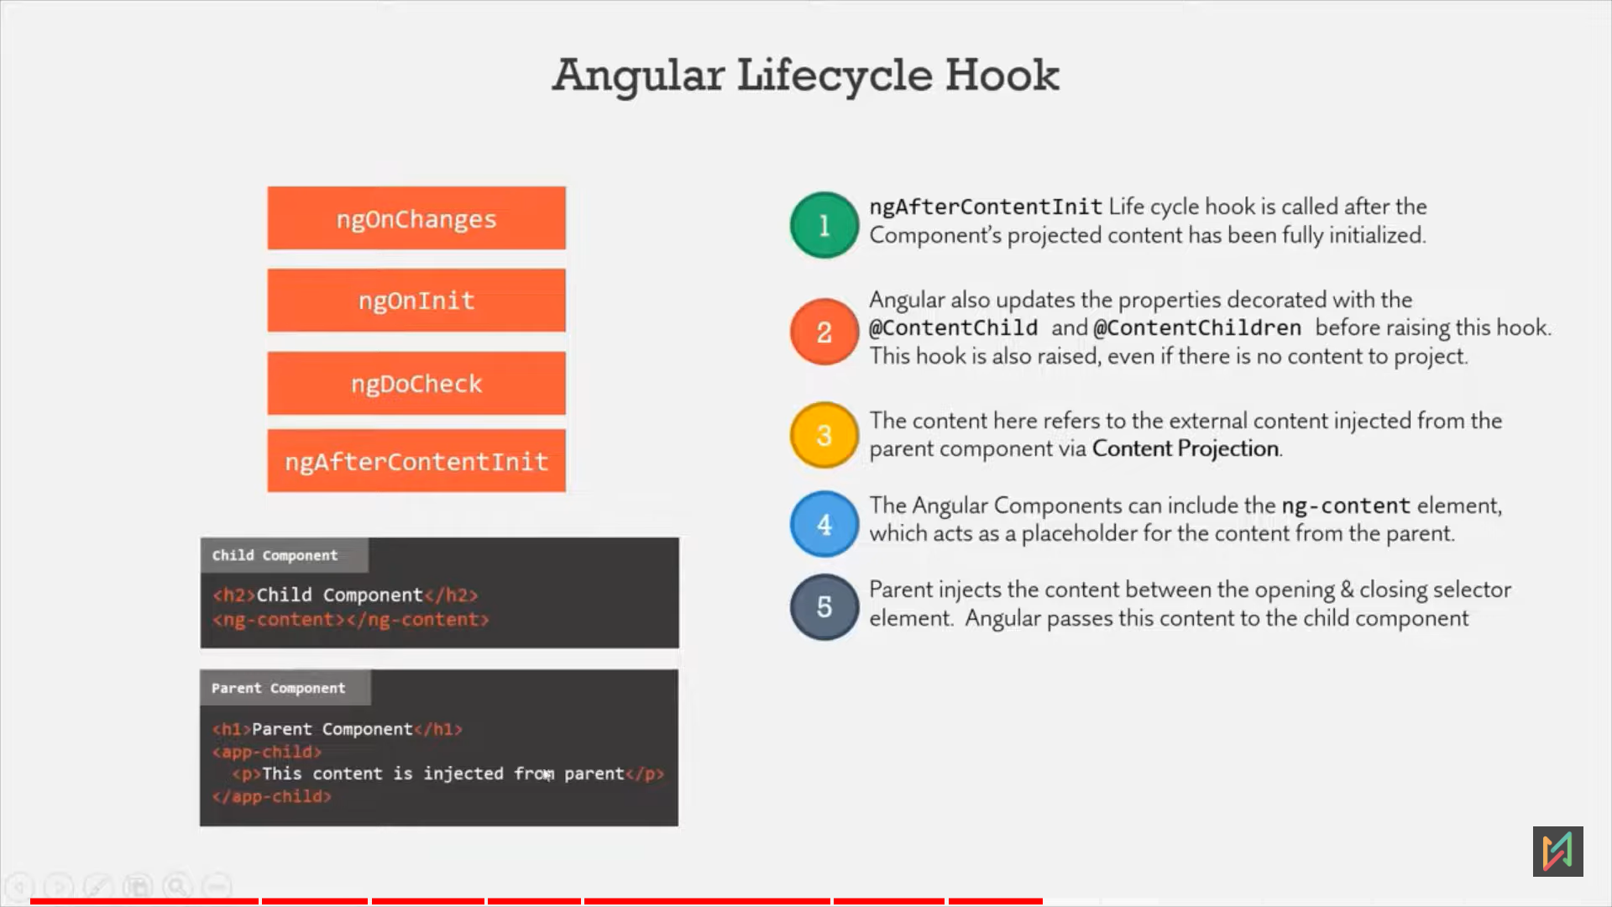

- ngAfterContectInit will only invoke once during initialisation, if content is changes, then ngAfterContentChecked hook will get call everytime.

- This 2 hooks (ngAfterContectInit, ngAfterContentChecked) are component only hook, they are not available on directive.  
  
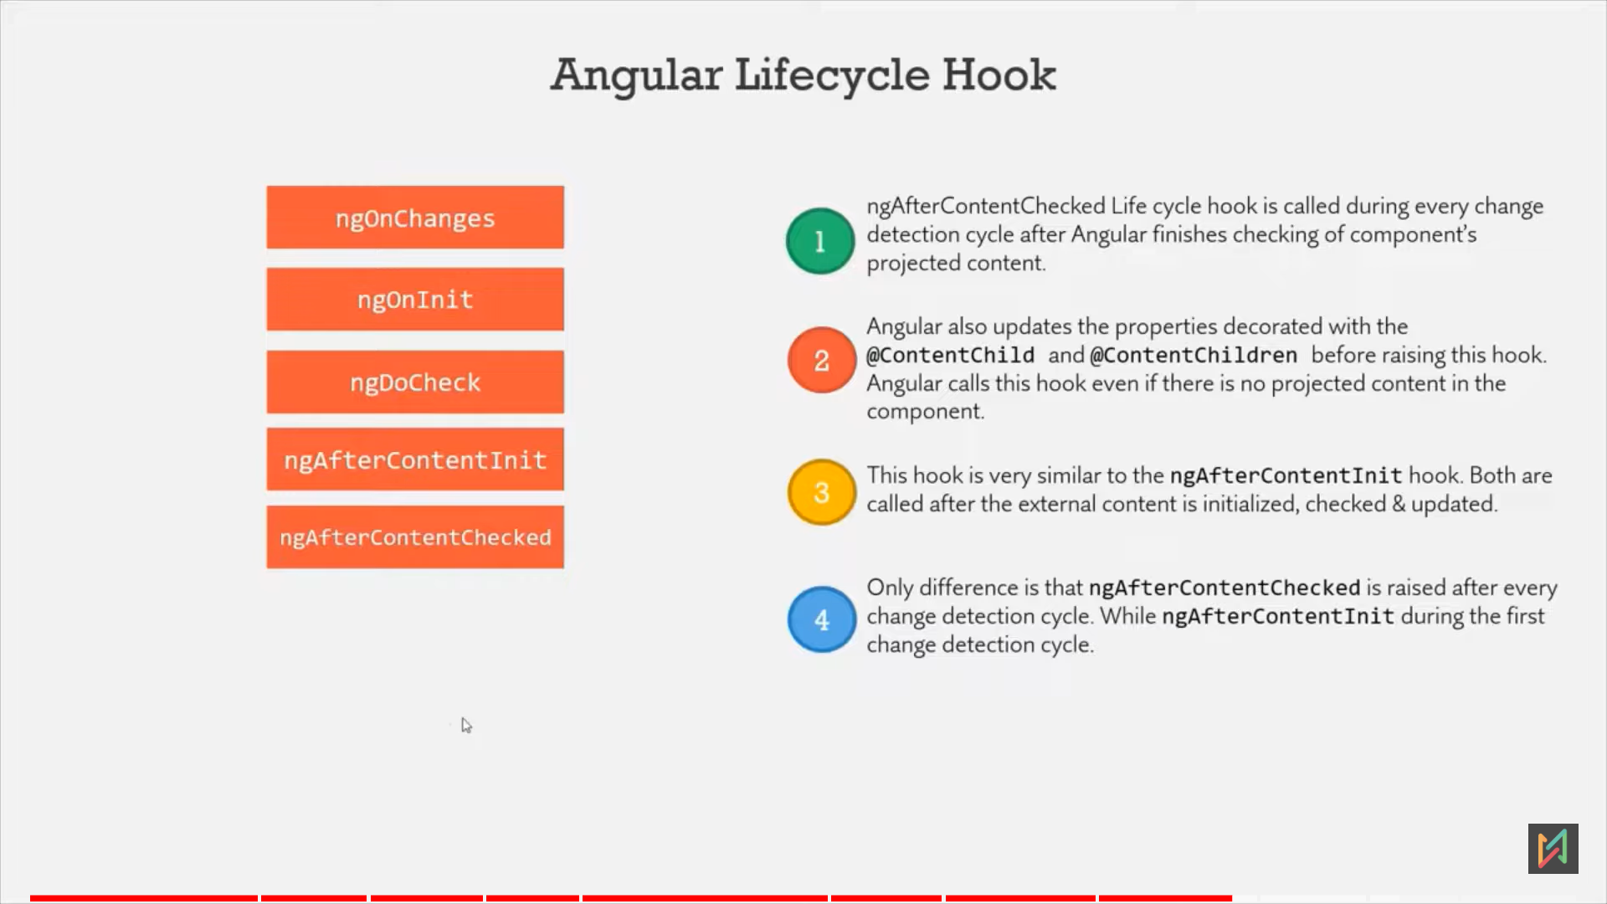 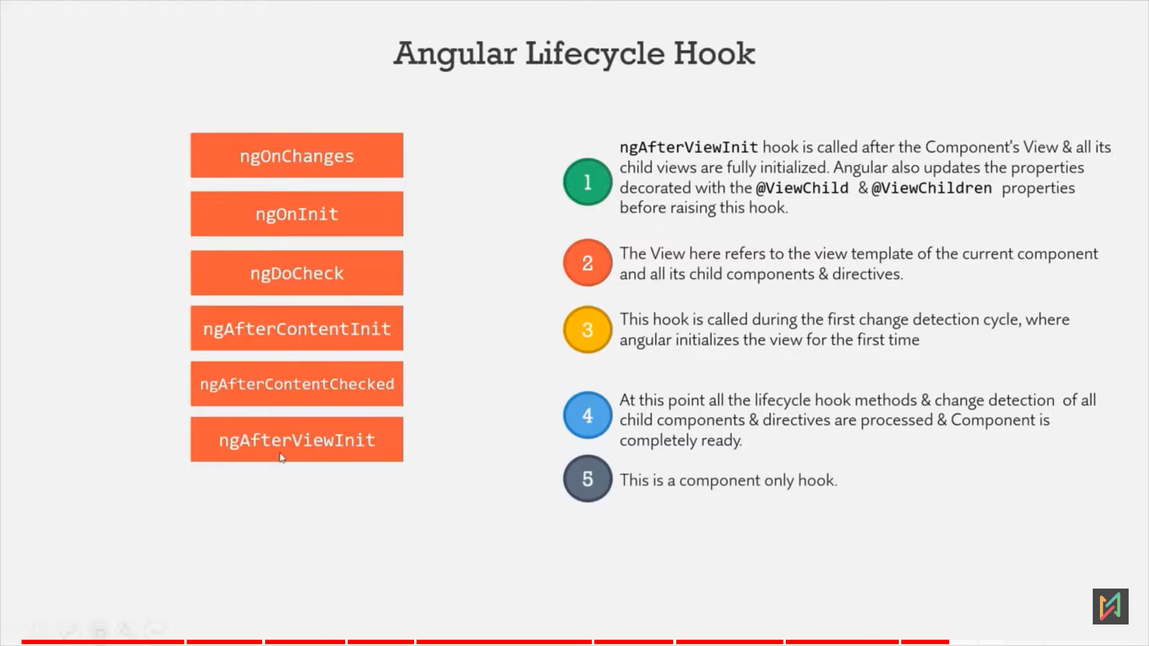 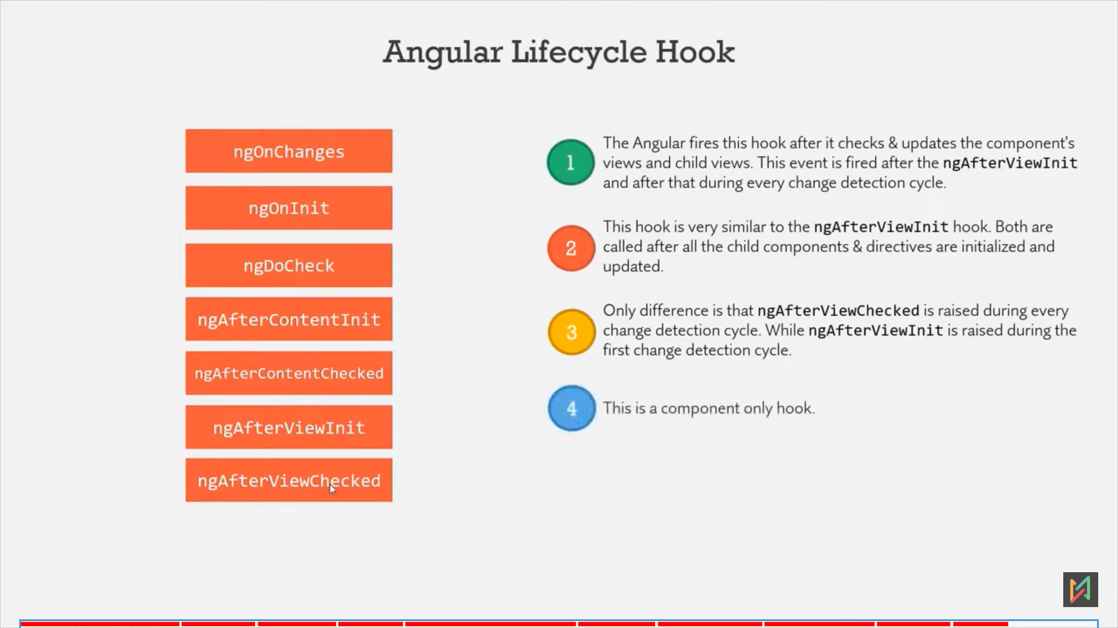 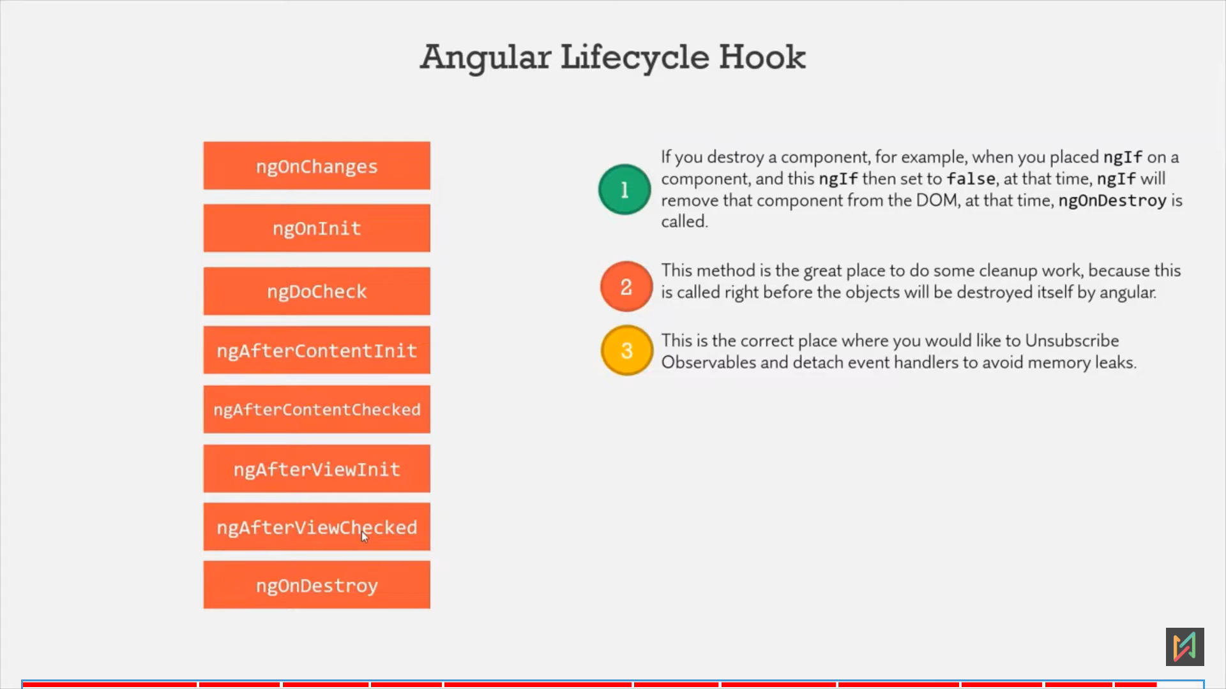

# @ContentChild Decorator

* Used to access HTML elements, component or directives from view template of parent component in the component class of child component.
* Note: ContentChild variable will be initialise just before ngAfterContentInit, so it wont be availate at ngOnInit (value is undefined).

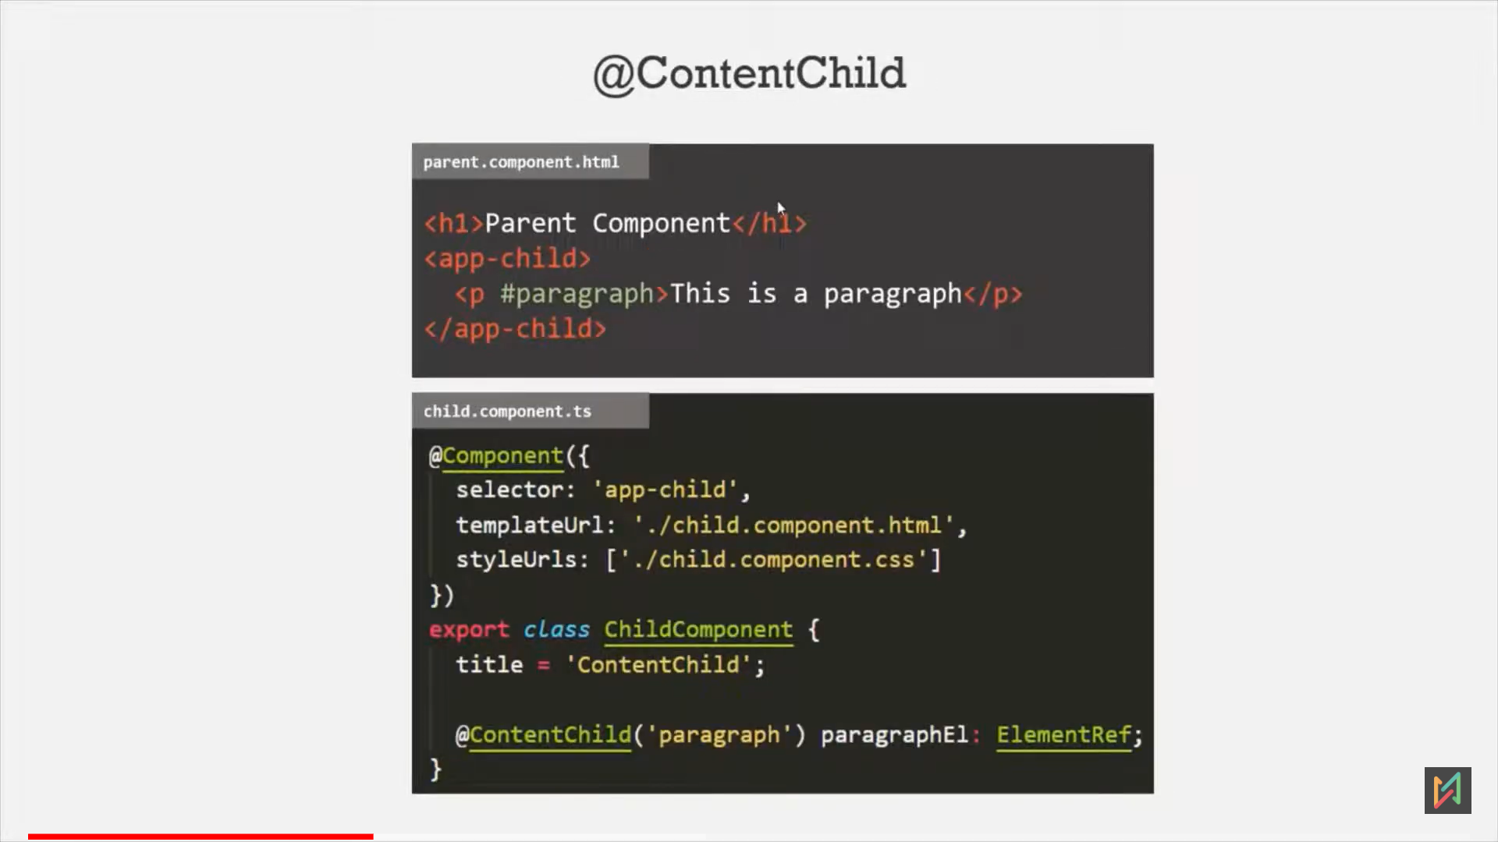

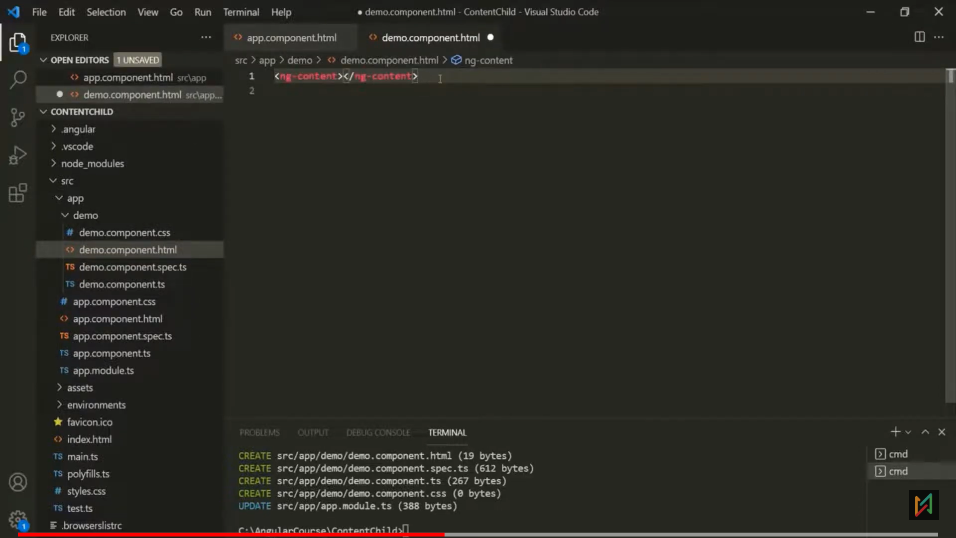

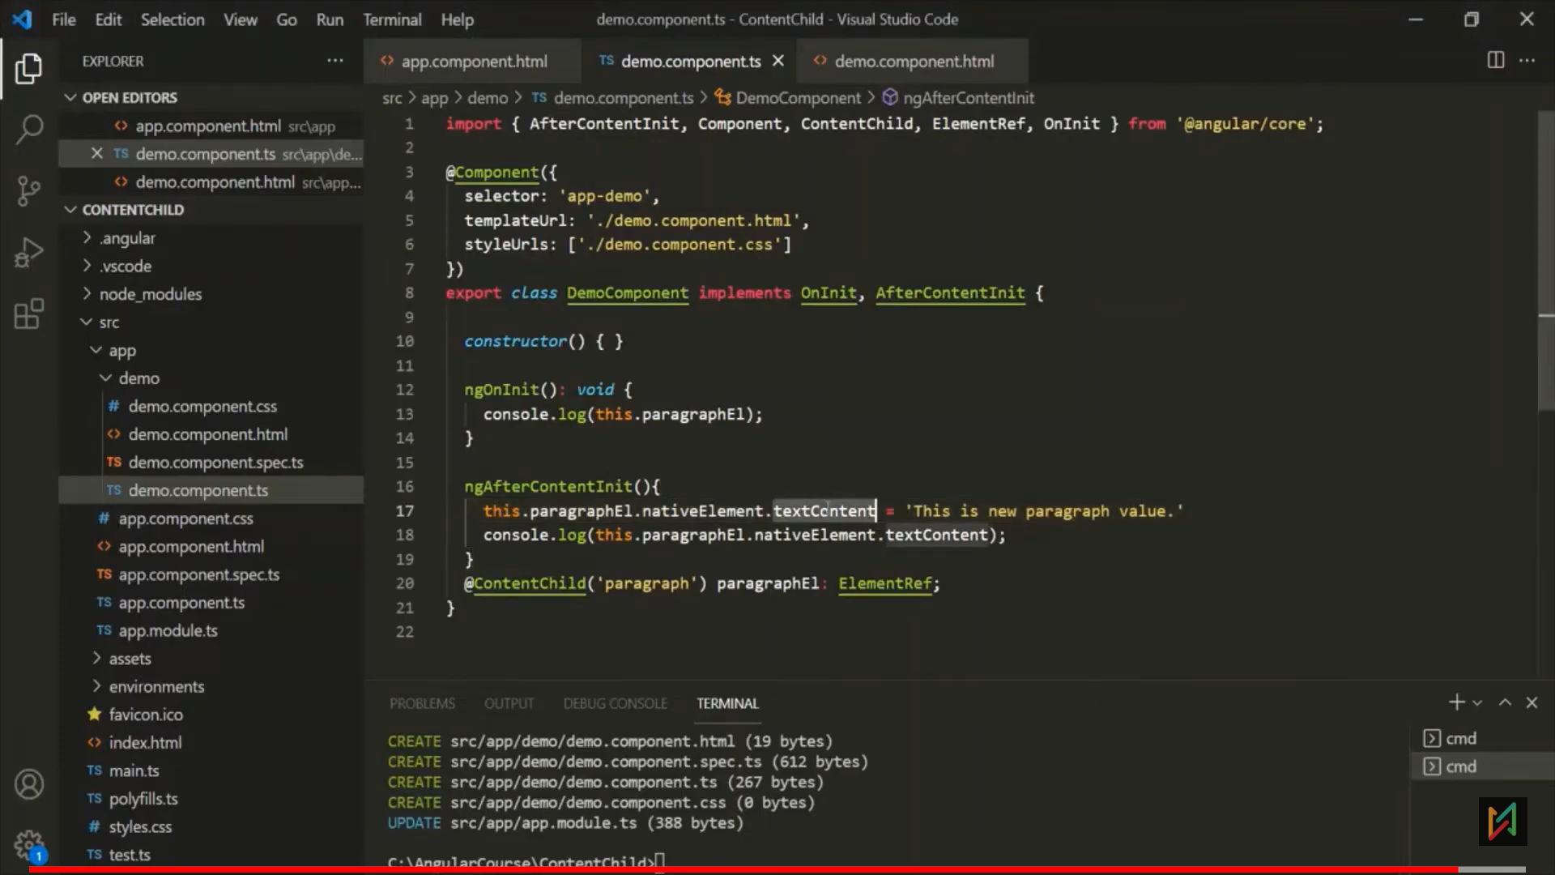 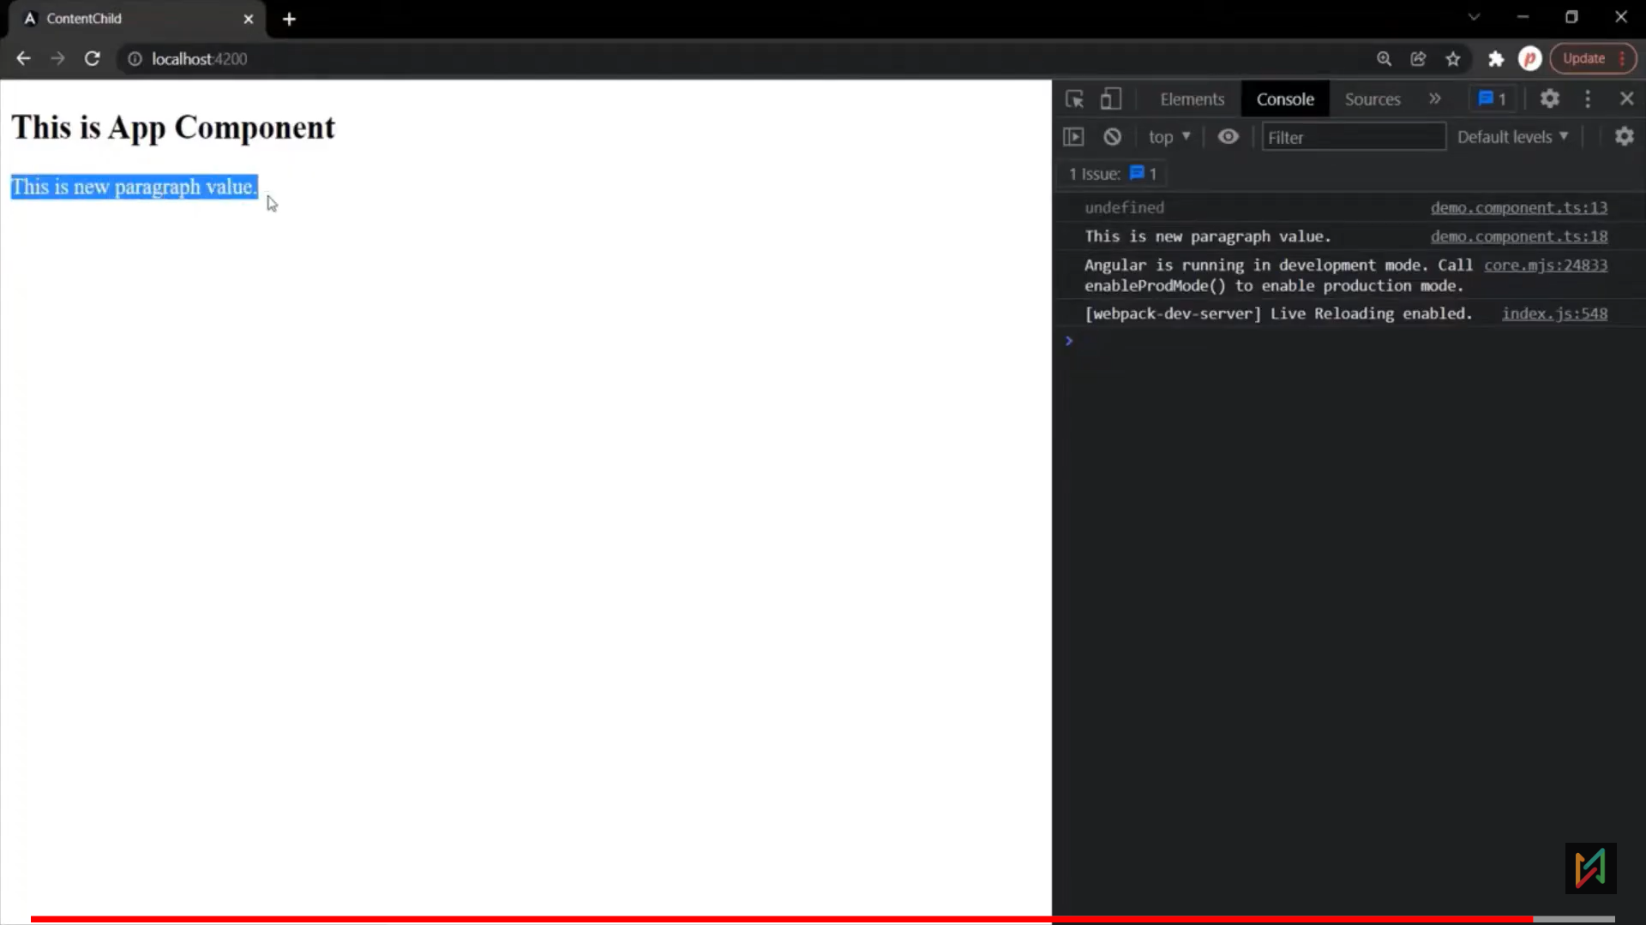

# Custom Attribute Directive

* Directives are simply instructions to the DOM.

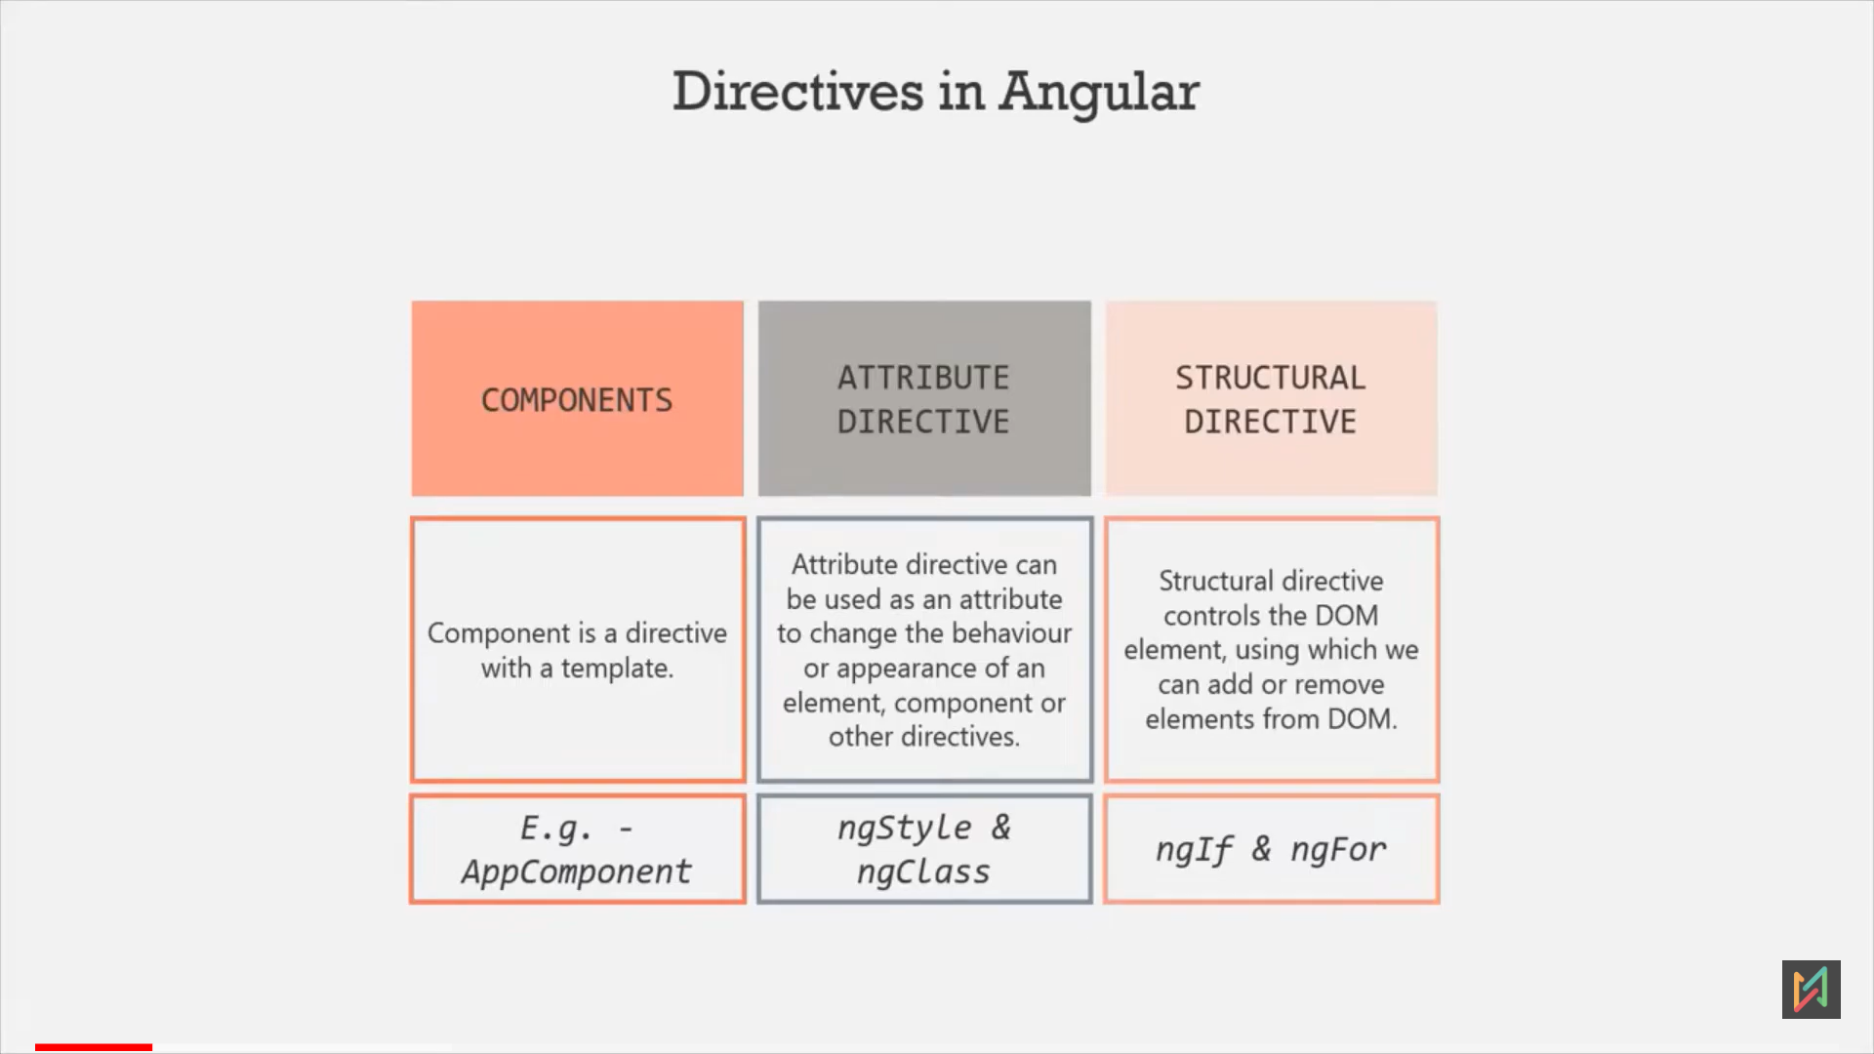

Eg1: below, in constructor, we created a attribute directive with selector as attribute type [].

Whenever will add this directive selector on any tag, that tag reference will get pass in constructor parameter.

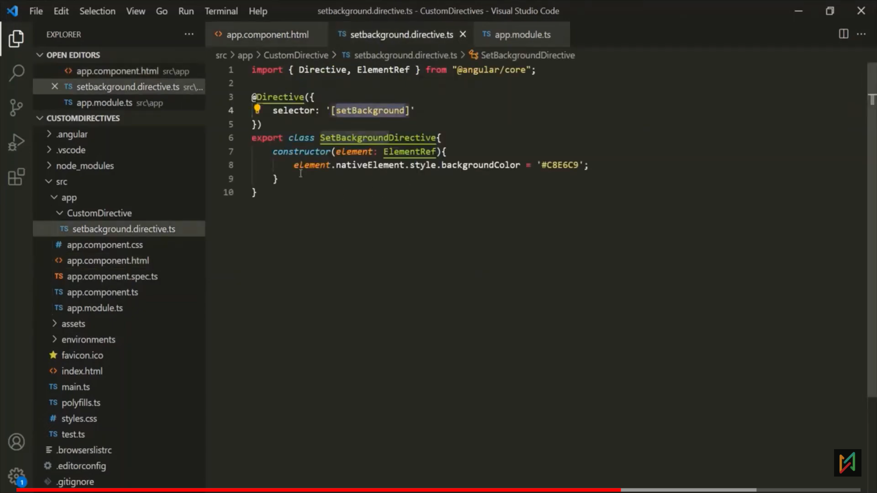 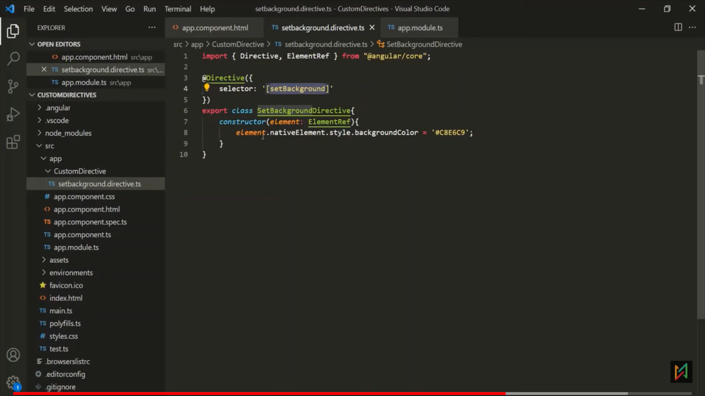

* But its not good practive to write logic inside constructor. Pass logic in ngOnInit.  
  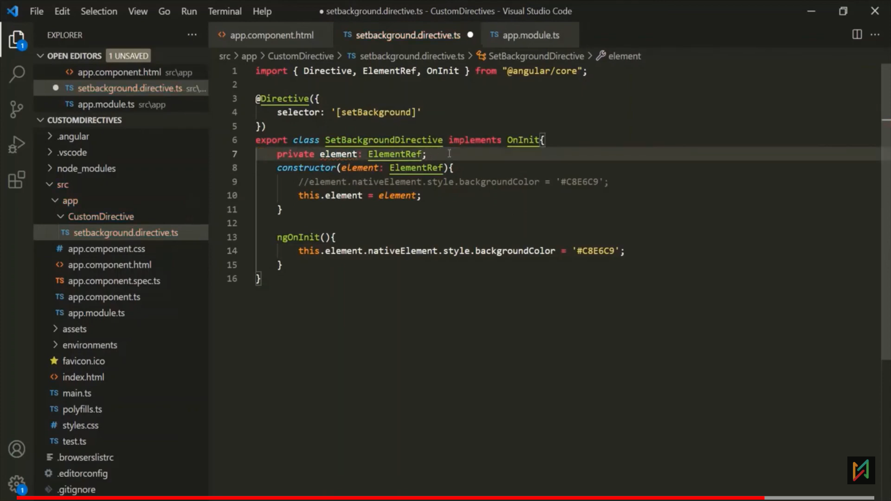
* Or: private will create member variables automatically.
* 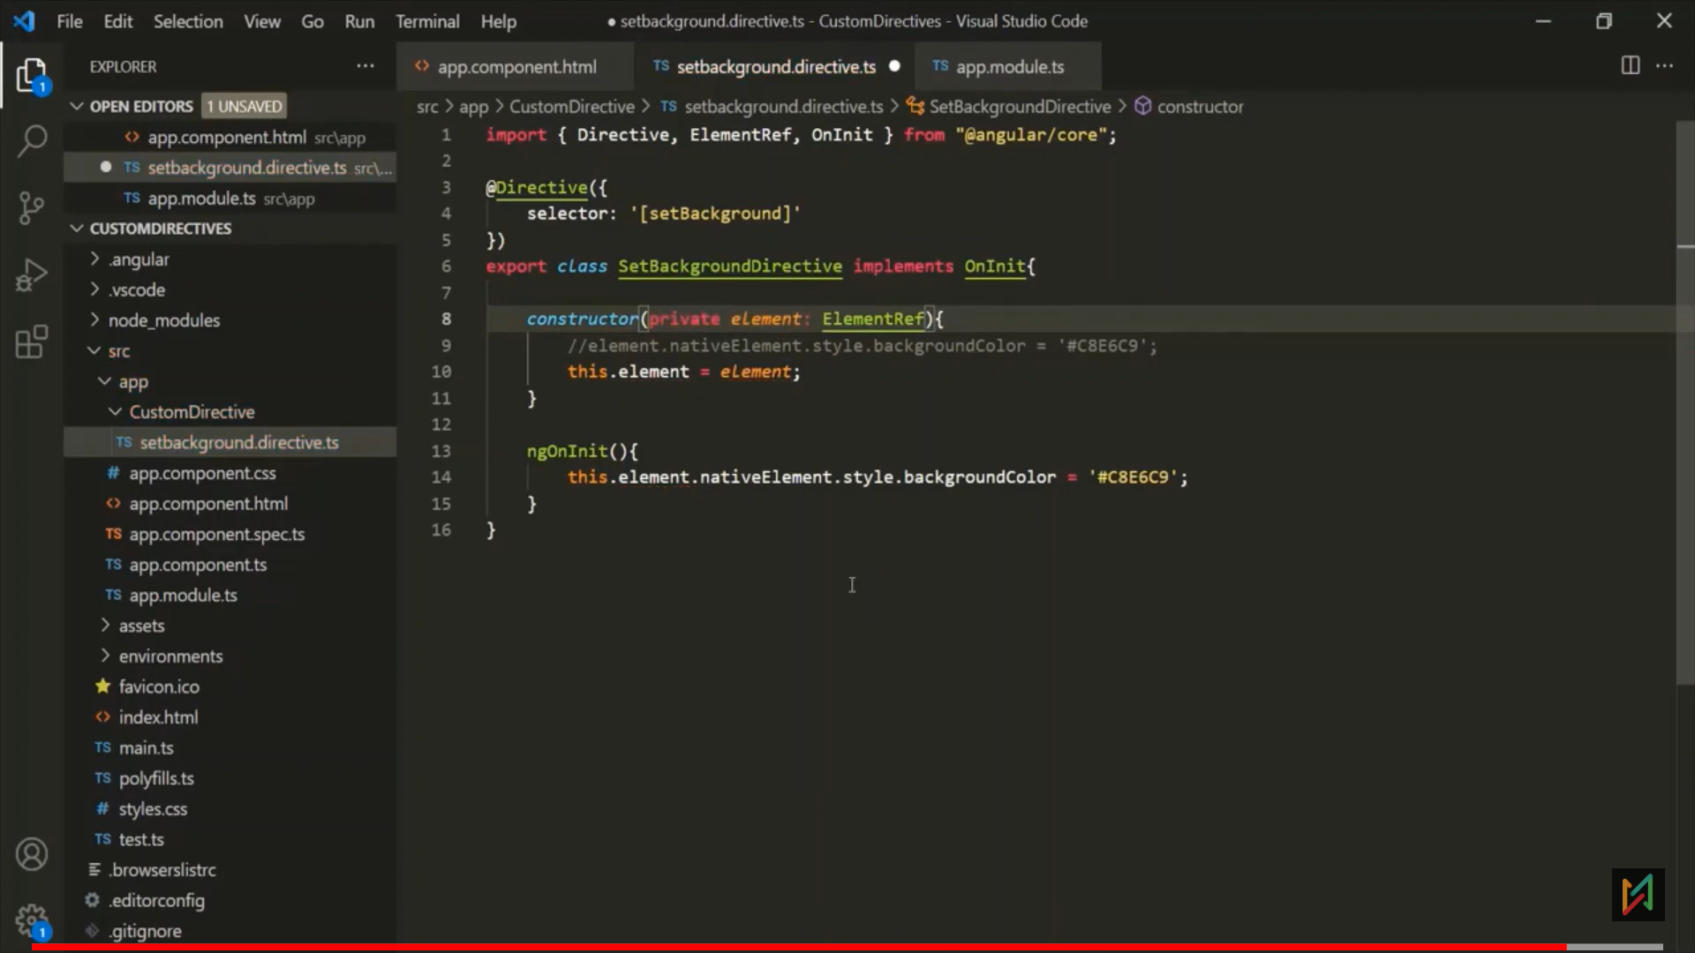 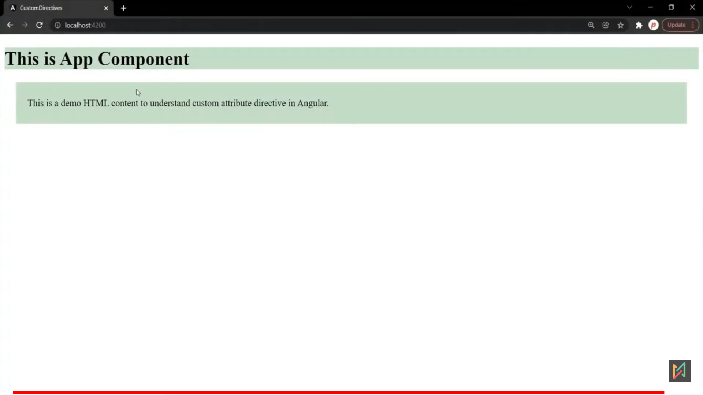

Problem: Here using nativeElement property, we got a direct access of DOM element, It’s not advicible to give direct access of DOM elements. To overcome this, use renderer2

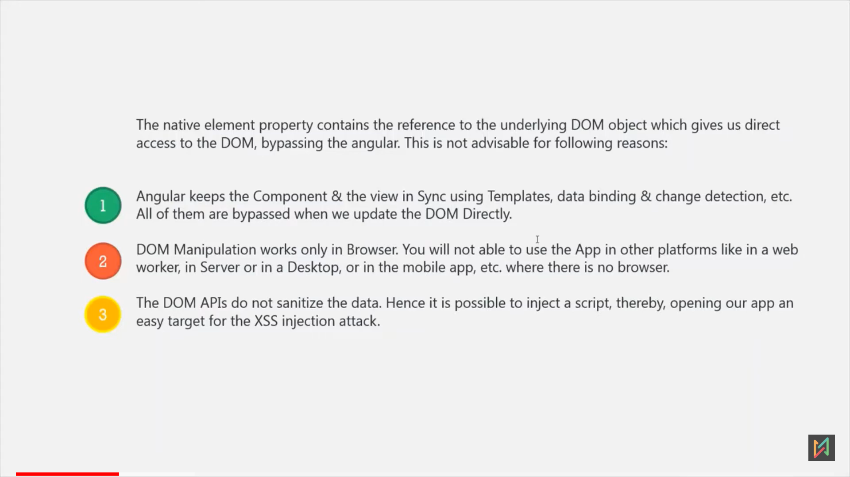

**Renderer2**

* ng generate directive highlight
* Renderer2 is a class, which allows to manupulate the DOM elements without accessing the DOM directly.
* Renderer provides methods, using those we are set/manage style, class or attribute to a html elements.

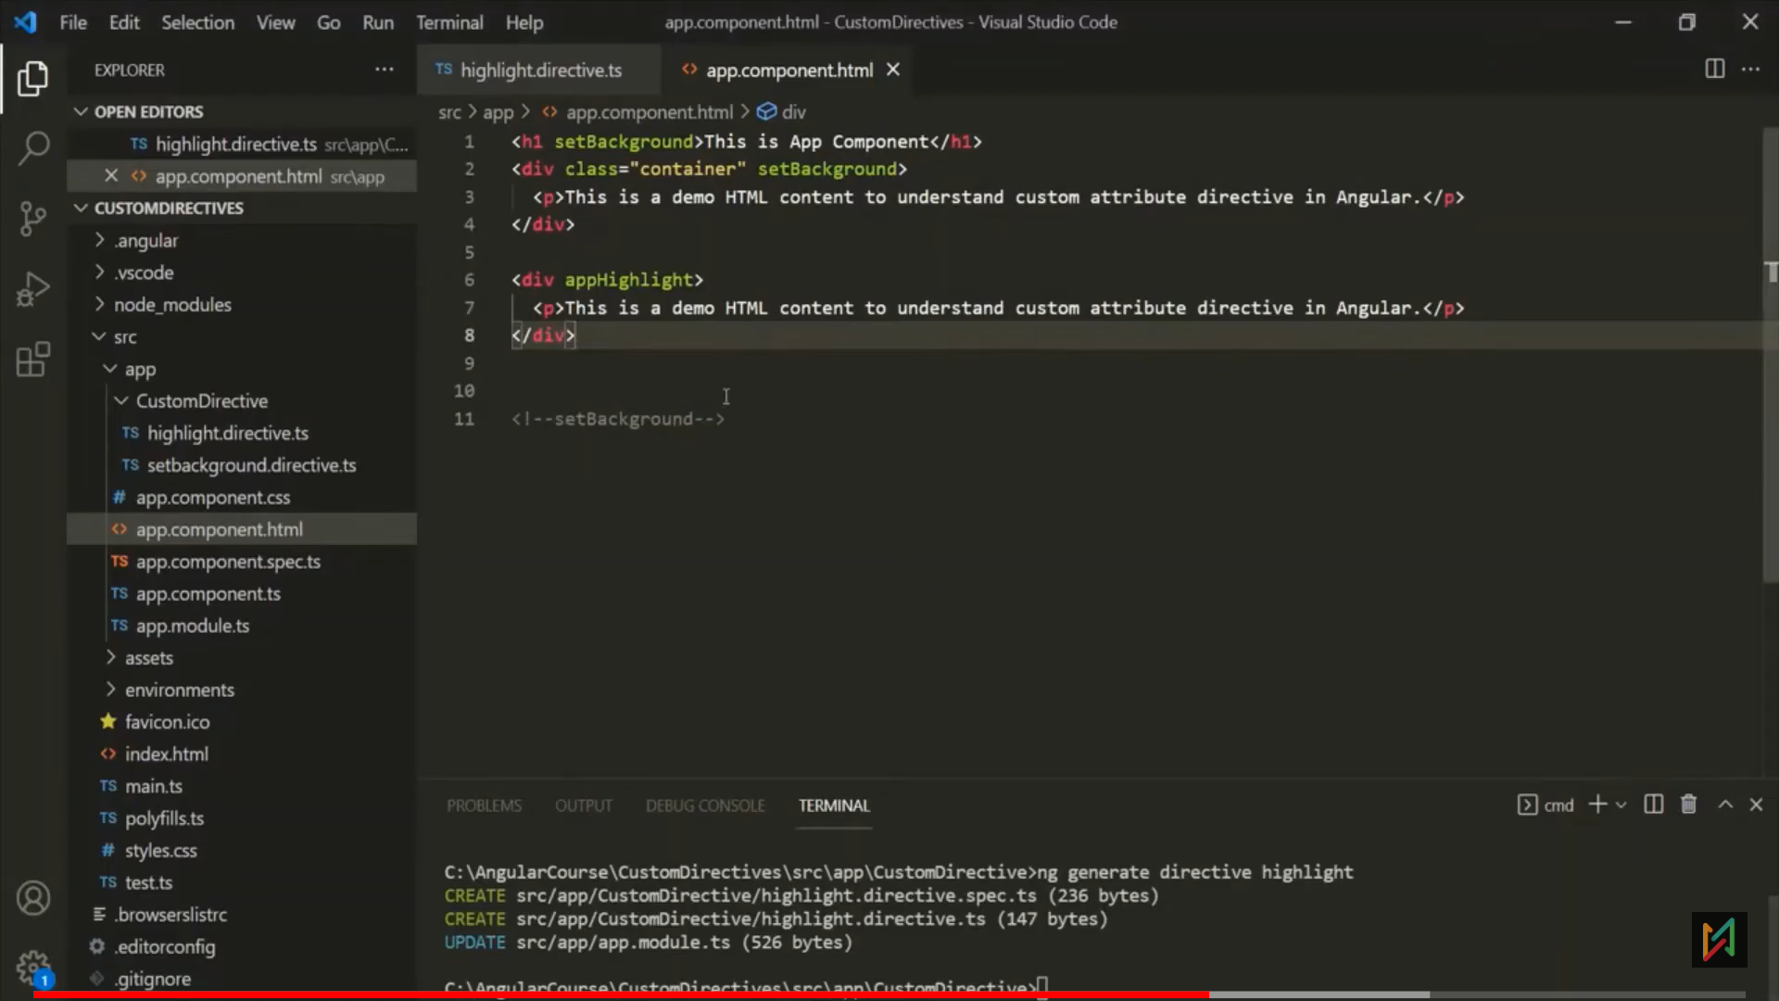 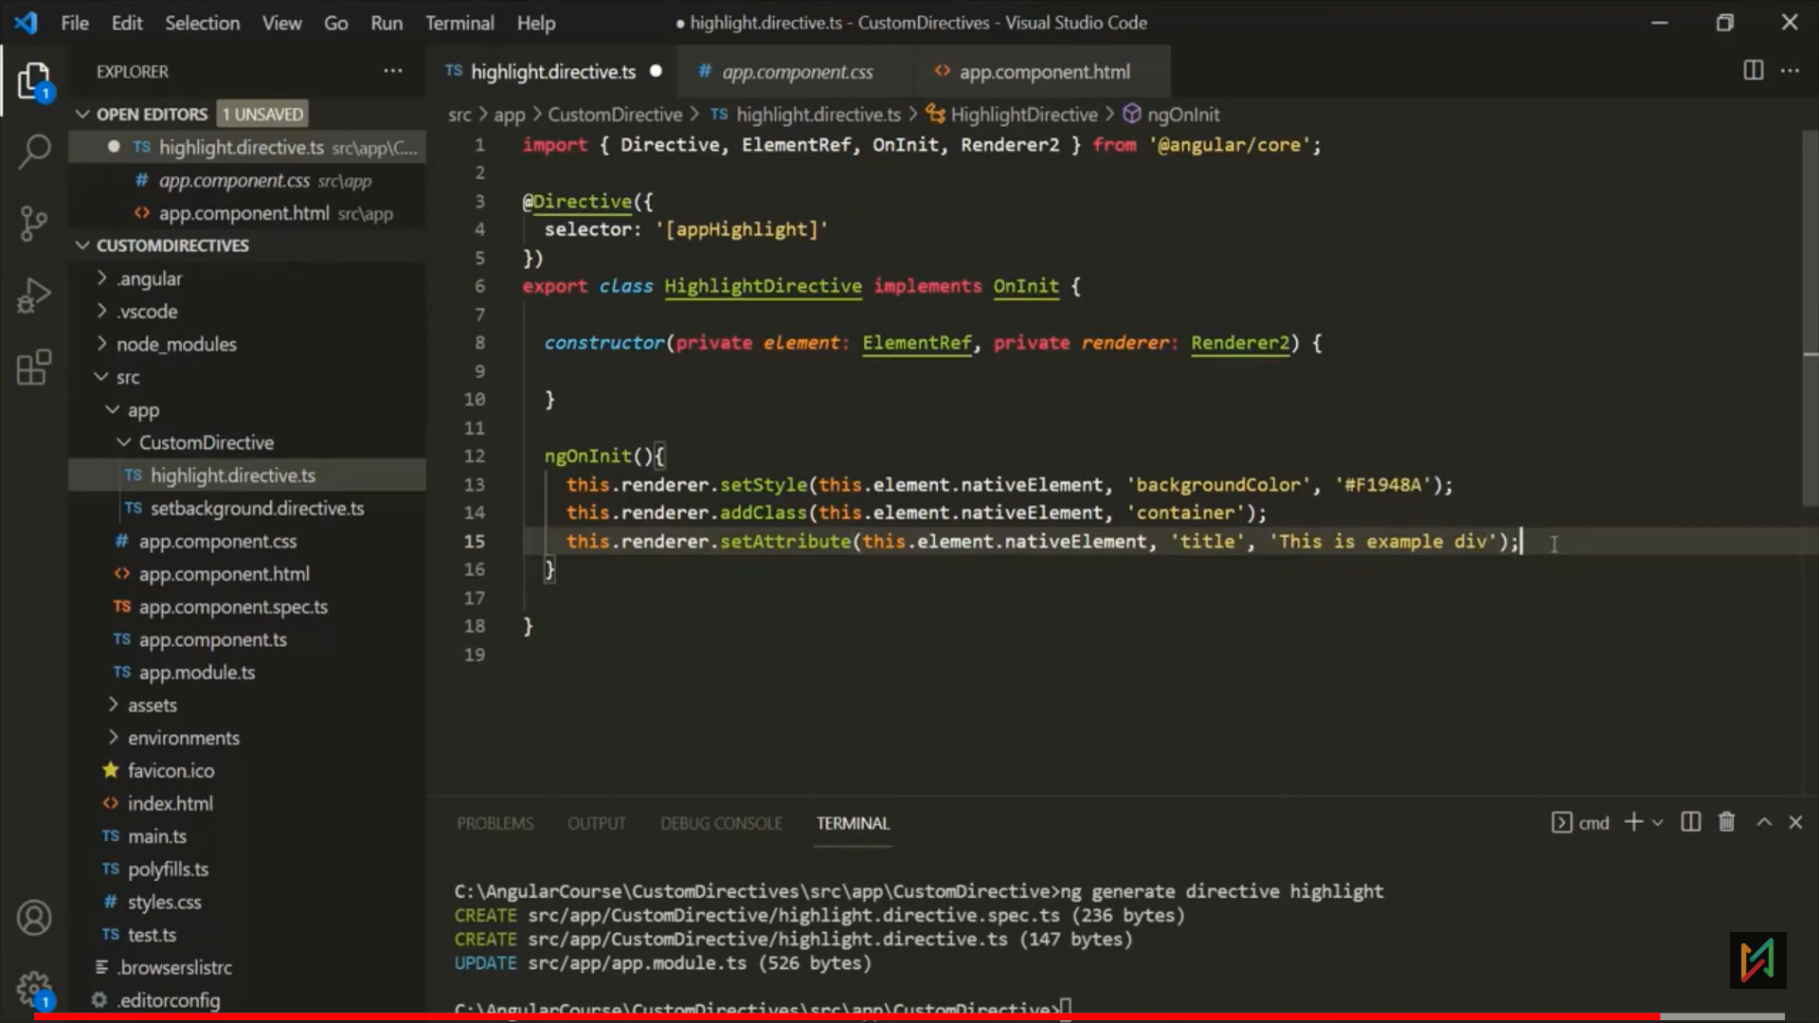 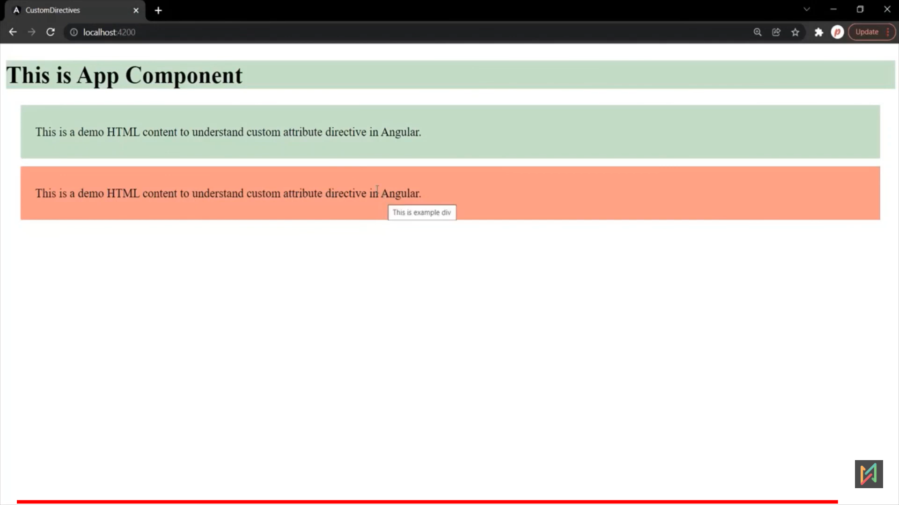

**@HostListner Decorator.**

* Using renderer, will just apply style, class or attribute
* When we want to apply dynamic event on element using directive, the we use @HostListner. 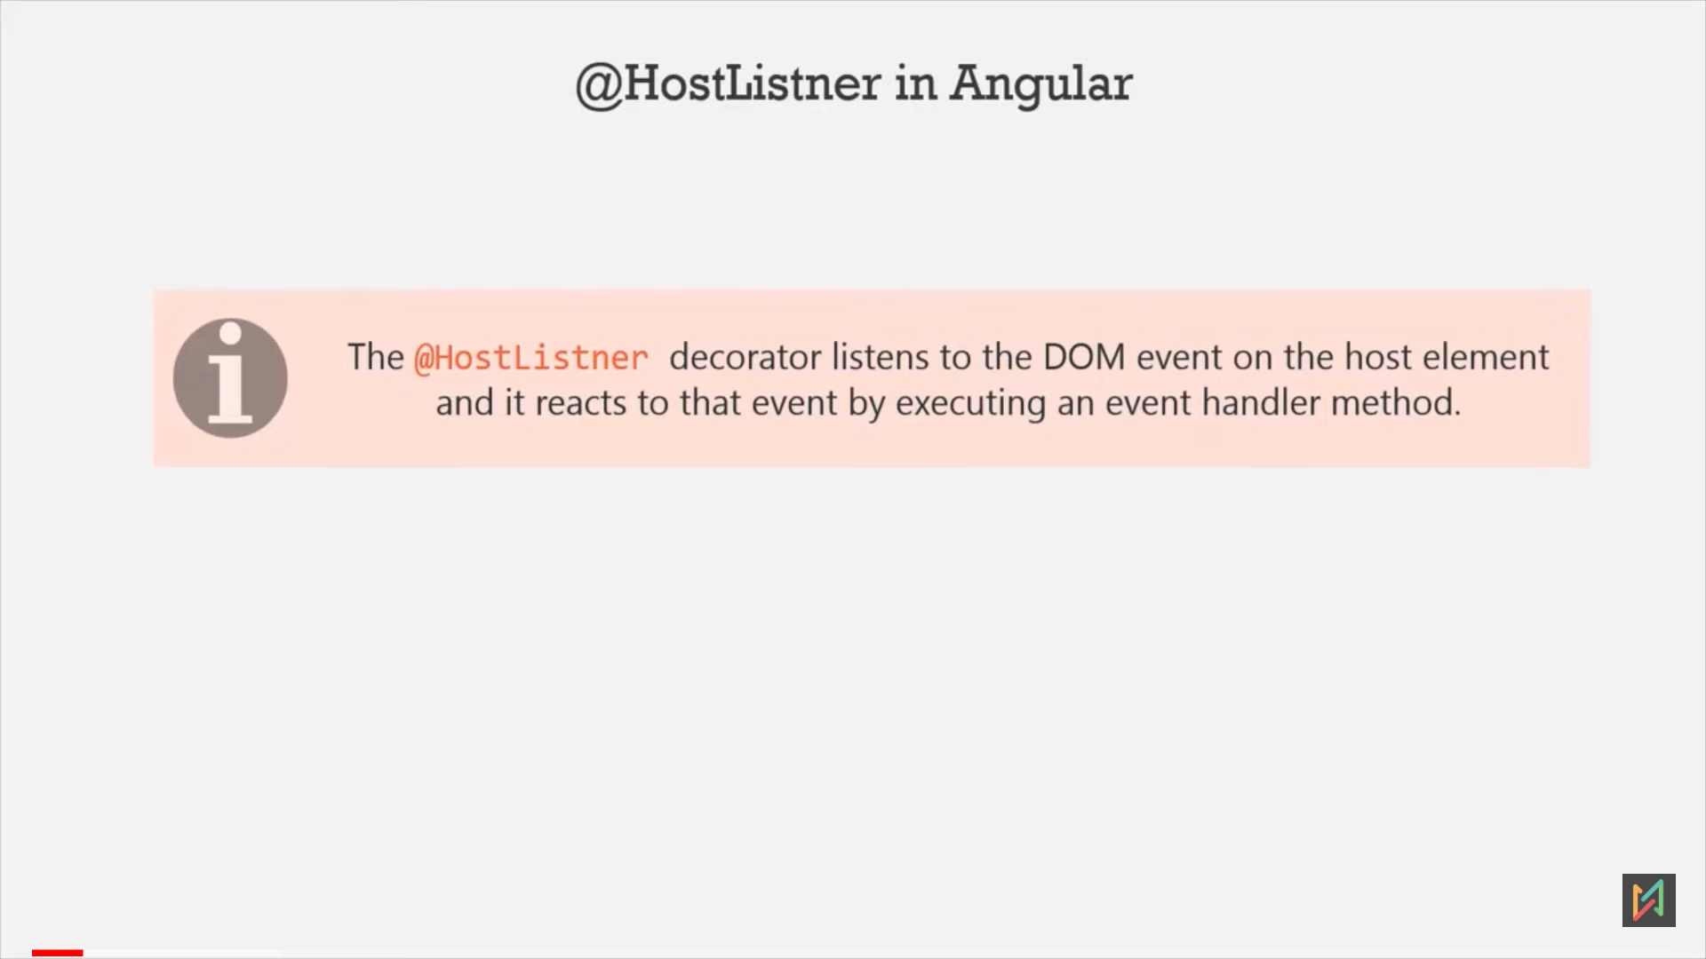 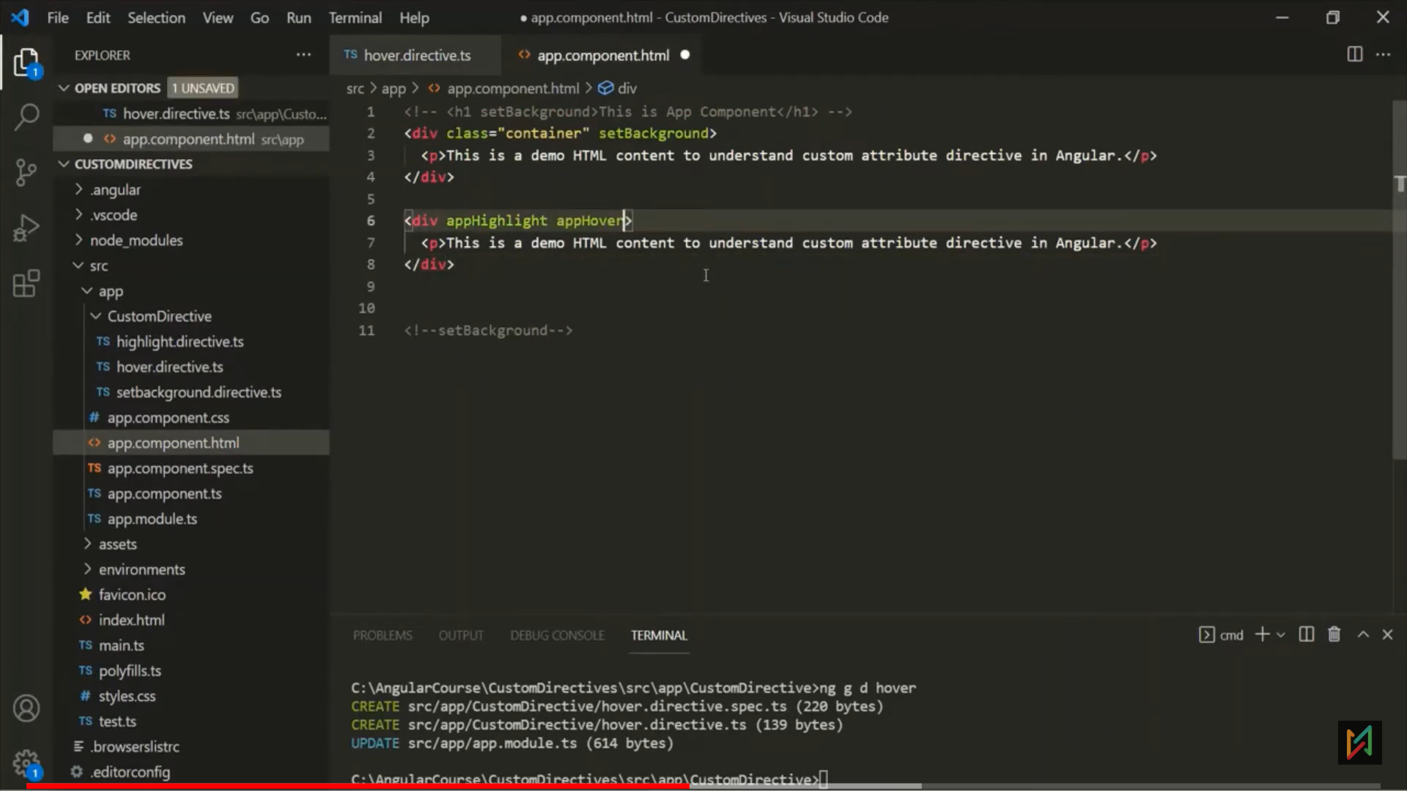 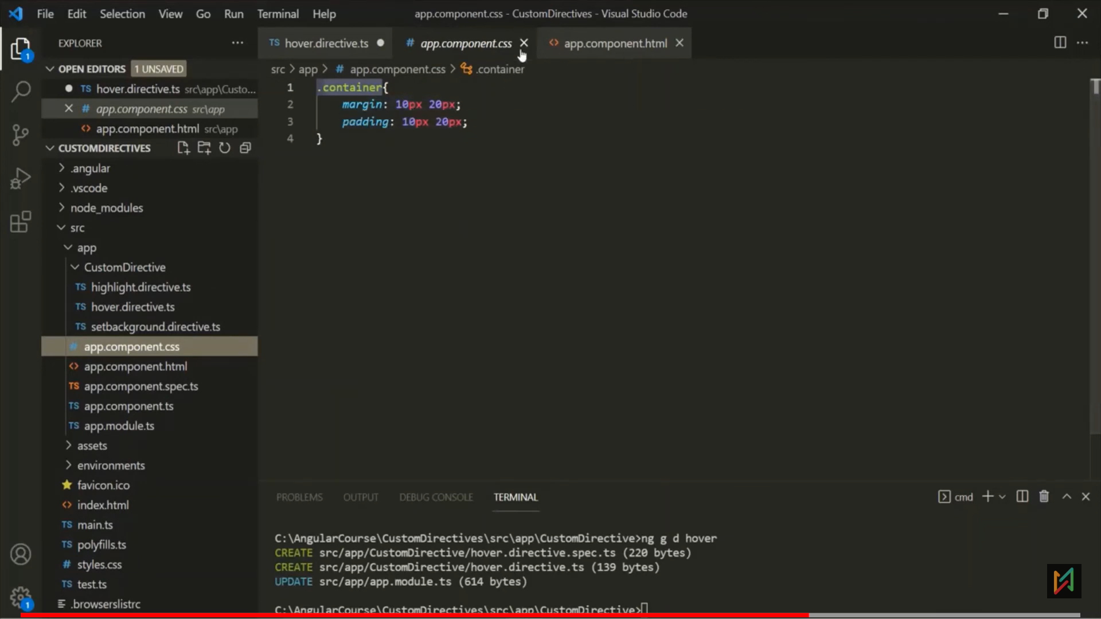 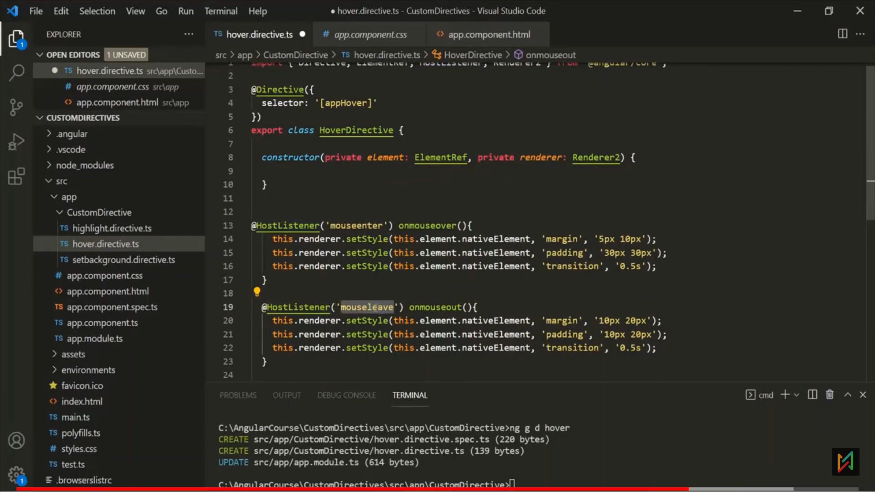 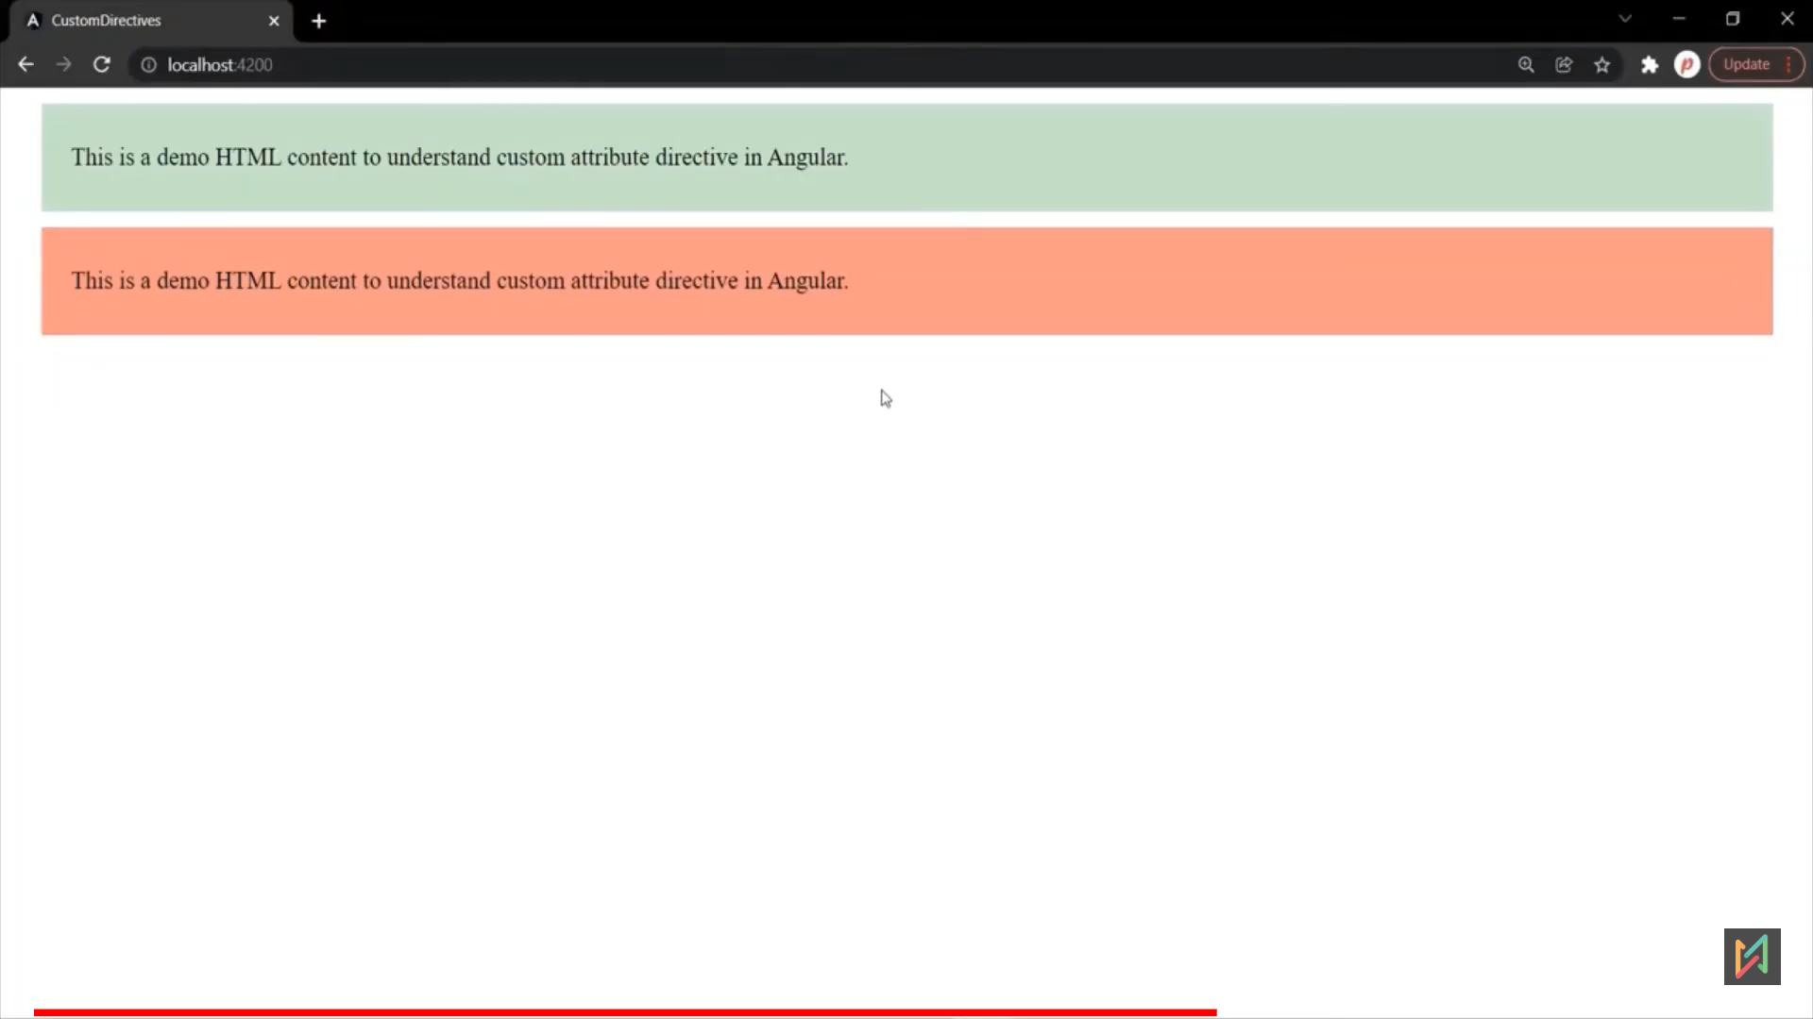 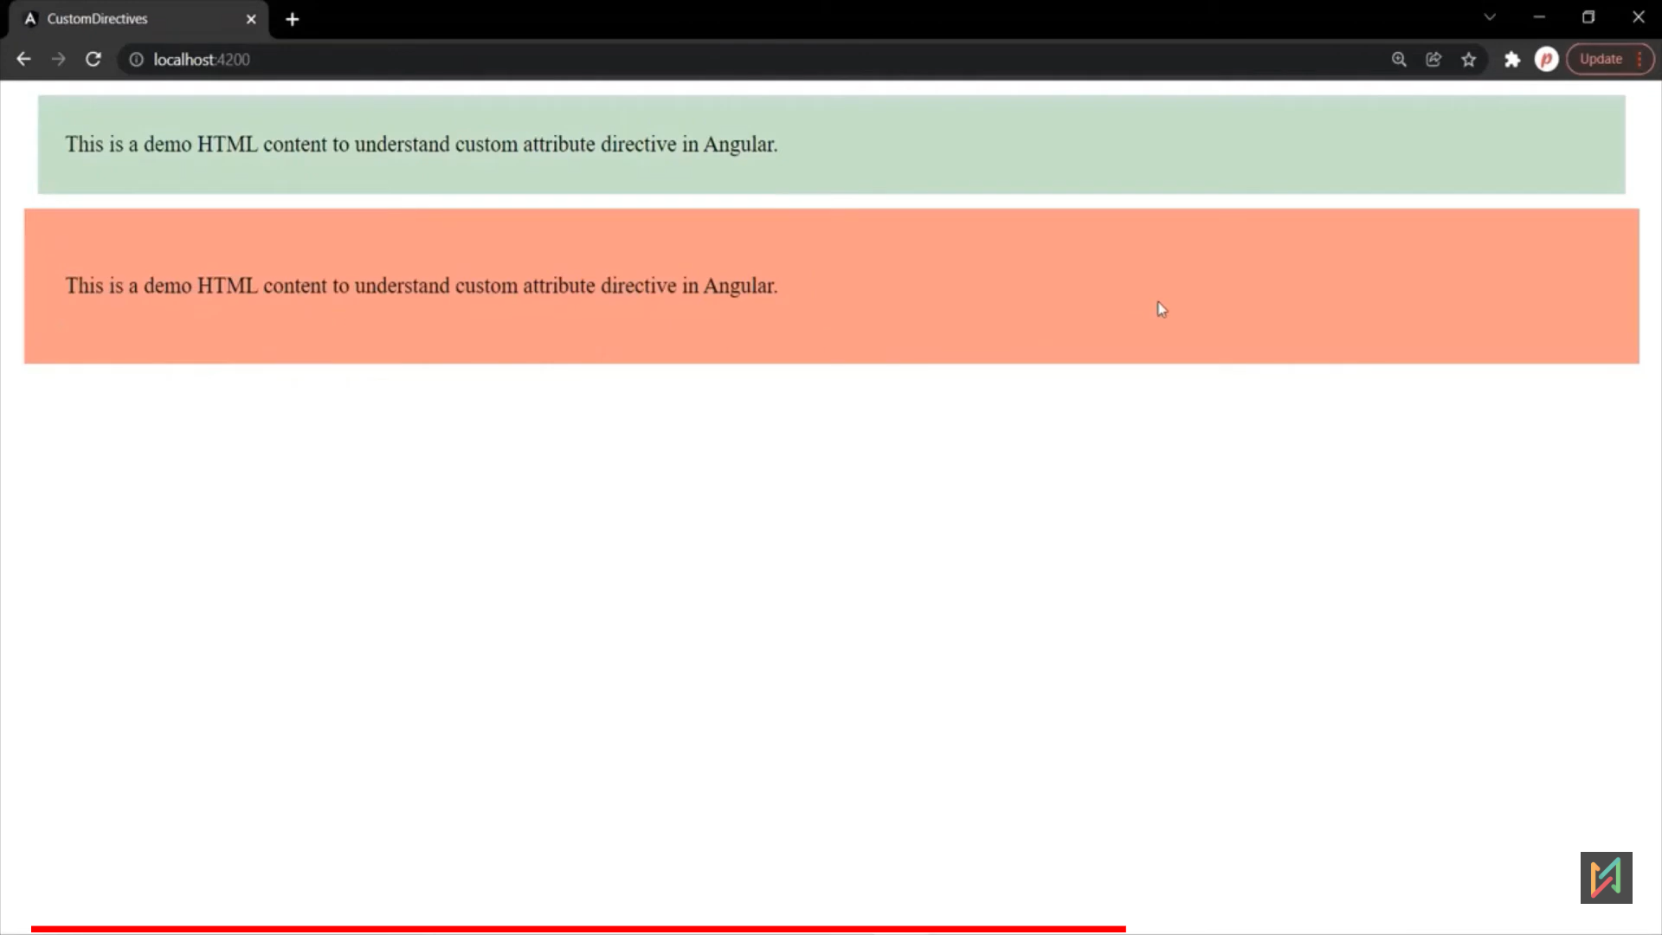

**@HostBinding Directive**

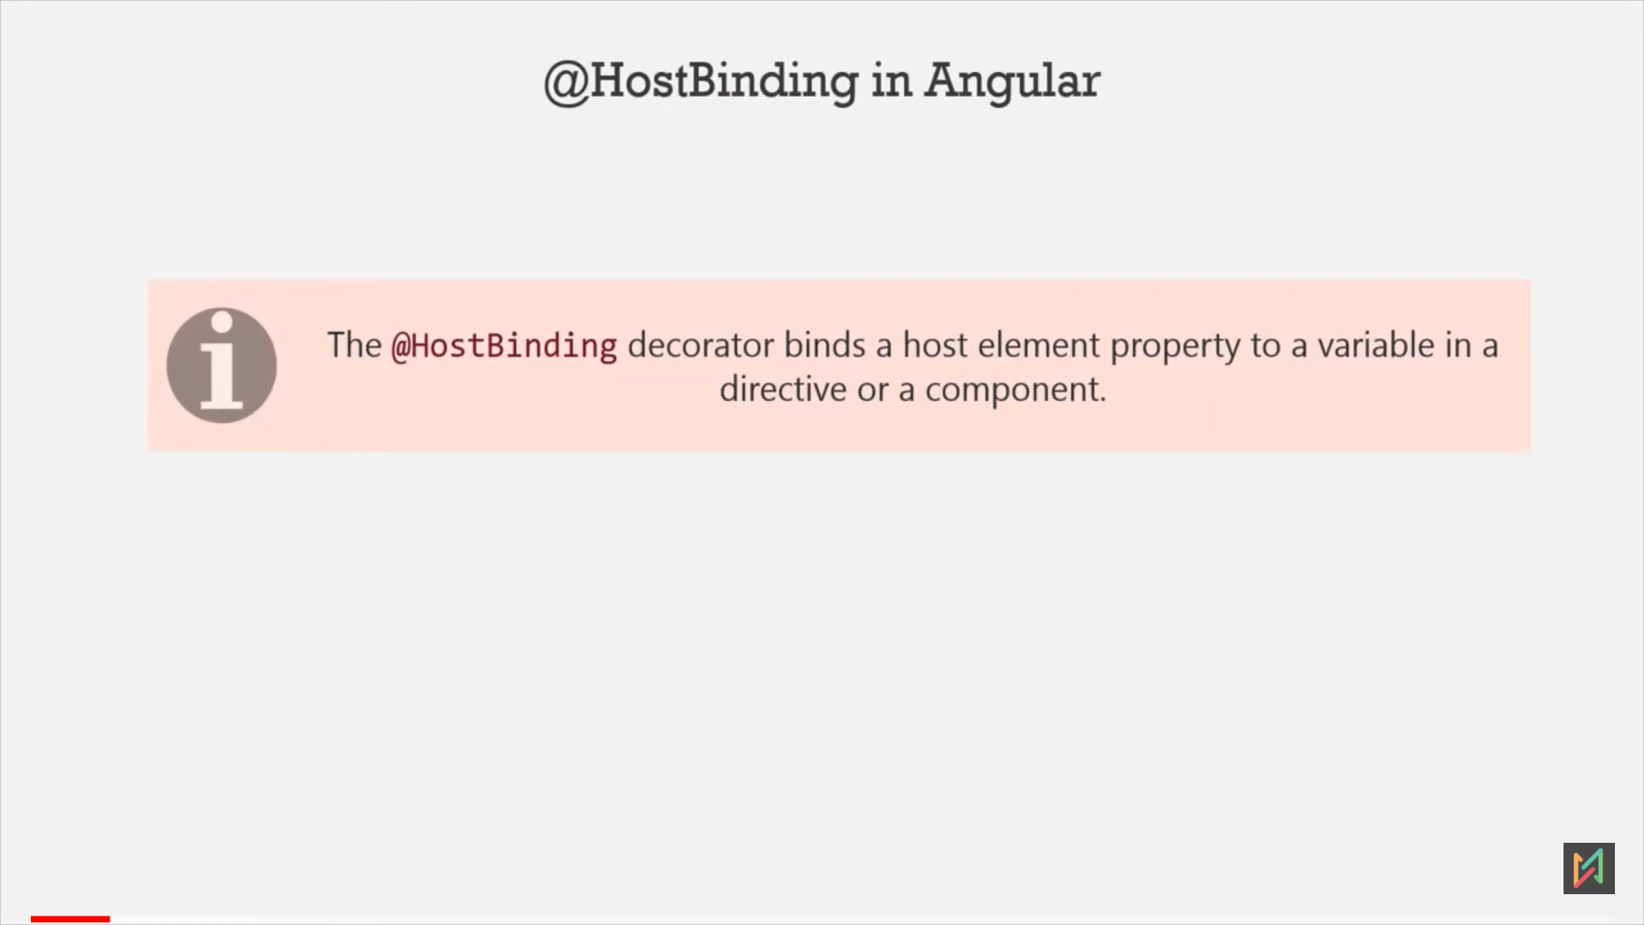 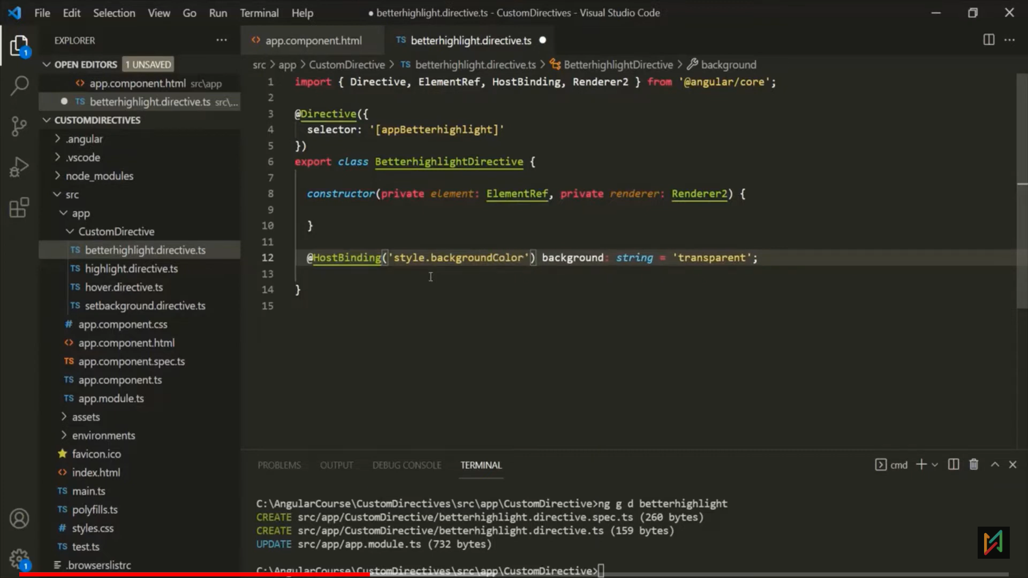 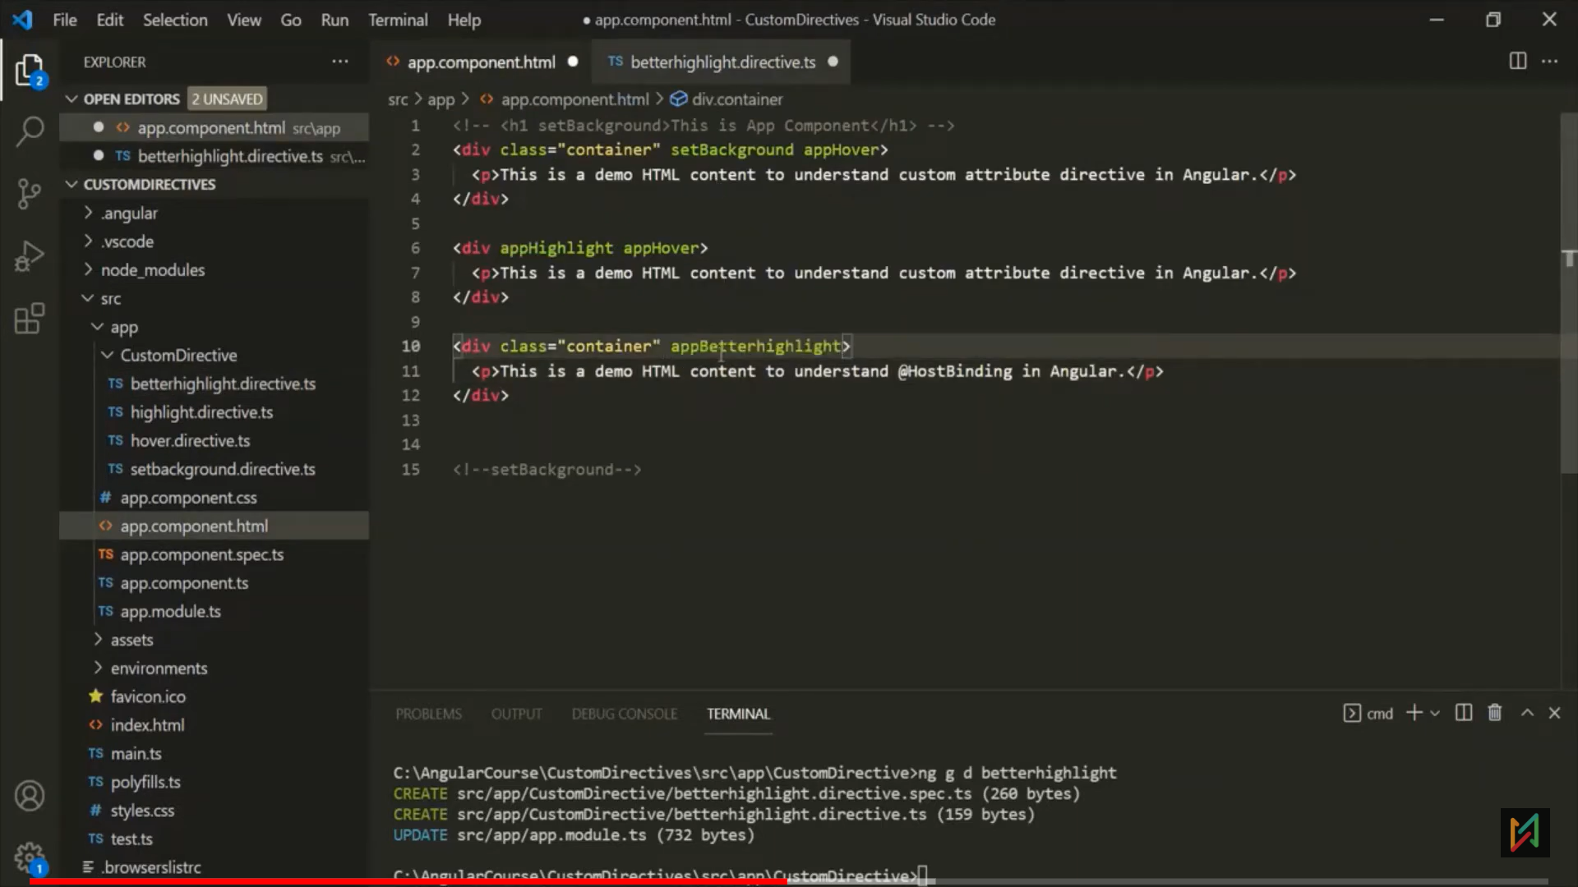 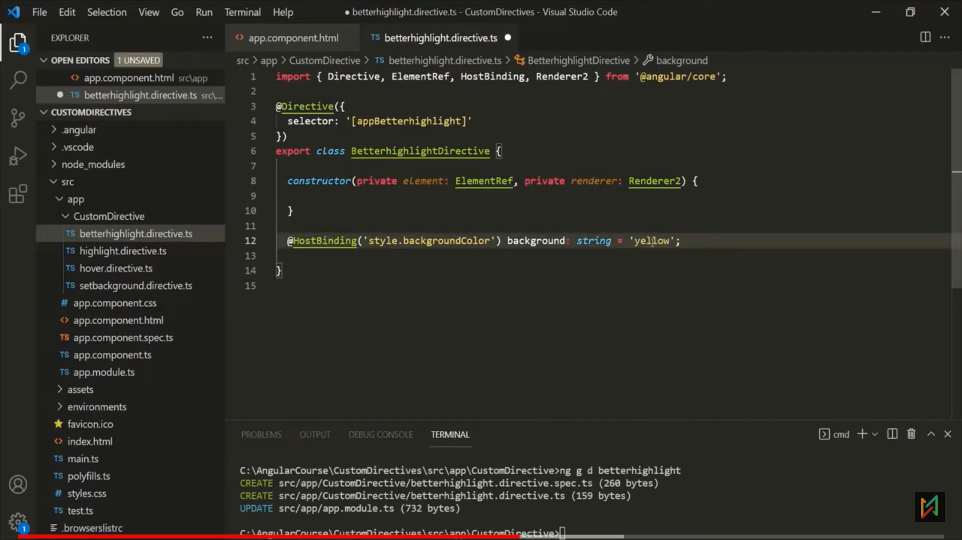 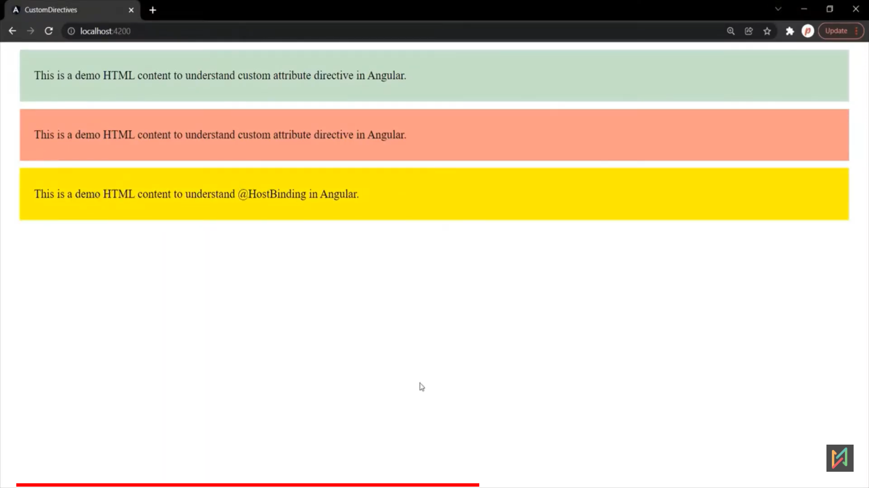

Eg 2:

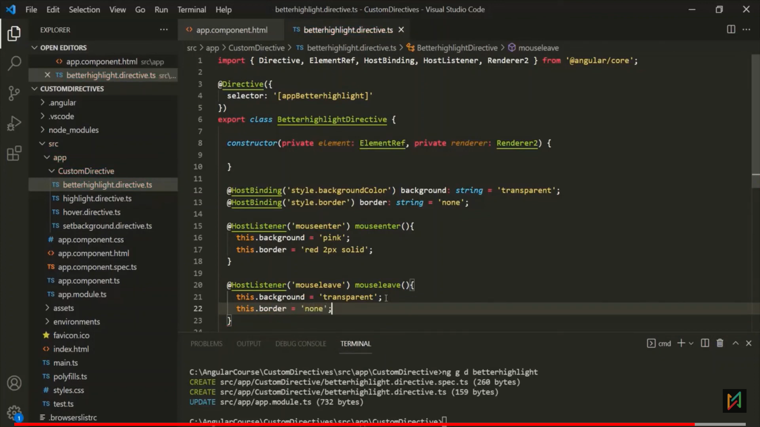 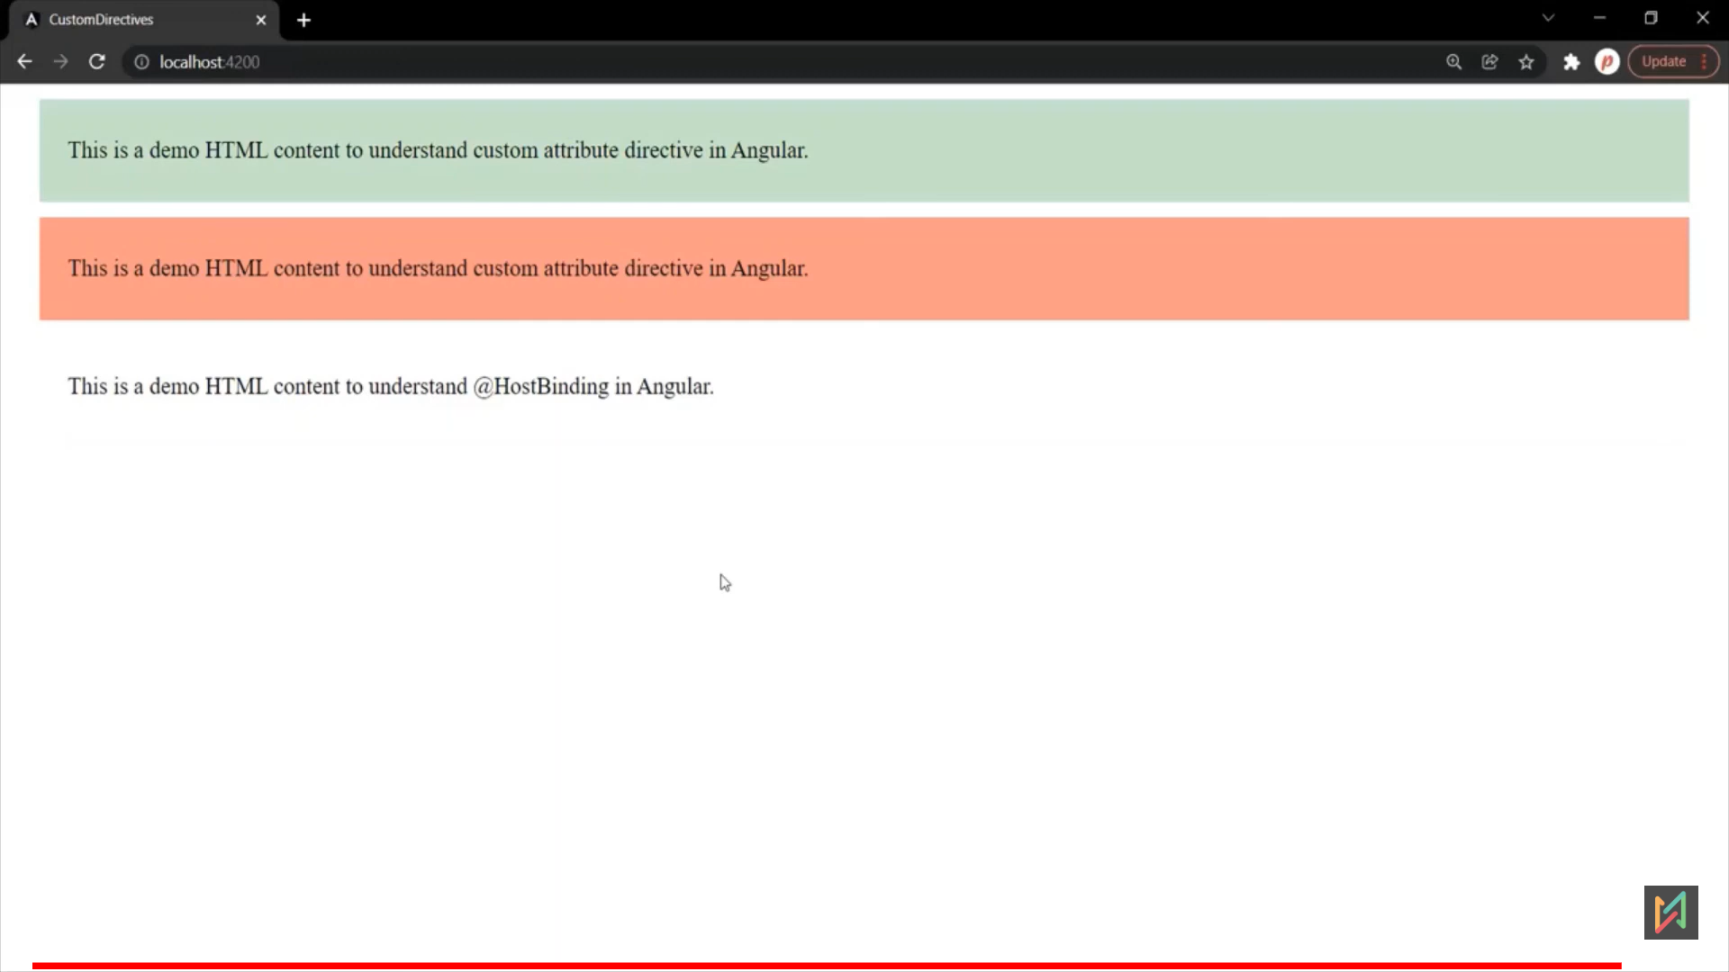 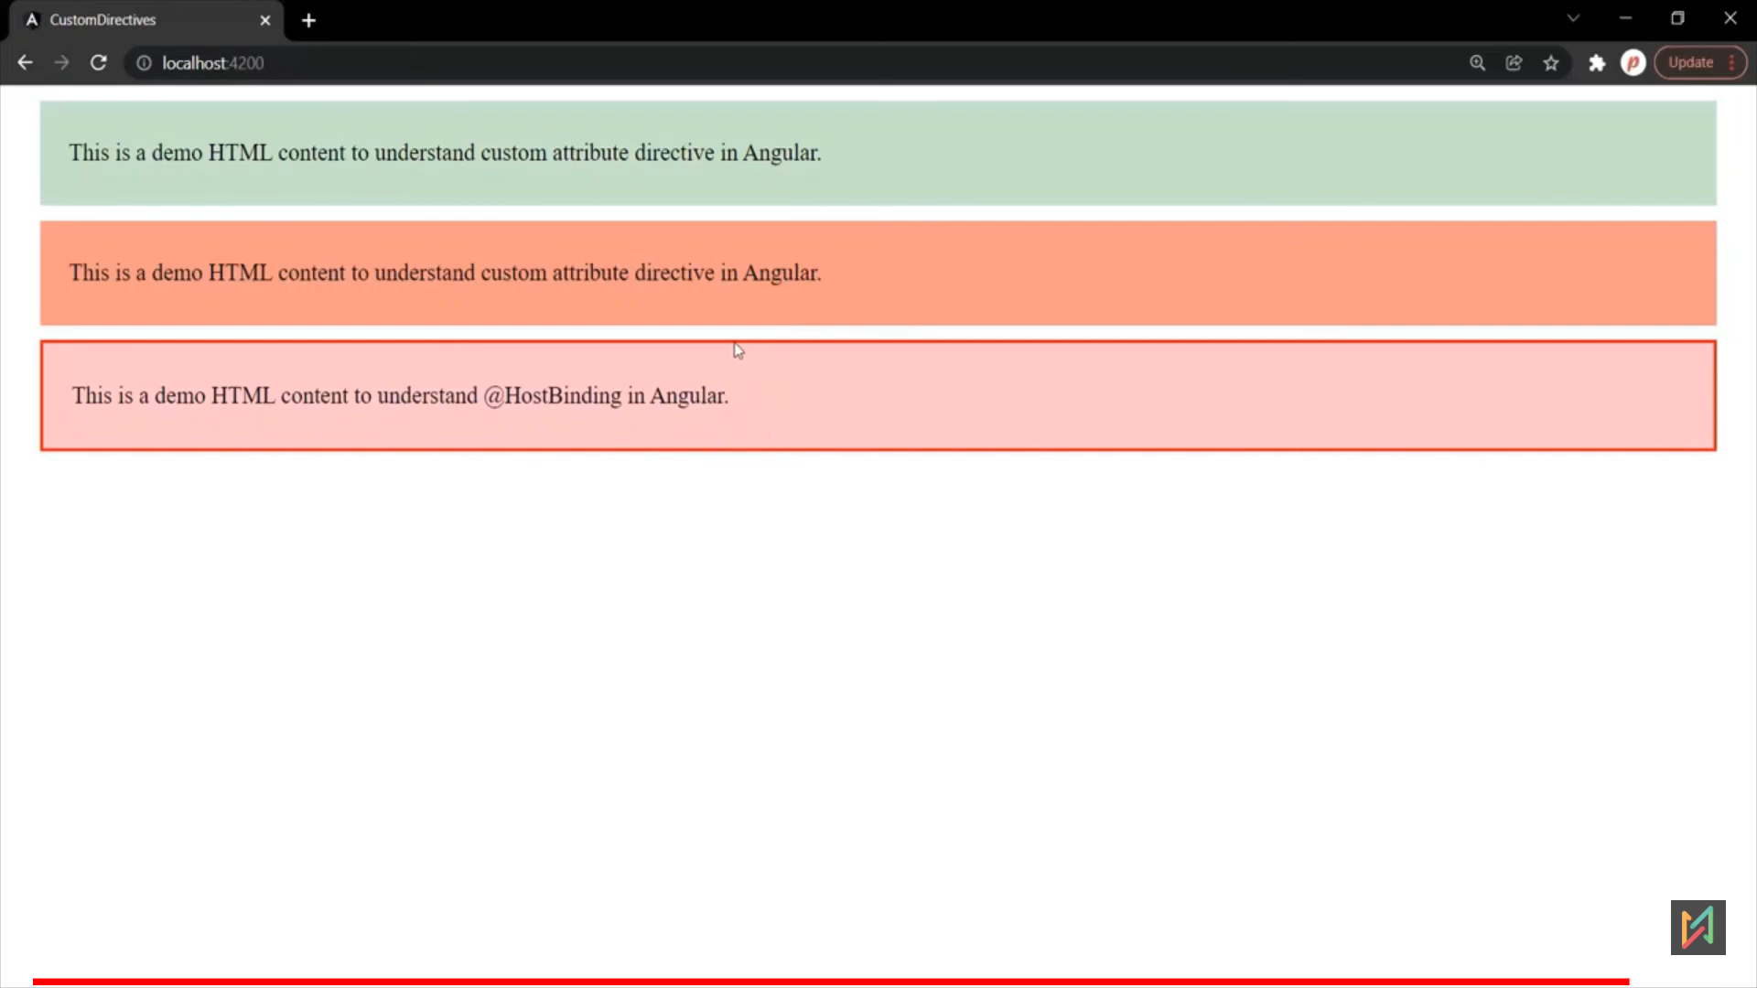

**Custom Property Binding Directive**

* In above @HostBinding example, while binding, we are hardcoding the values, like color: pink.
* In custom property binding, Component will pass the values, and will set those values.

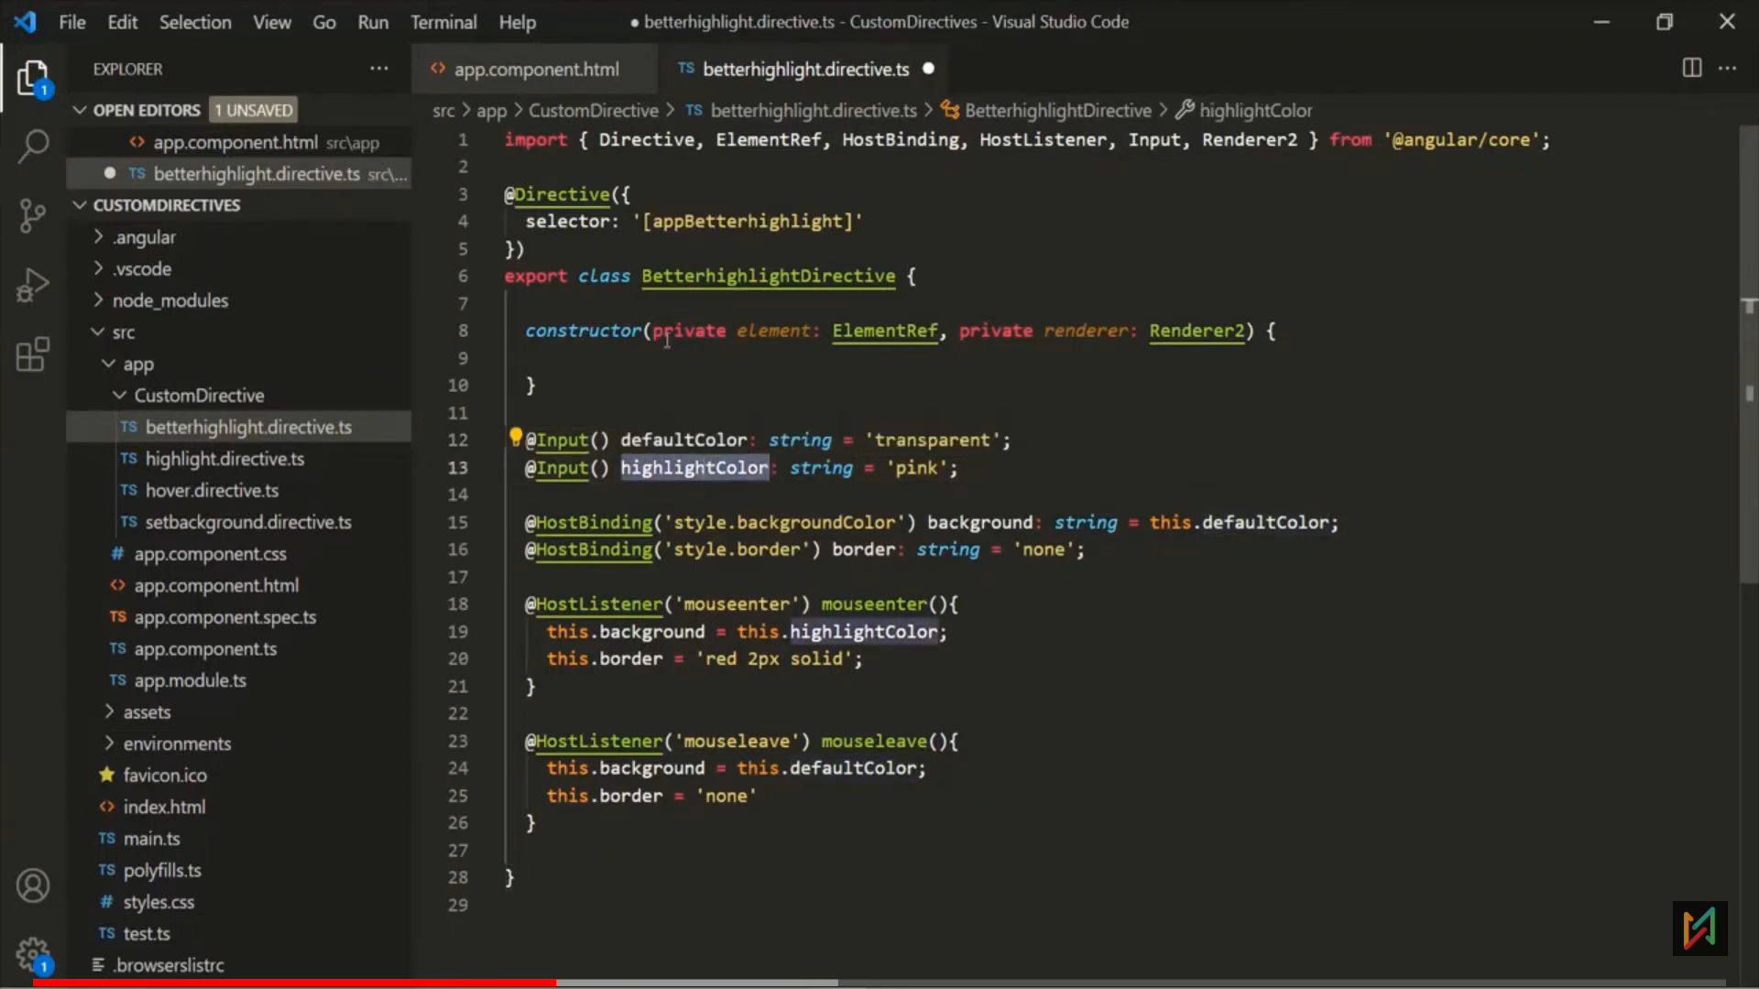 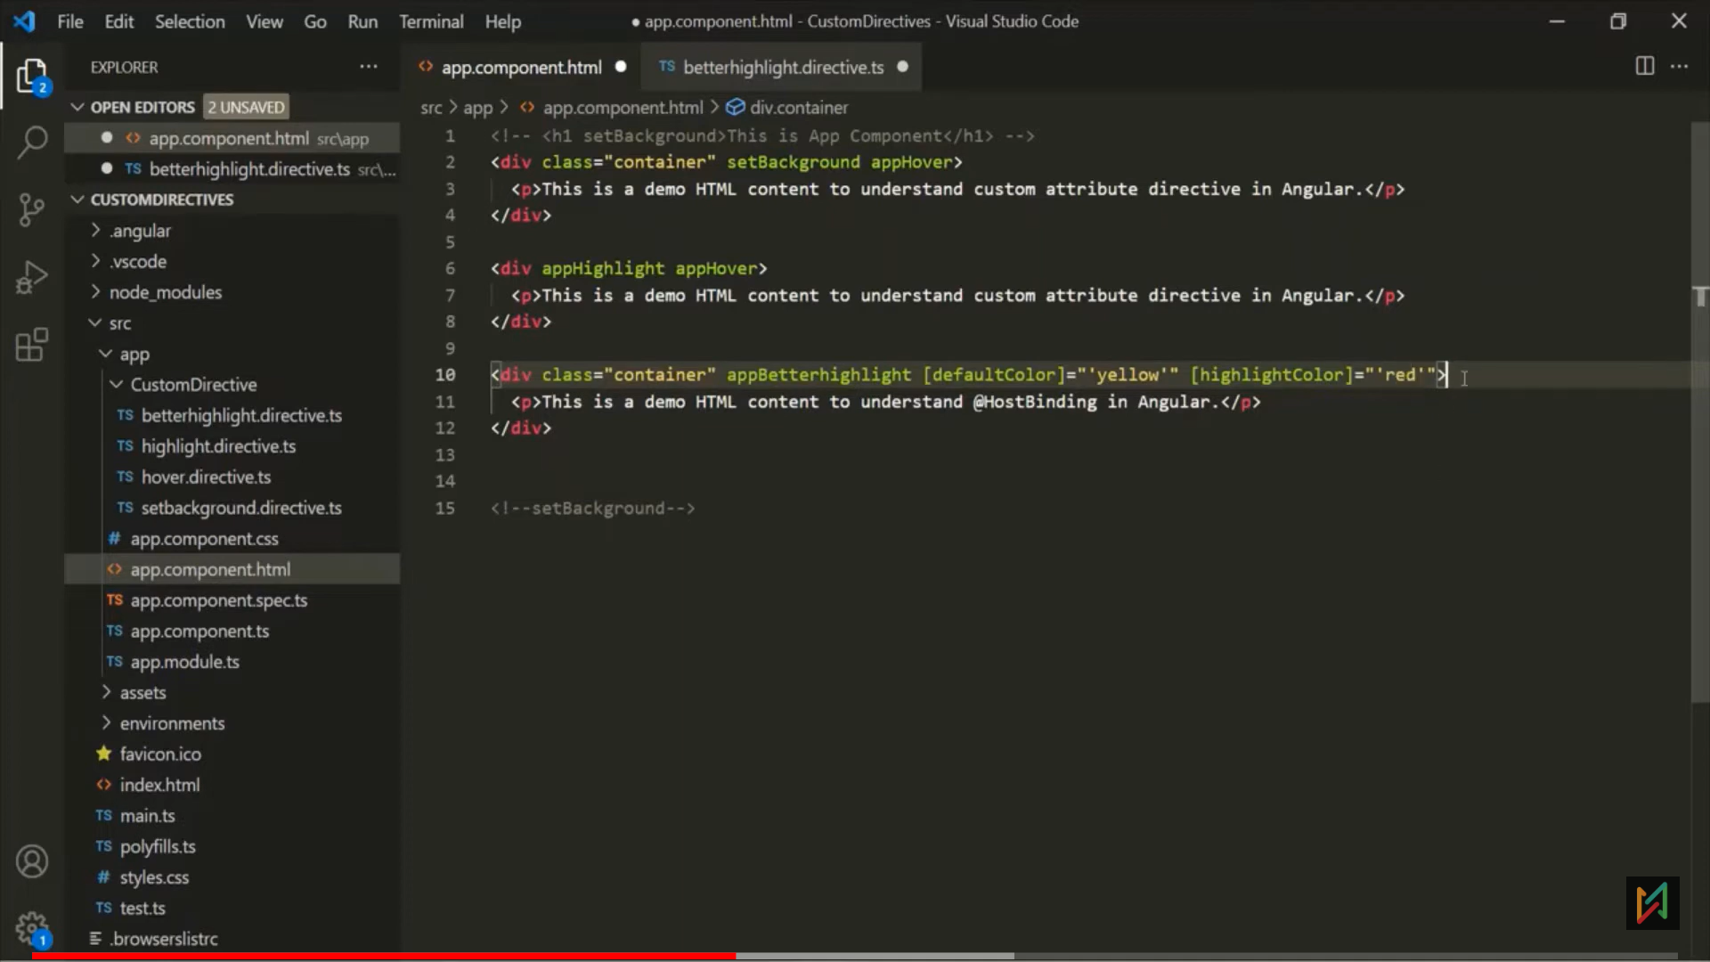 Bug: when page loads, its setting initial background-color value as transparent.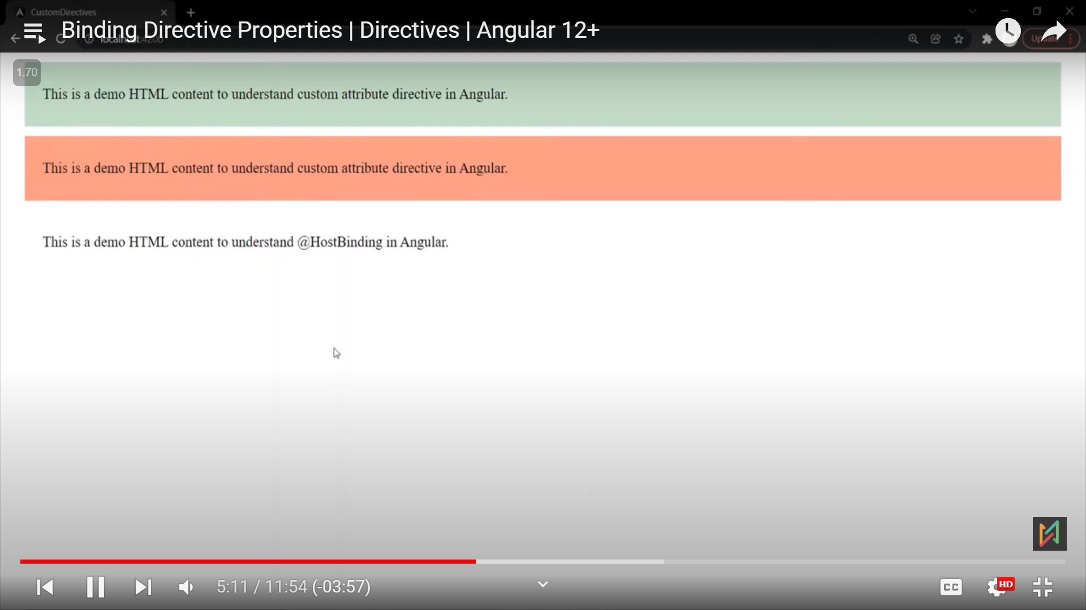 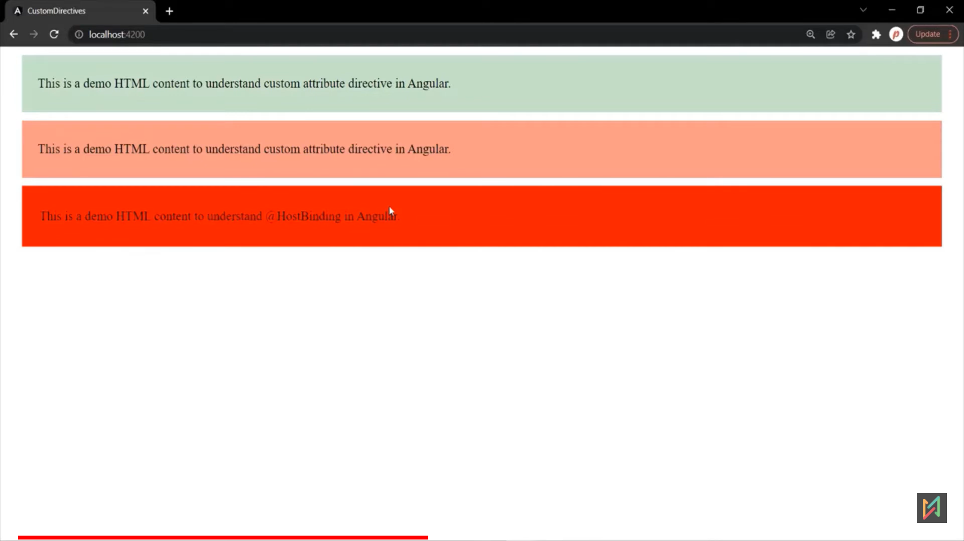 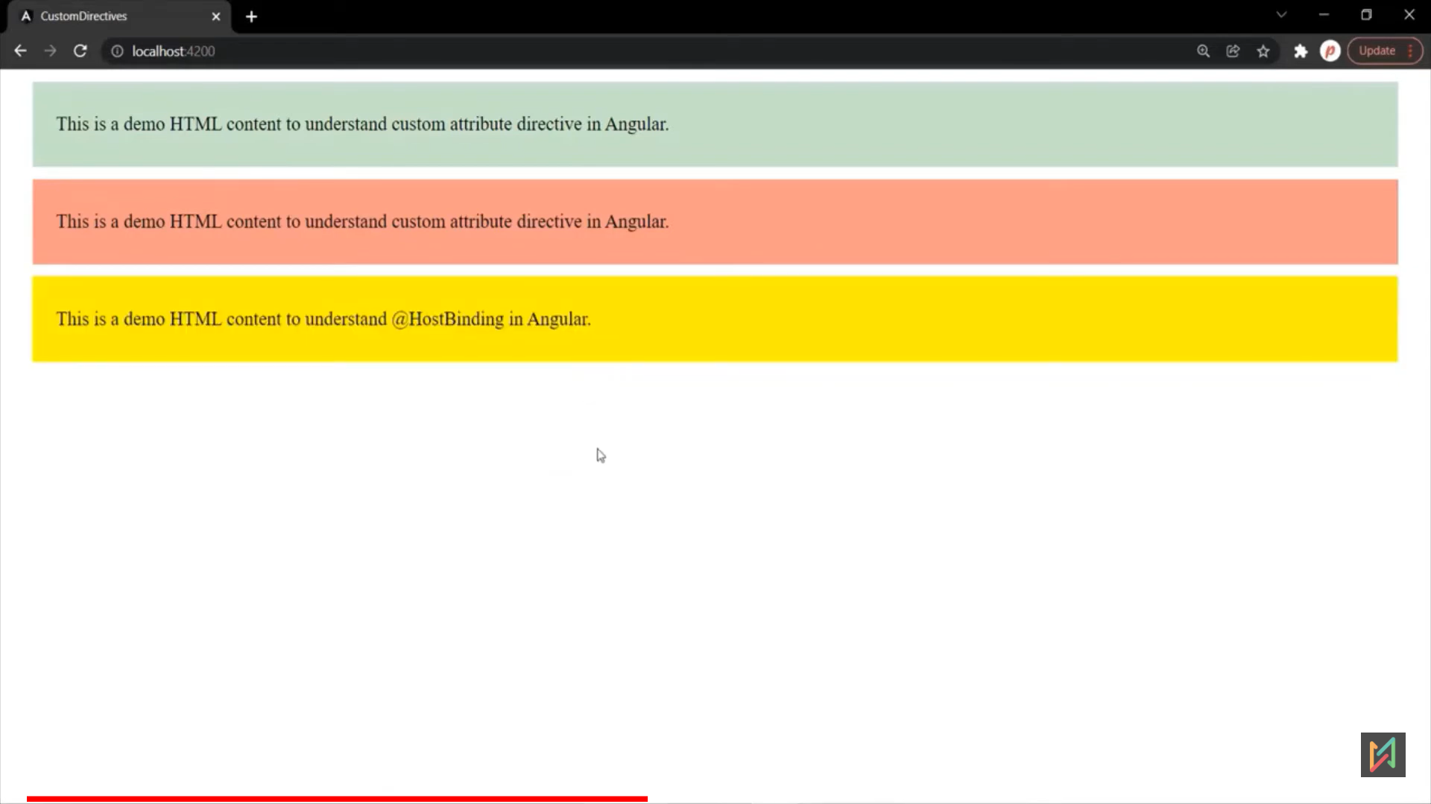

Bug Fix: initial background color in ngOnInit():

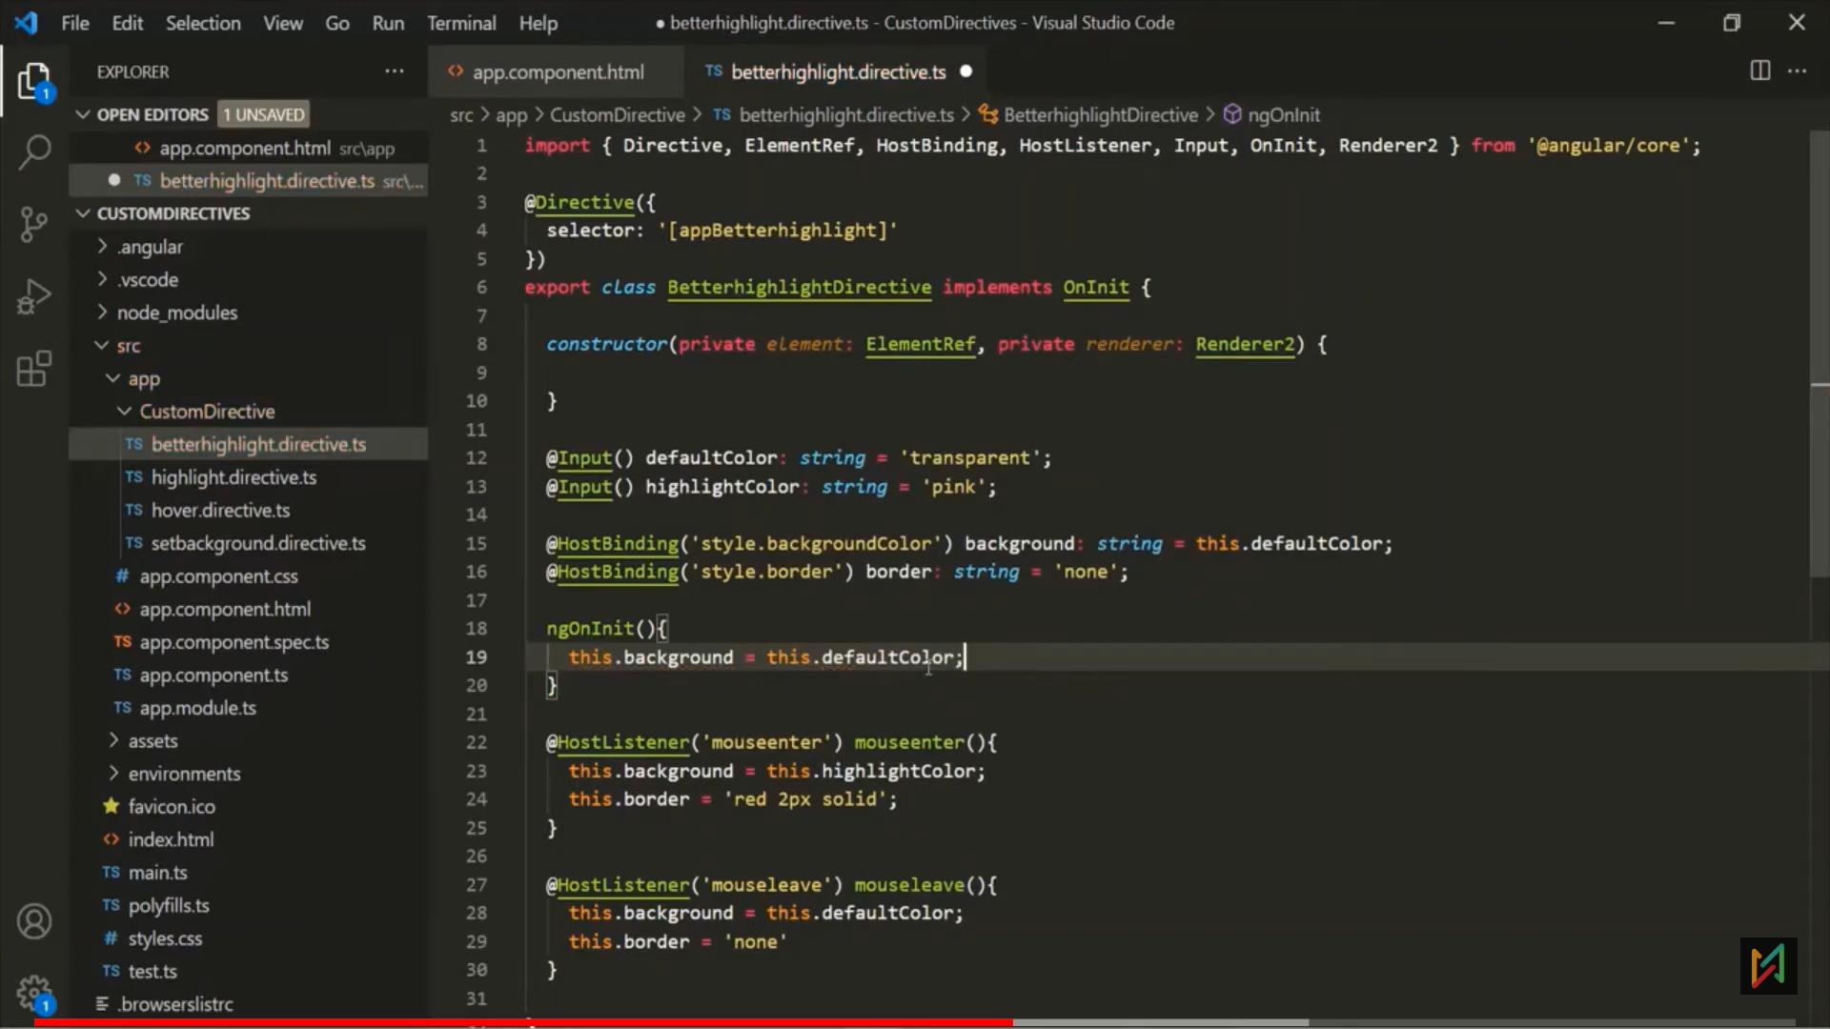 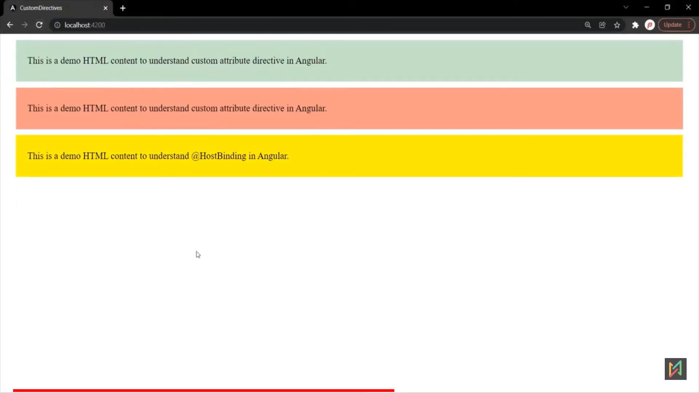

eg: 3: Passing alias name and use directive as propertyBinding. 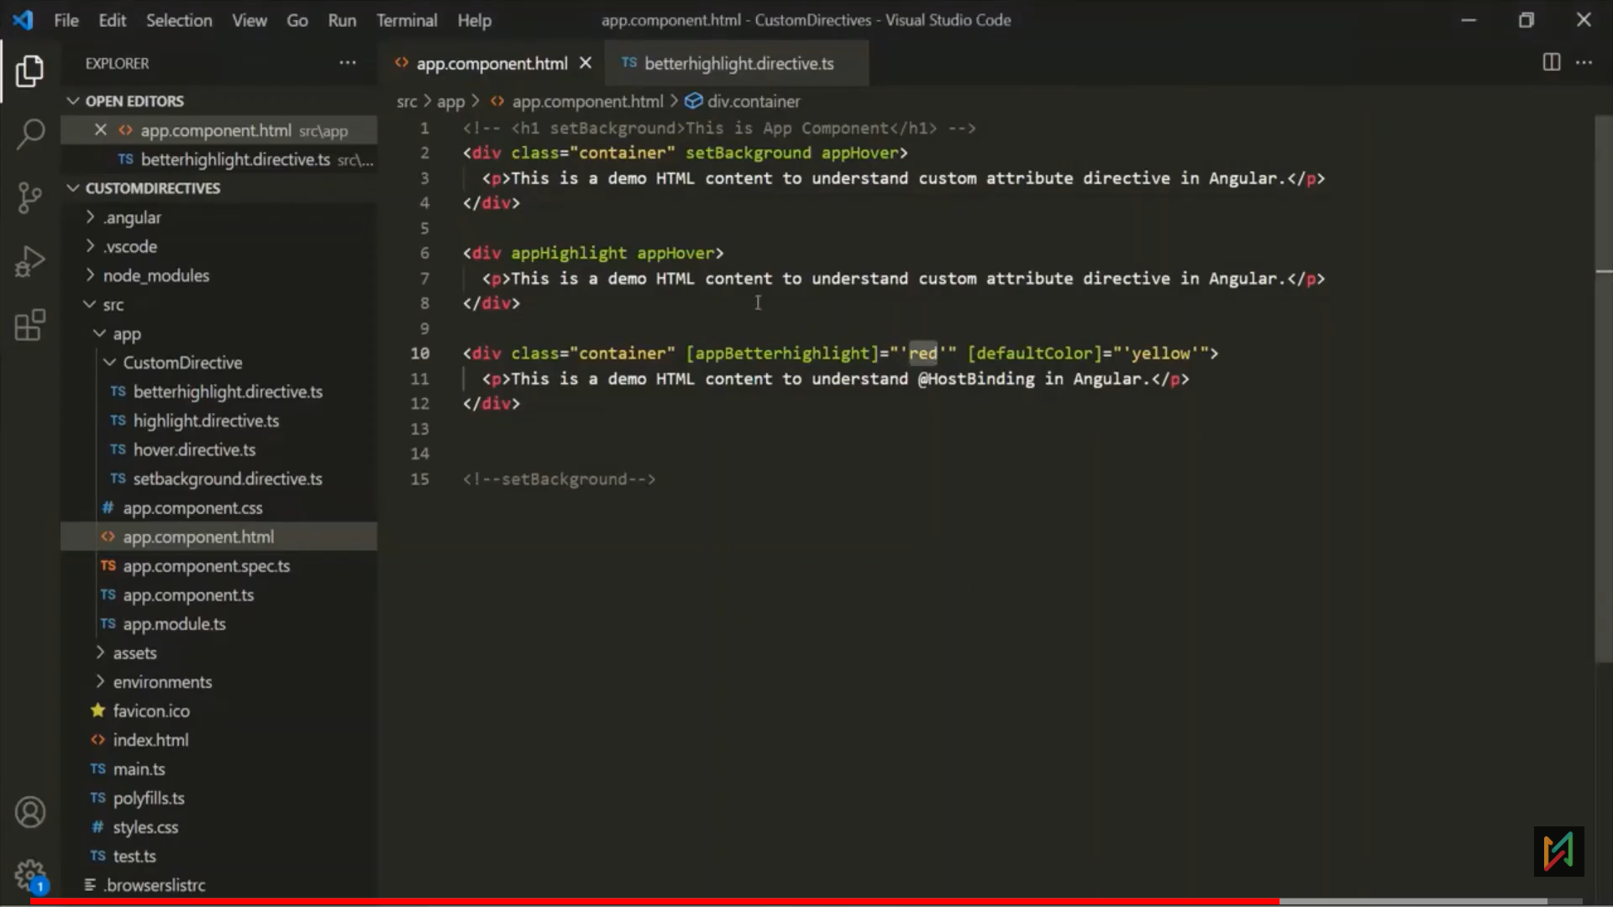 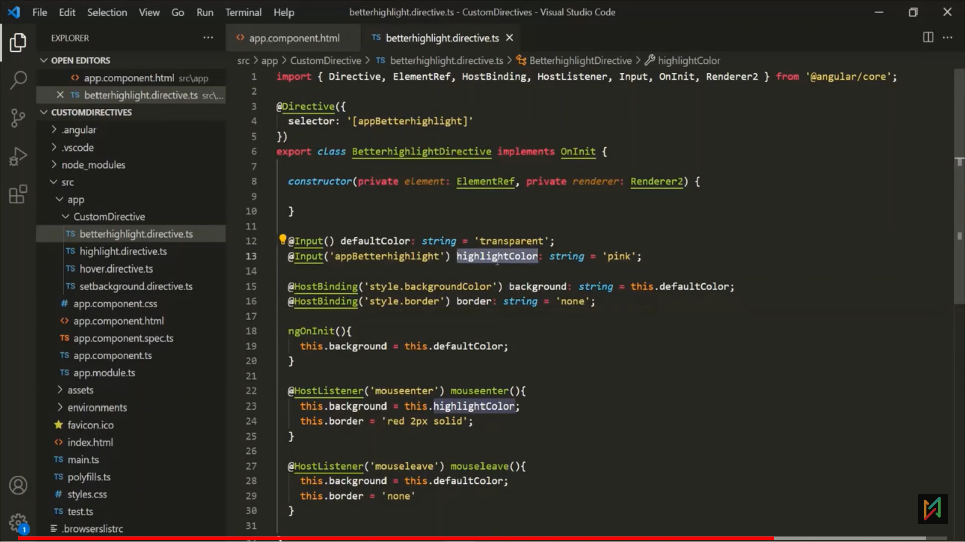

eg.4 : Now title is native property, how angular will decide the property?  
-> First, it will check in custom directives, it that property is not present, then it will look native property of that host element.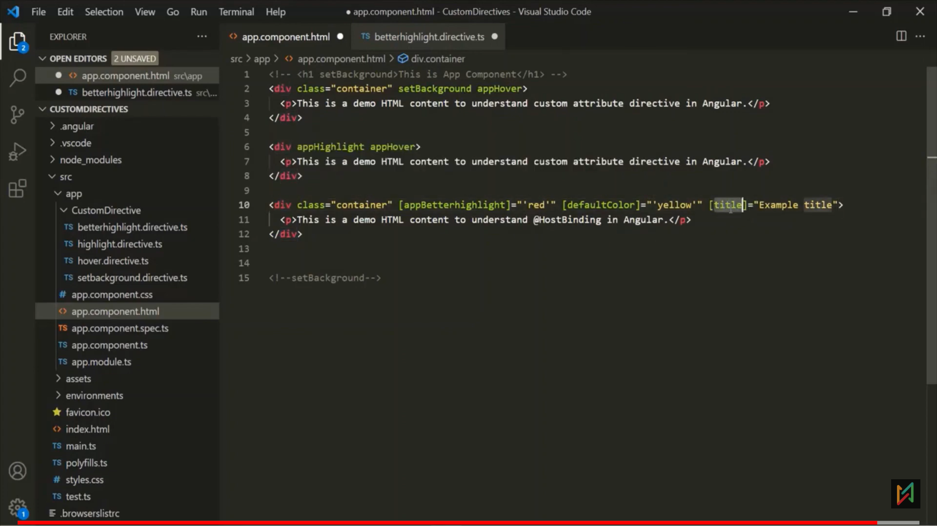 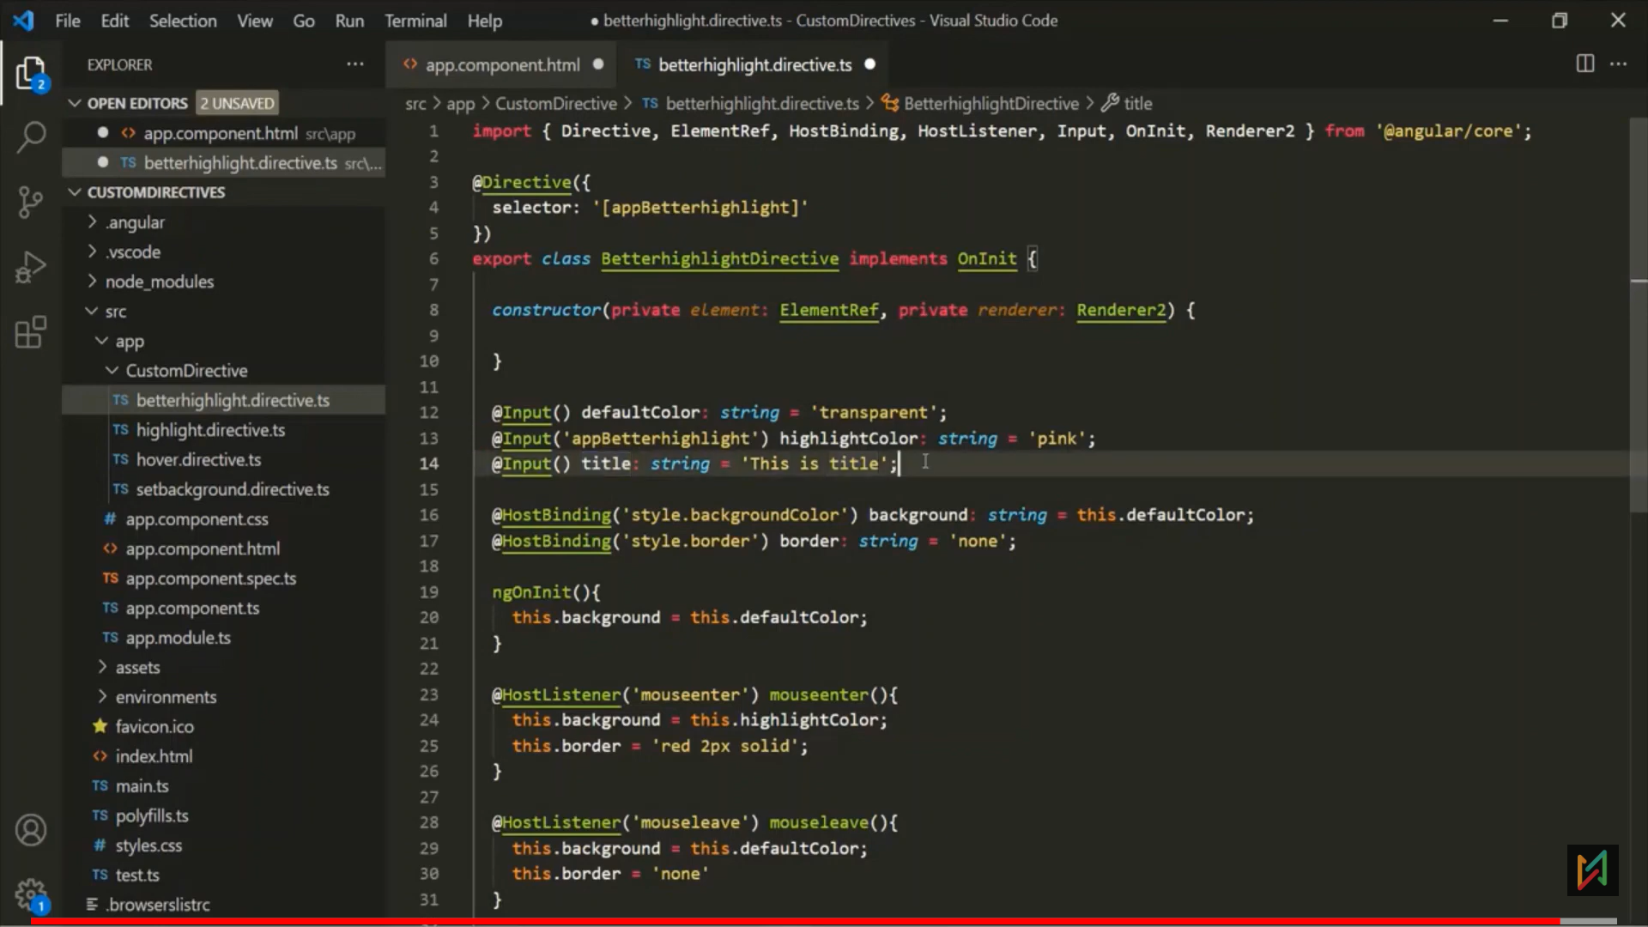

**Custom appClass Directive**

Same as [ngClass]= “{myDiv:”true”, container:‘false’}”

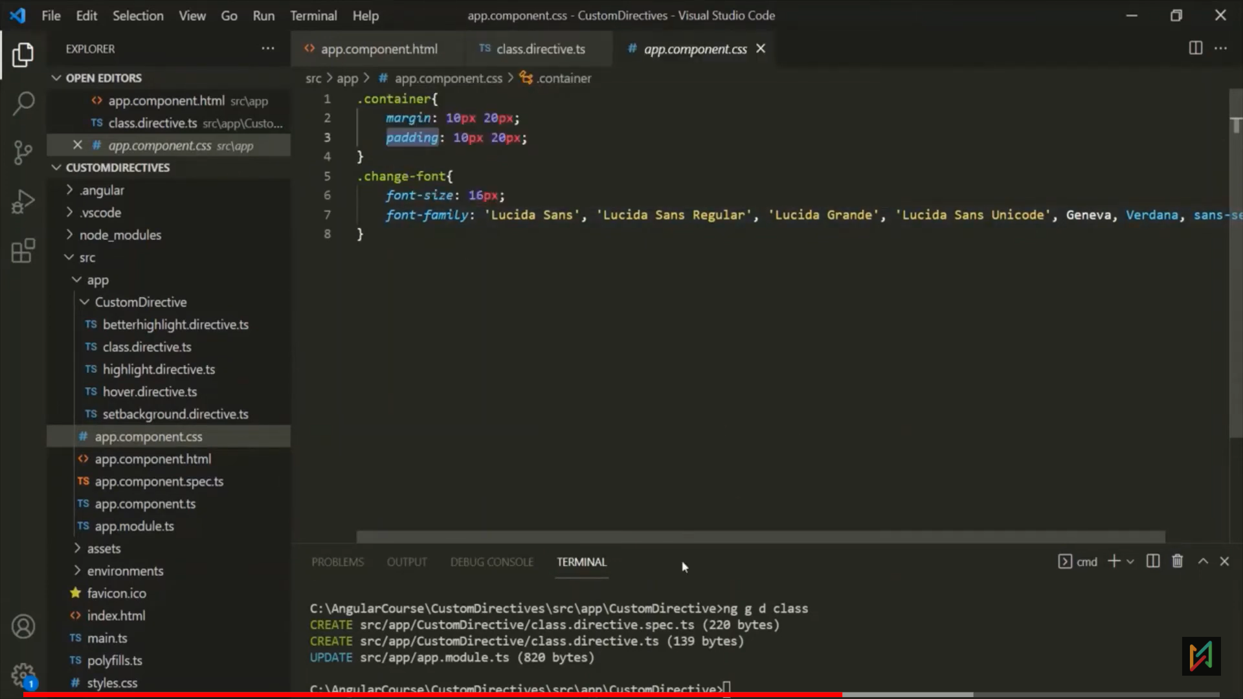 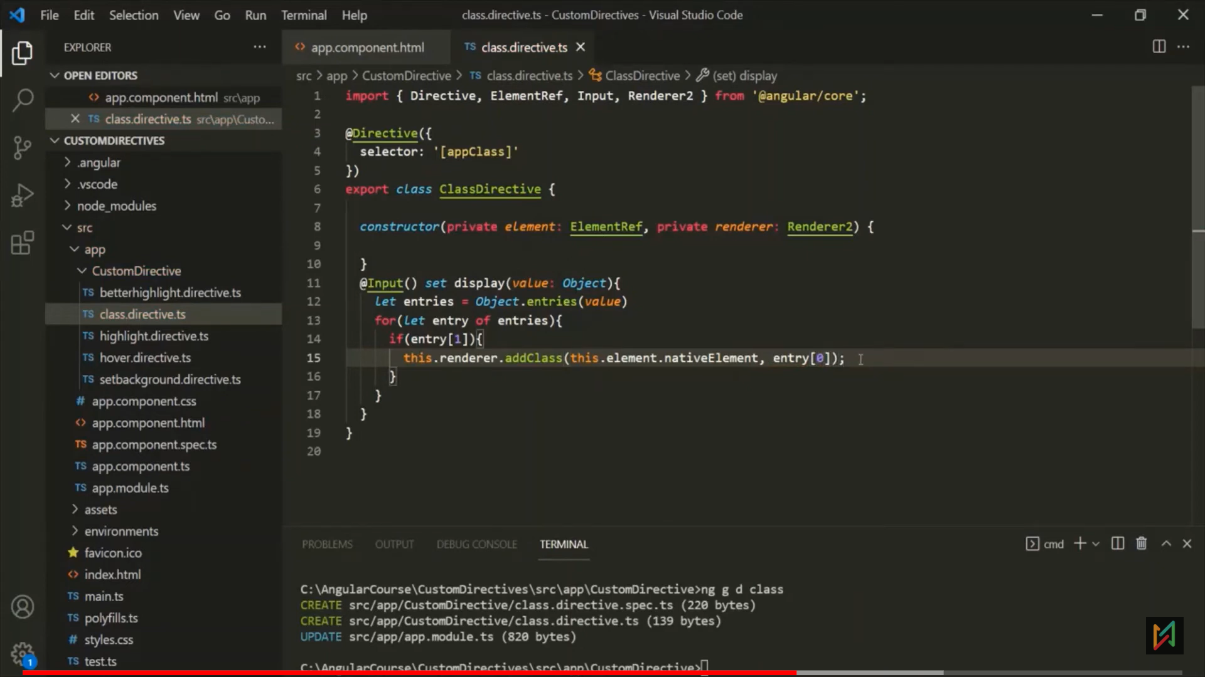

Or destructuring: 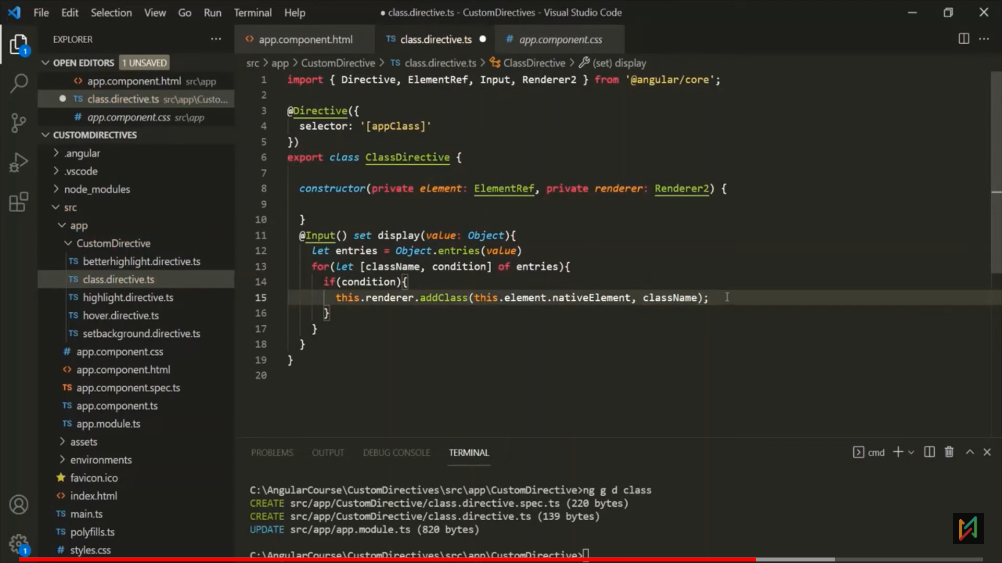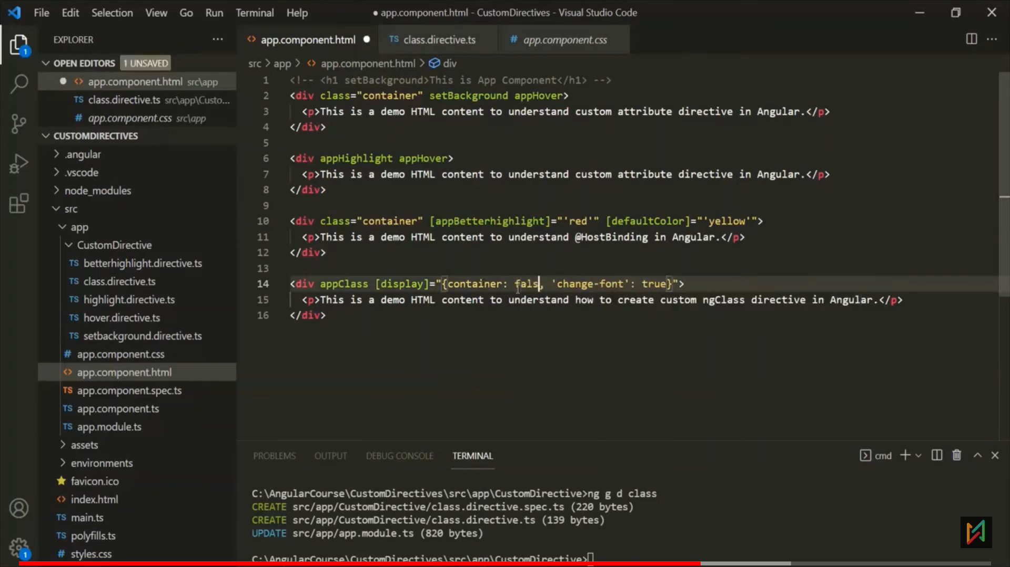 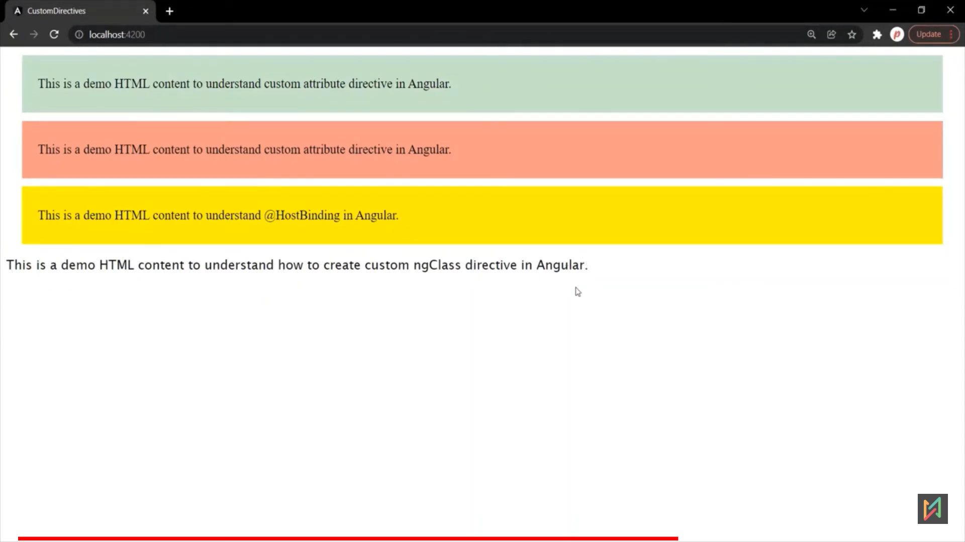

Eg.2 pass as alias name: 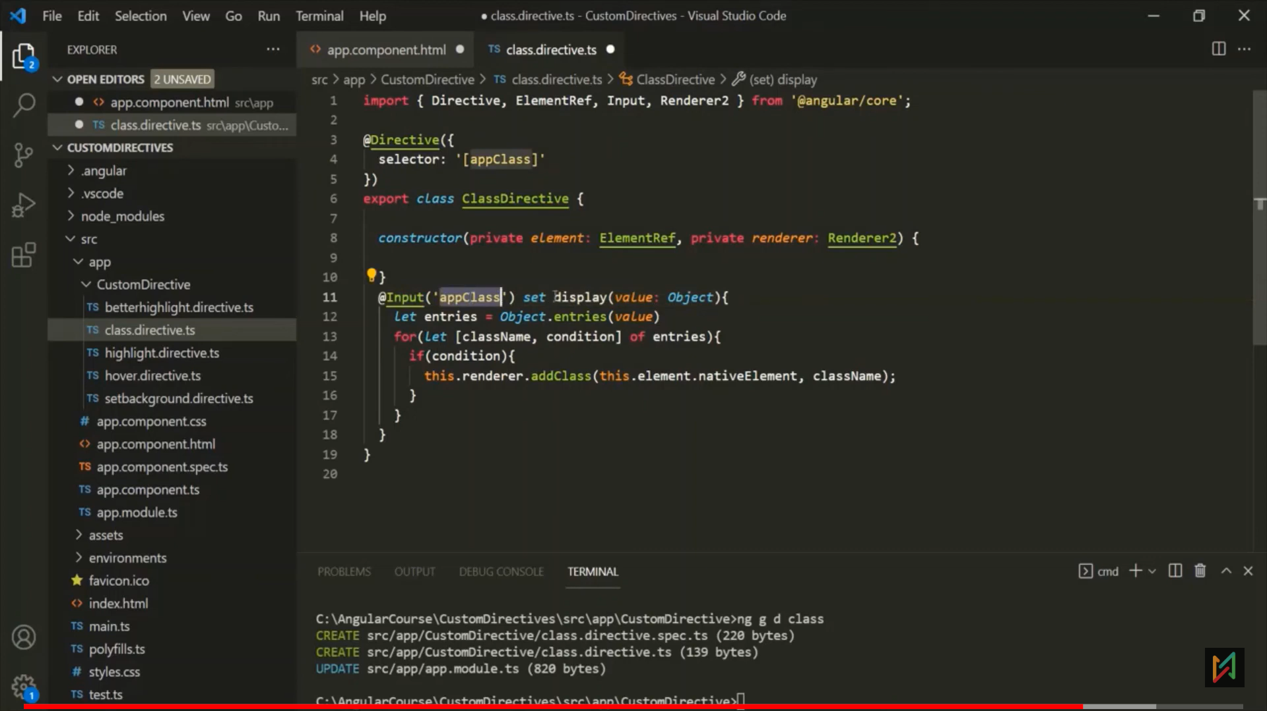

Or: 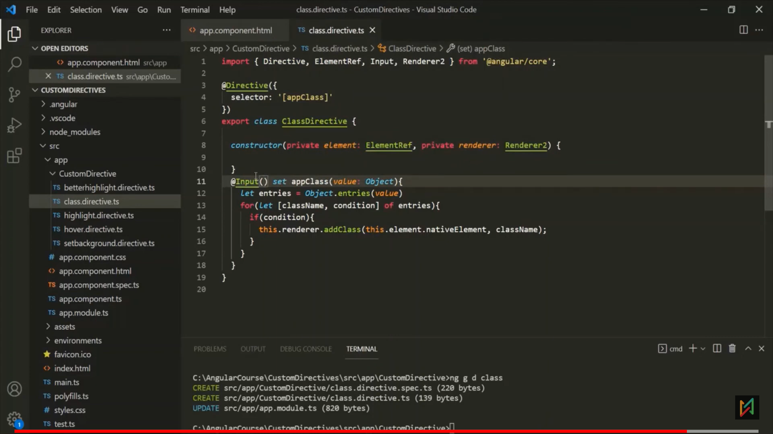 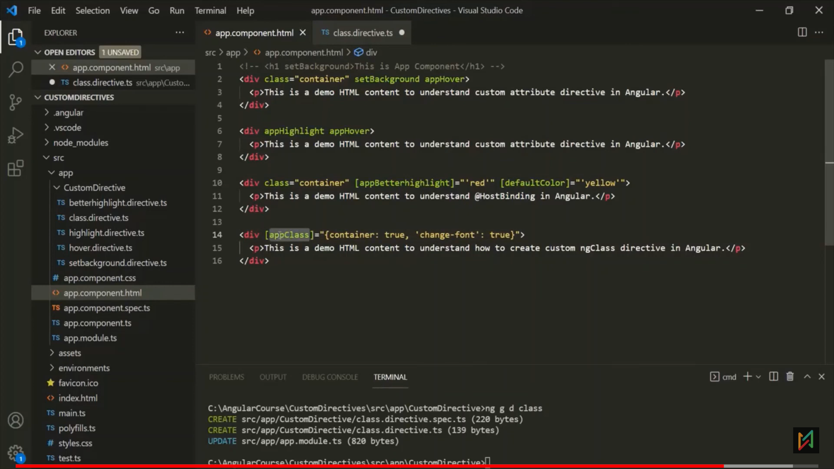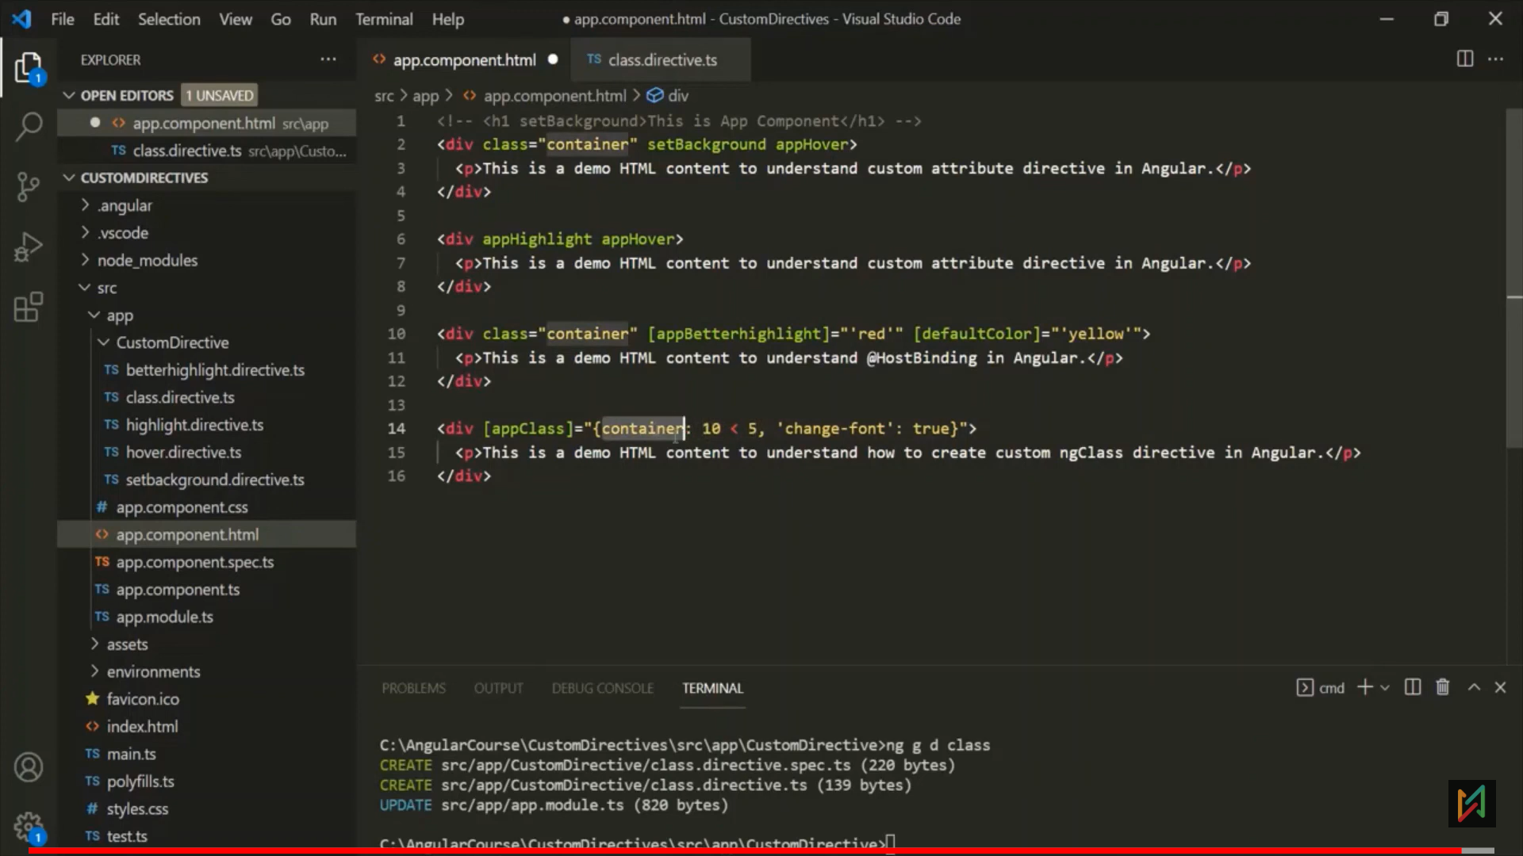

Custom Structural Directive

- 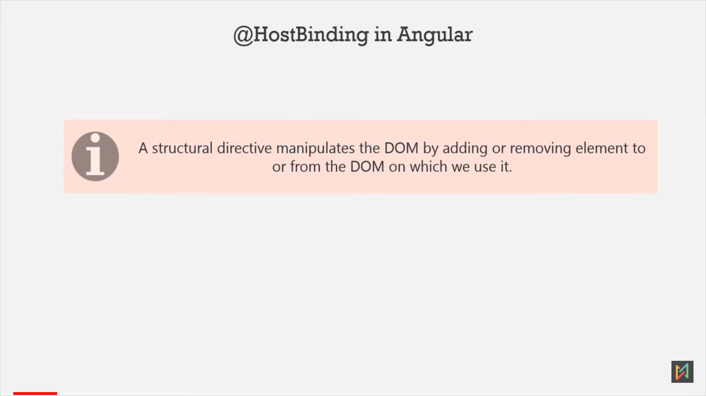

- Why we need (*) before structural directive?  
=> As a developer we can pass *, but internally resolve that * and create a ng-templay tag with property binding of the same structural directive.   
  
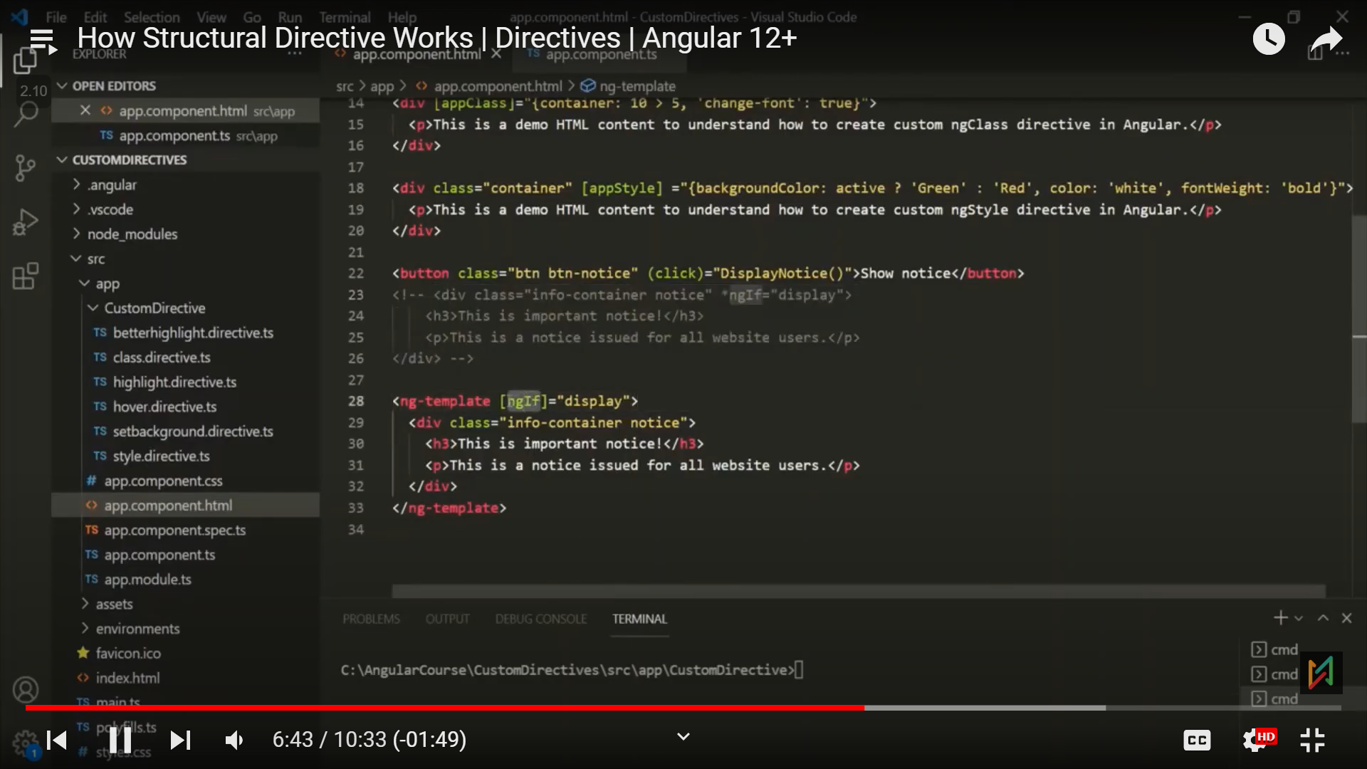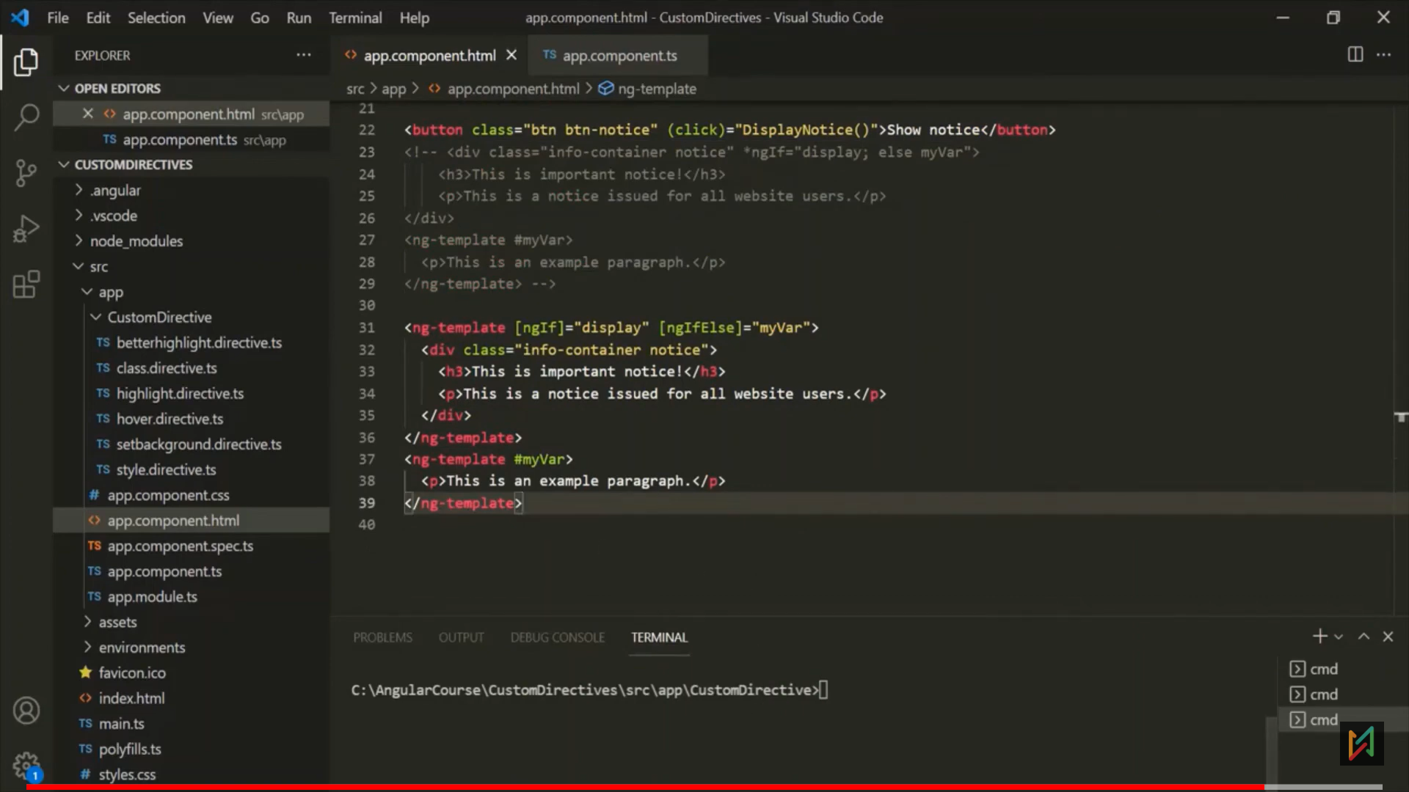

**Create Custom Directive**

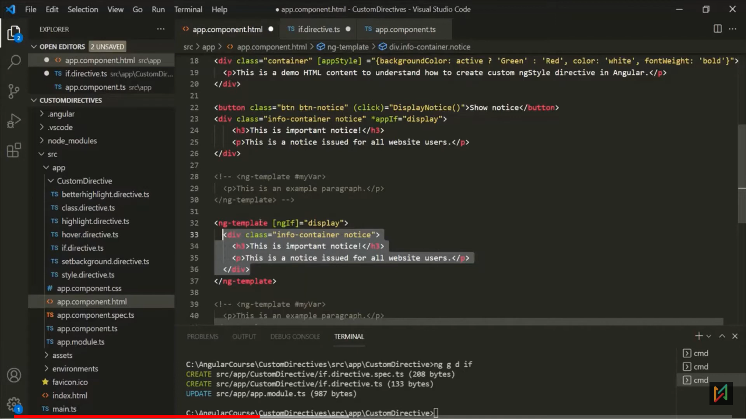

* Below, in constructor, first parameter of the constructor will store the view. (what to add/remove)
* Secornd parameter, is the container on which will add or review the view. (from where to add/remove)

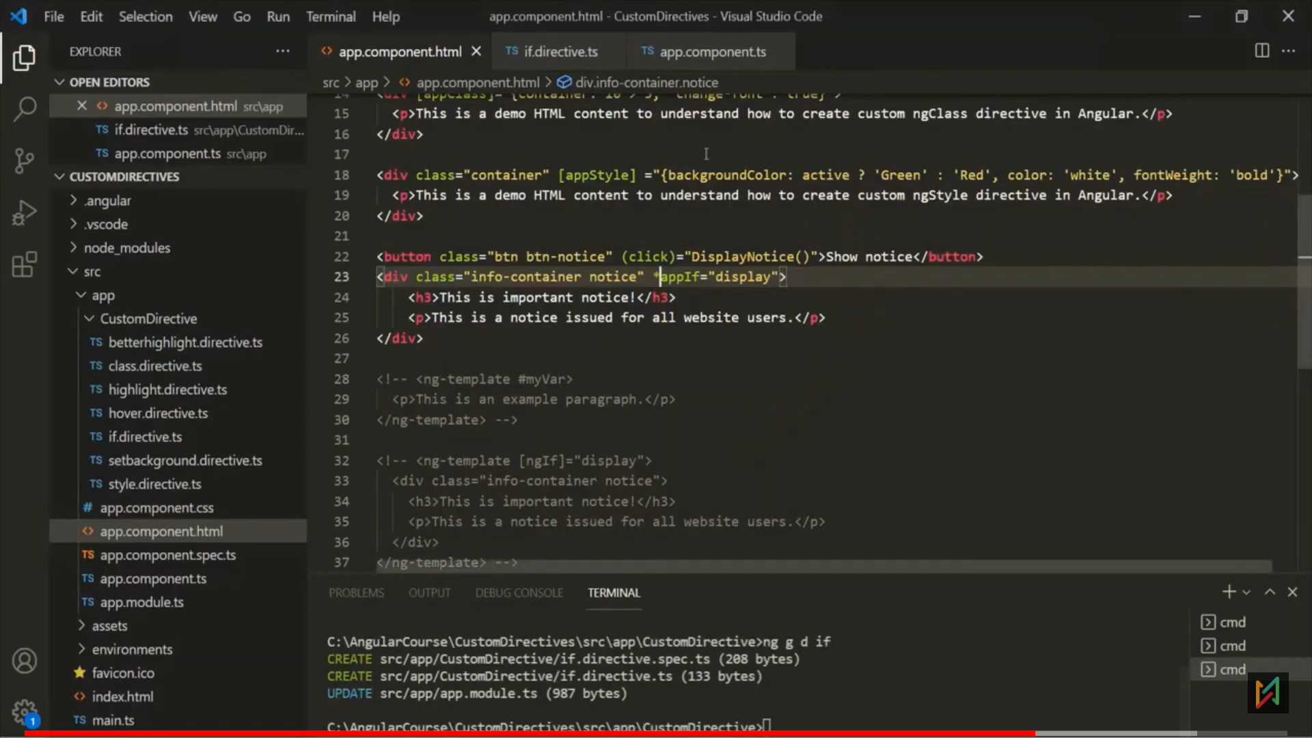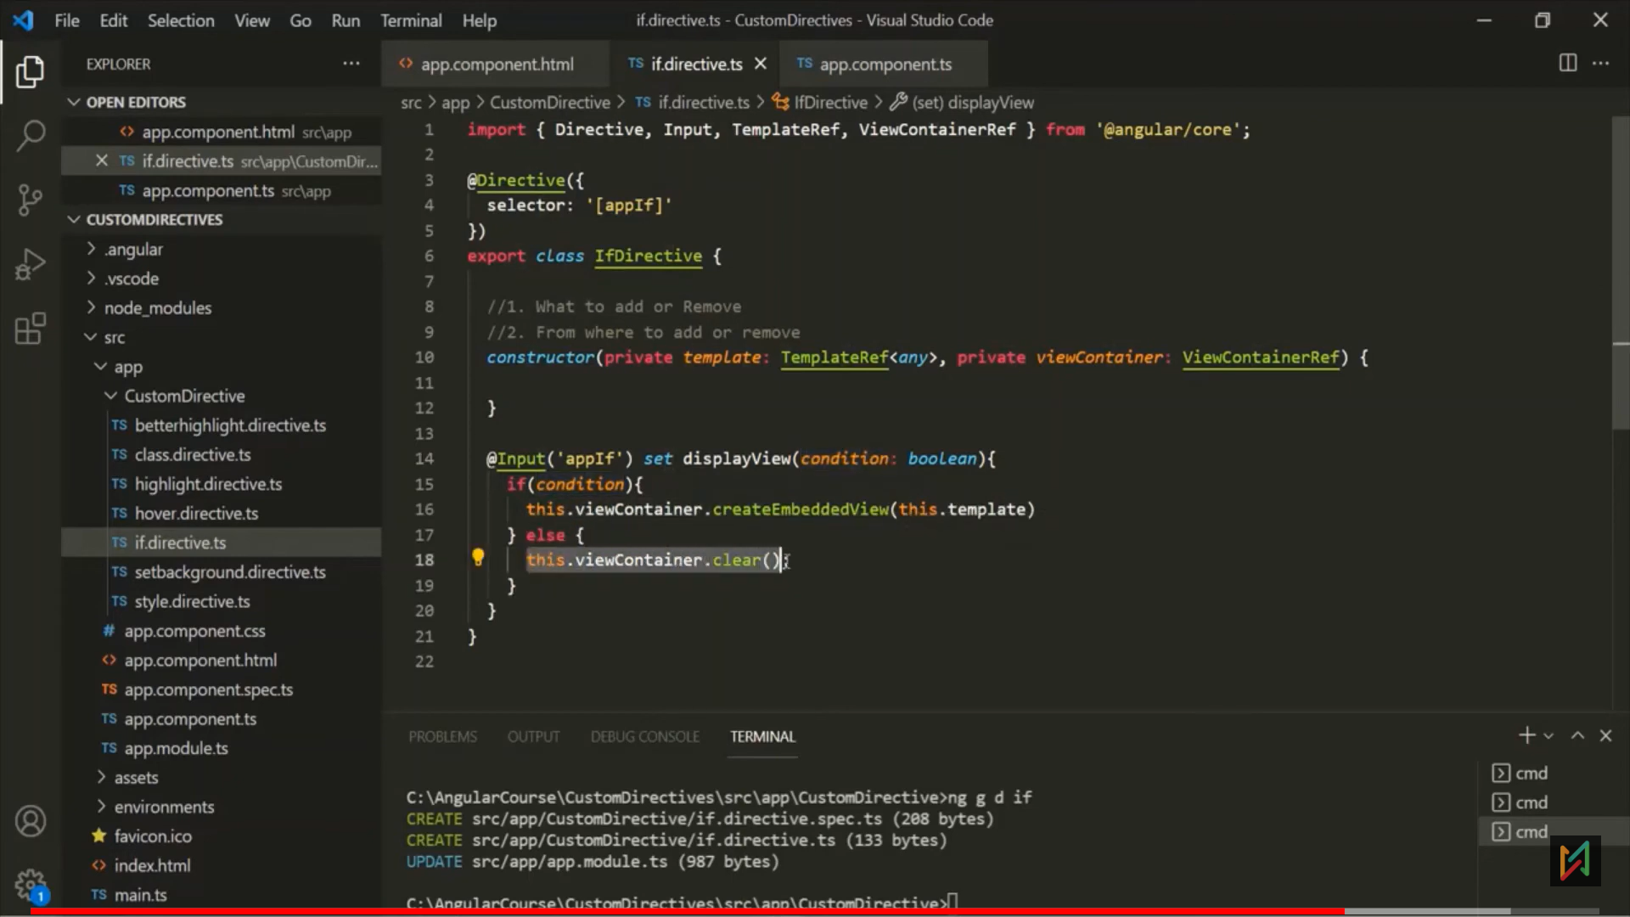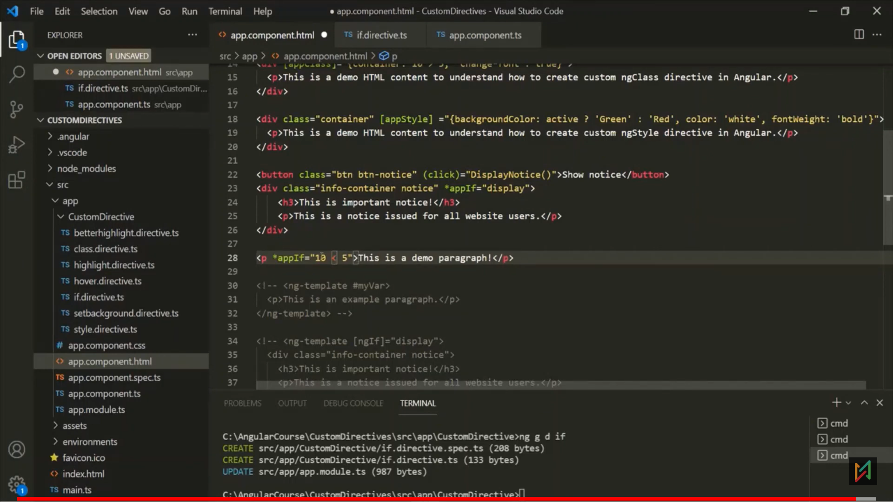

**Service**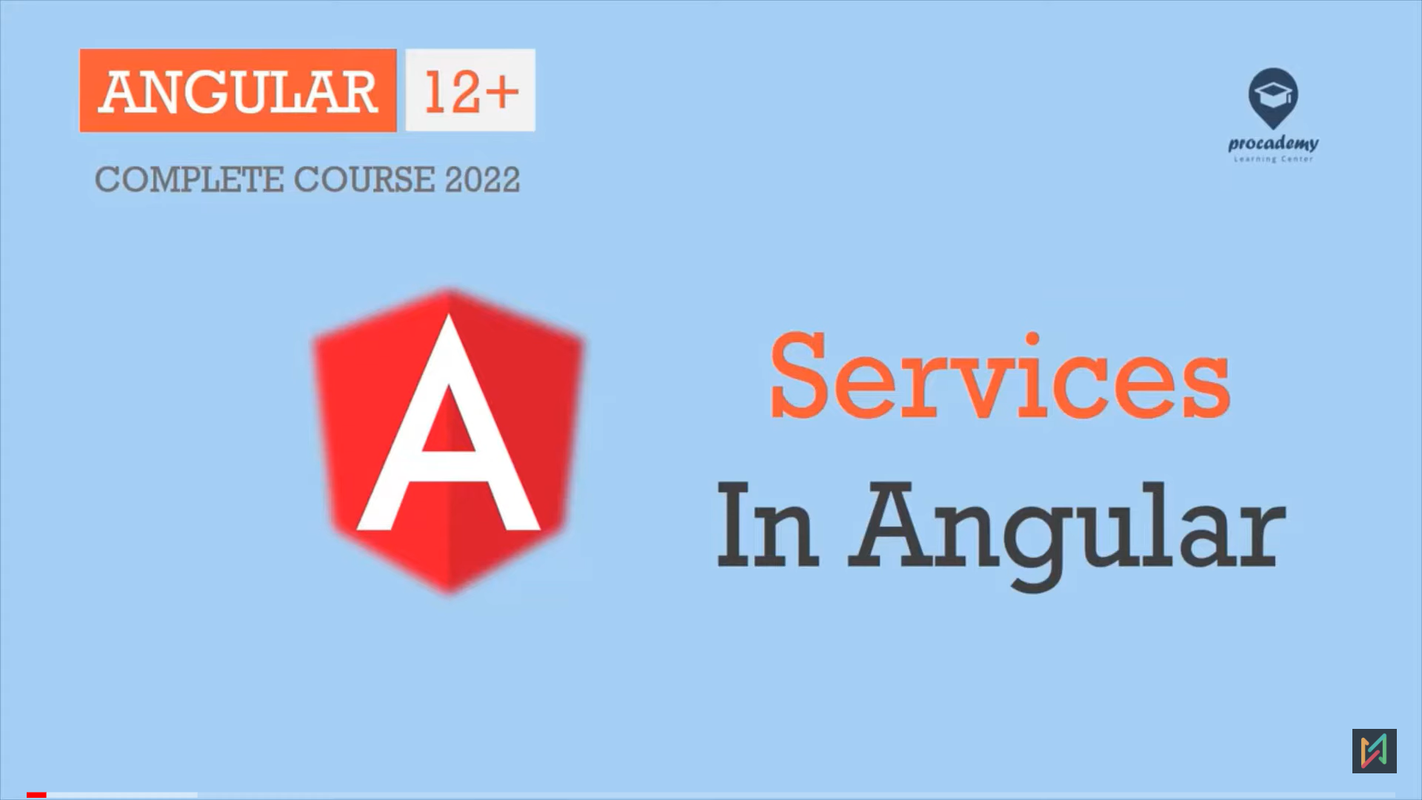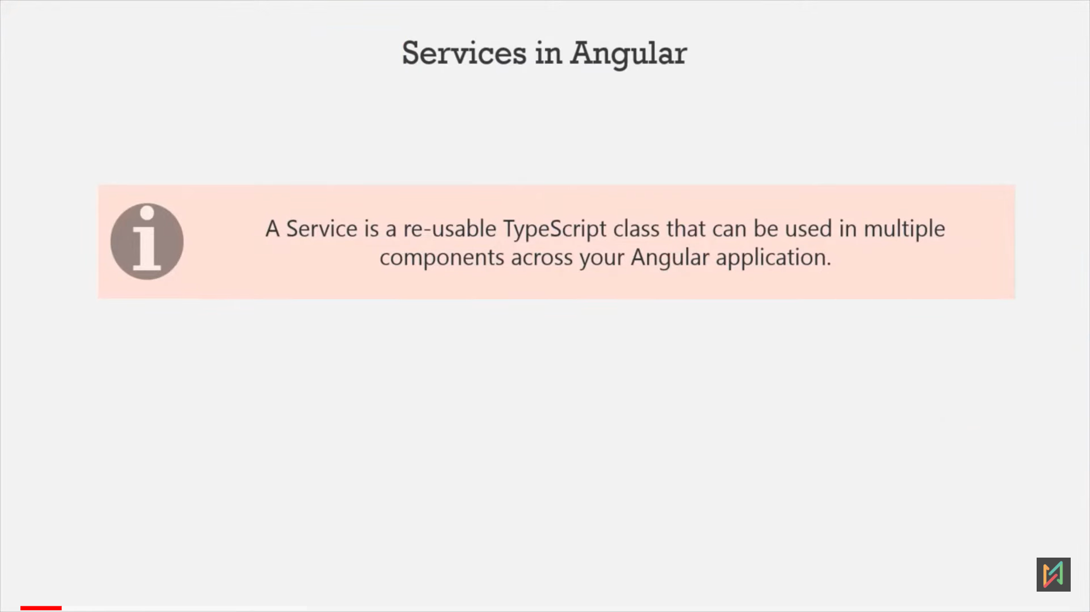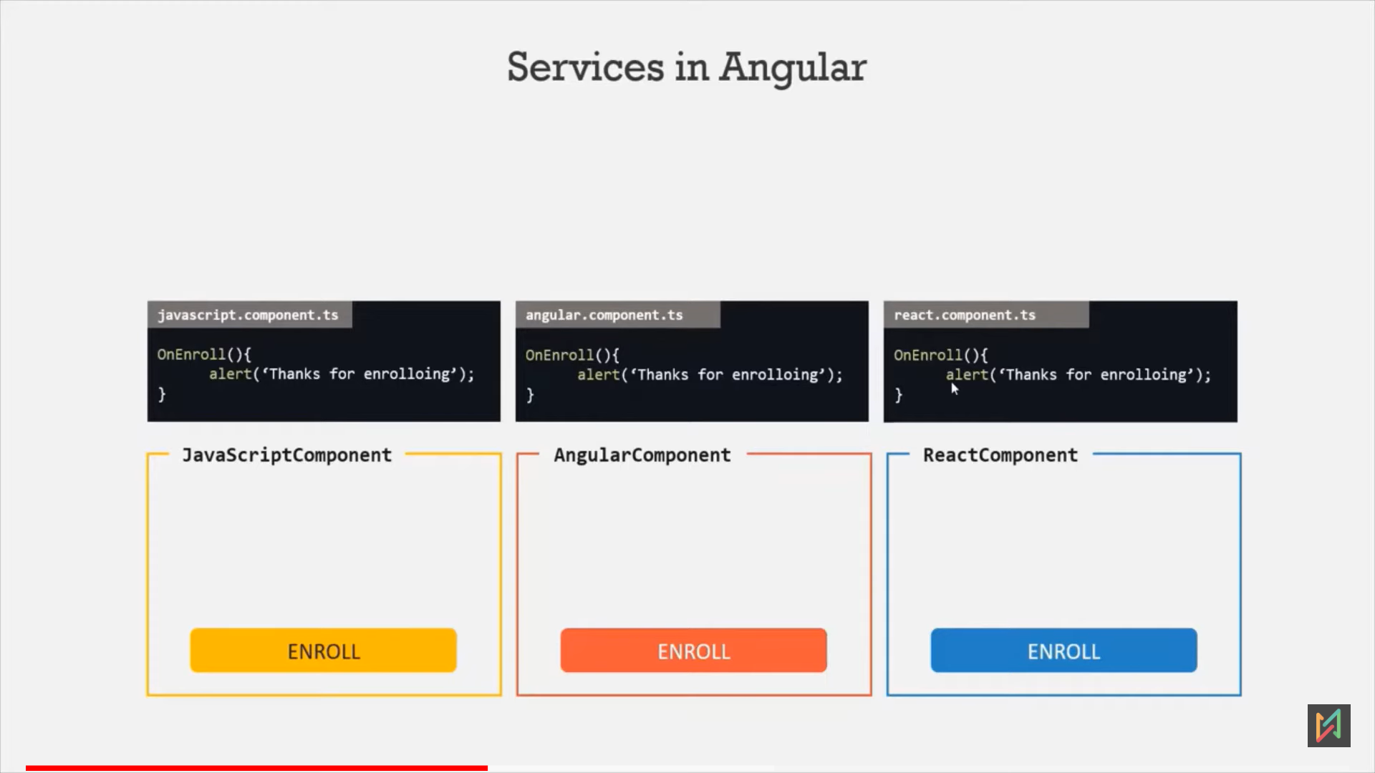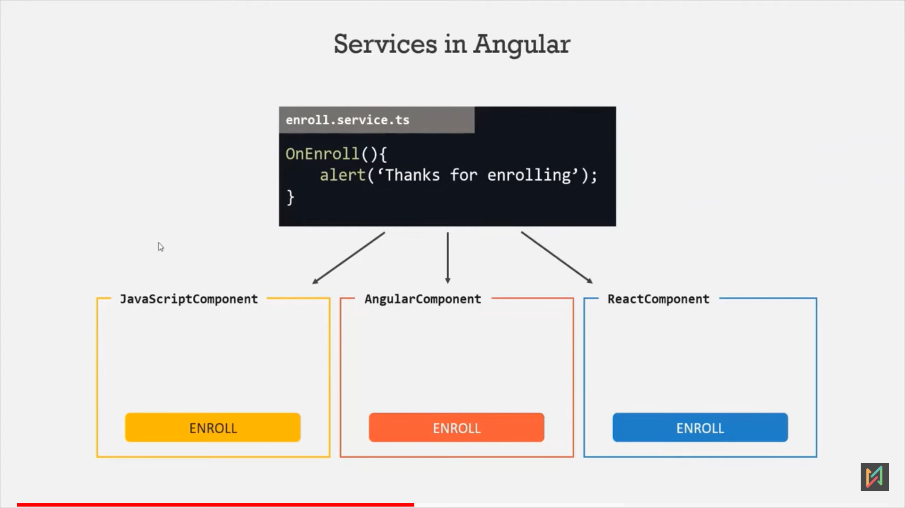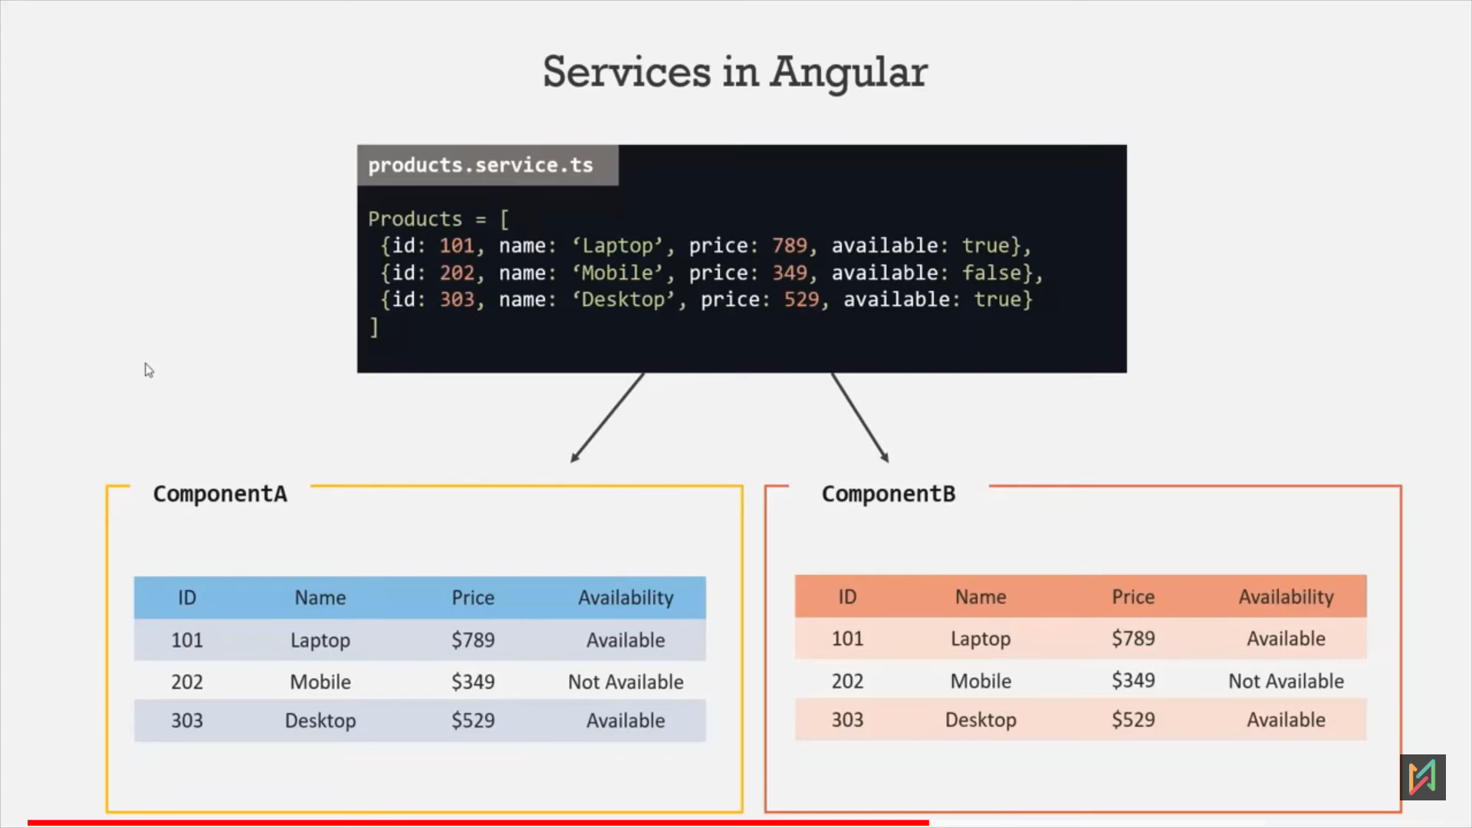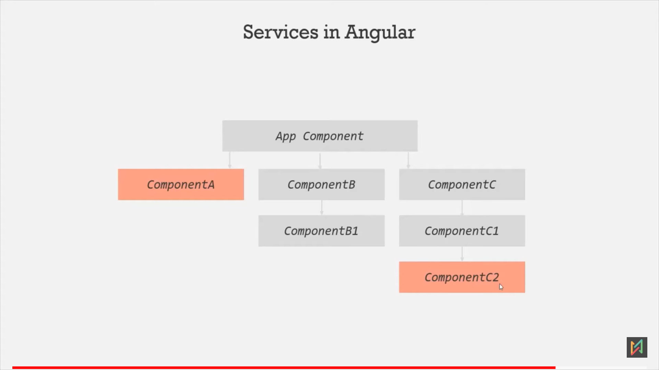here, we cant communicate ComponentA and ComponentC2 using @Input/@Output decorator. 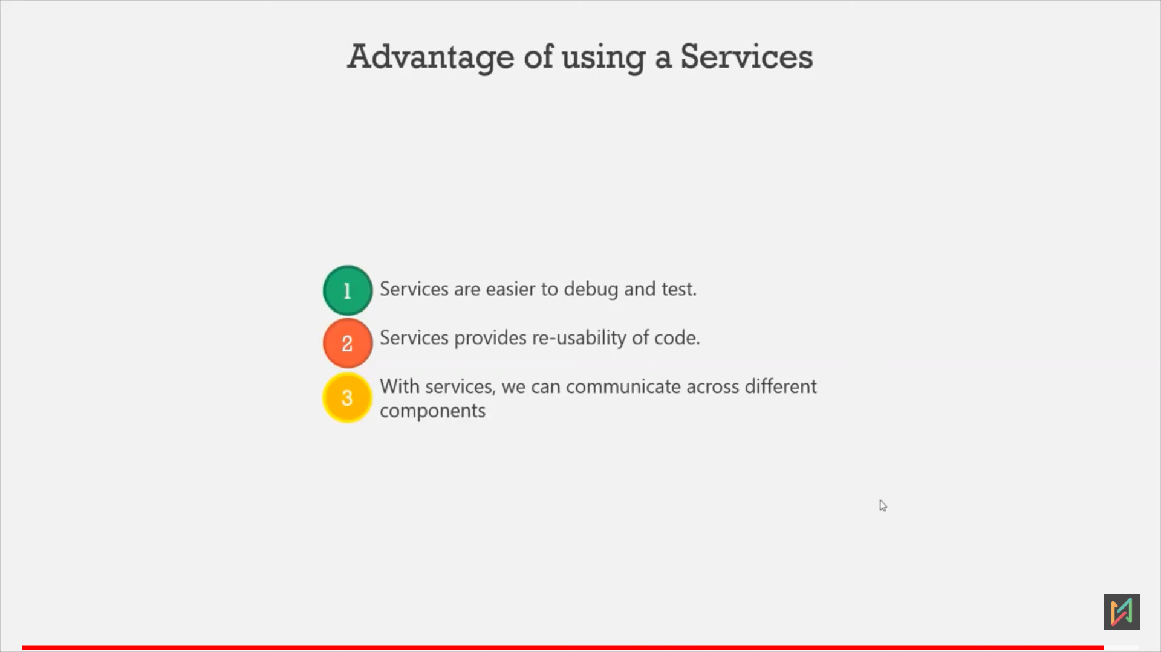

**Observable**

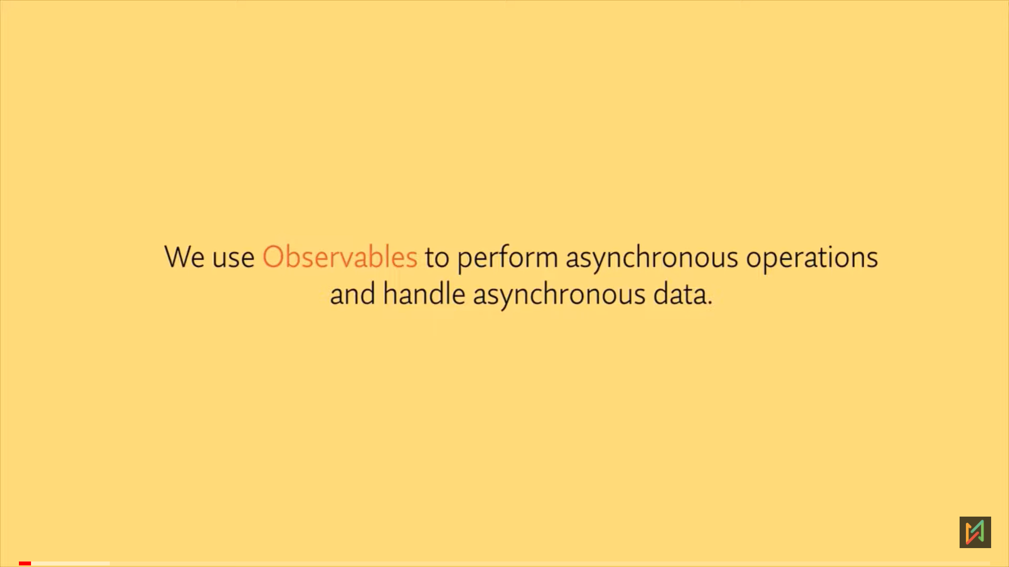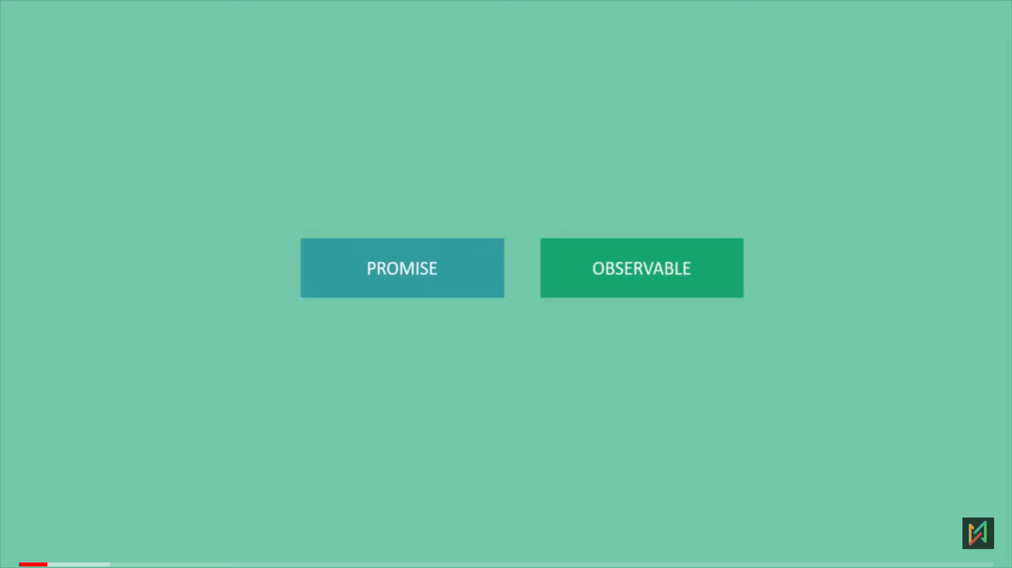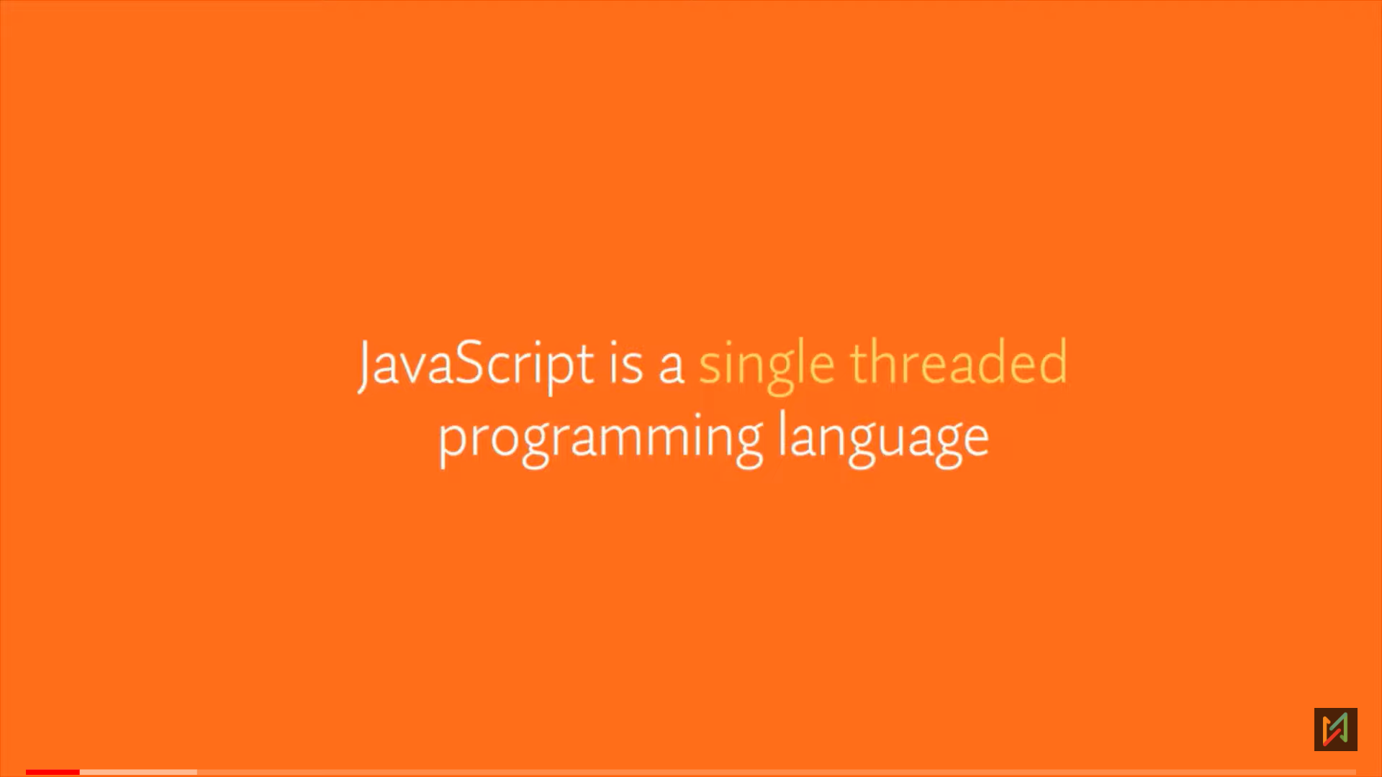

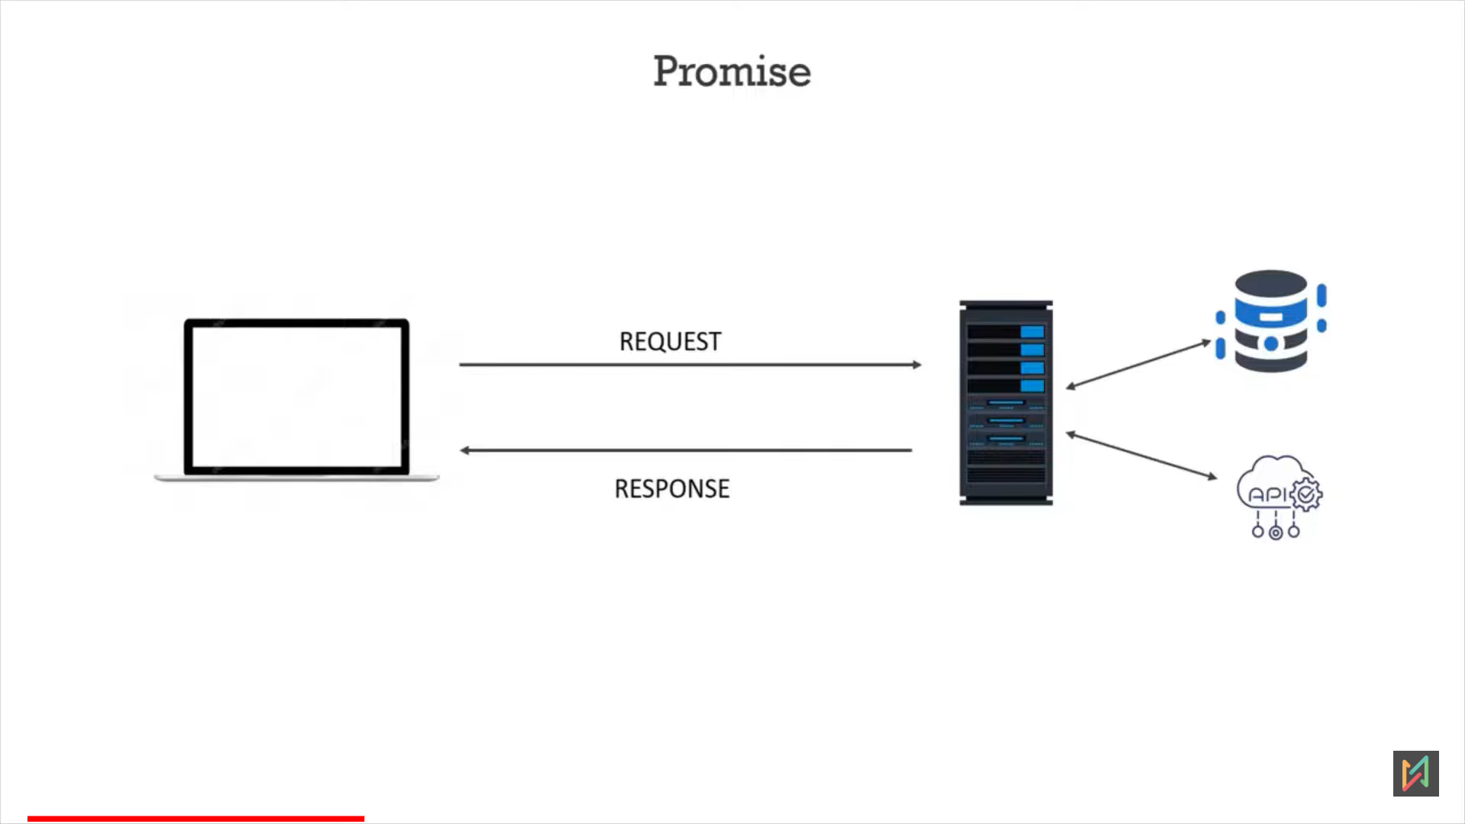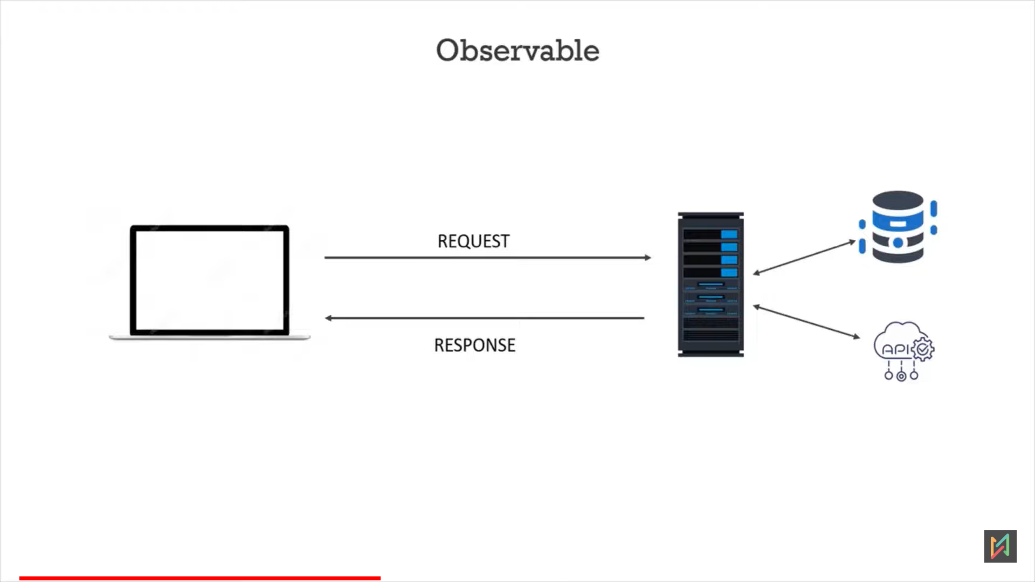

Promise call: Server will process the data, once the complete data is processed and ready, then only server will send a successful response, else promise will return an error.

Observable: It will not wait for the complete data to be available. It streams the data and sends the data in packets.

Diff2: Promise will always give the data, even no one using the data, bu observable will on give the data whenever requered.

Diff3: Promise is feature of native JS, And observable is a feature of JS library called RsJs, not an angular or JS.

